**Practical No : 1**

**Aim :** Exploring and Building a verification lab for Penerating Testing (Kali Linux).

Step 1: Install VMware Workstation Player 16. Double Click and install it.

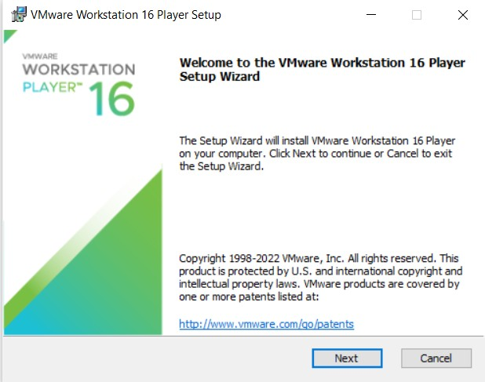

Accept the terms and conditions and click on next Button

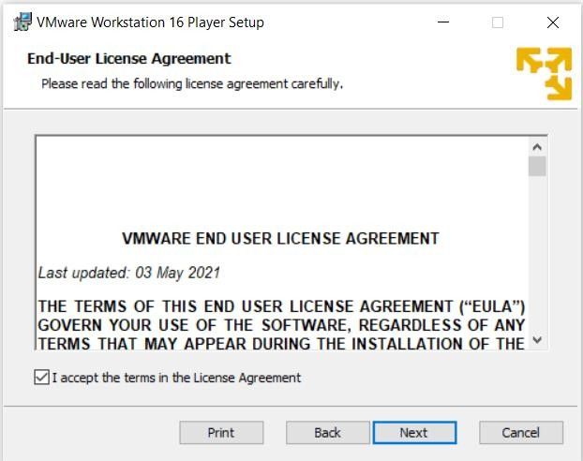

Click on next

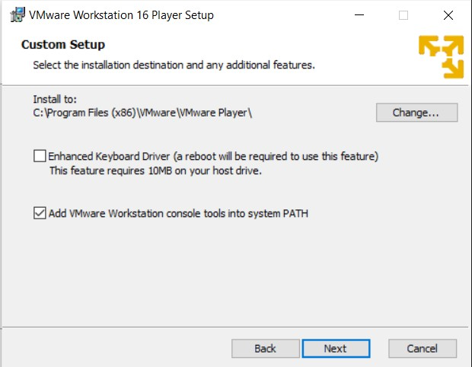

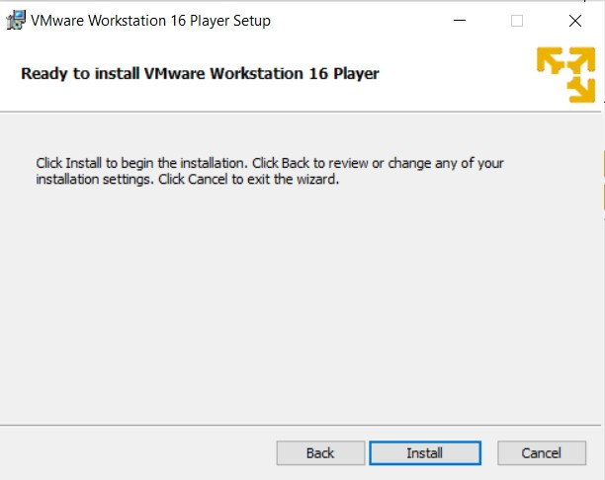

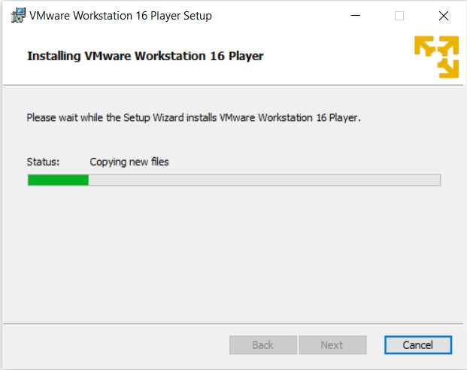

After Sucessful installation of VMware Workstation.

Open you Workstation and click on 2 Option i.e Open a Virtual Machine

Now give a name to you Virtual Machine and redirect to the folder where your .ios file is located.

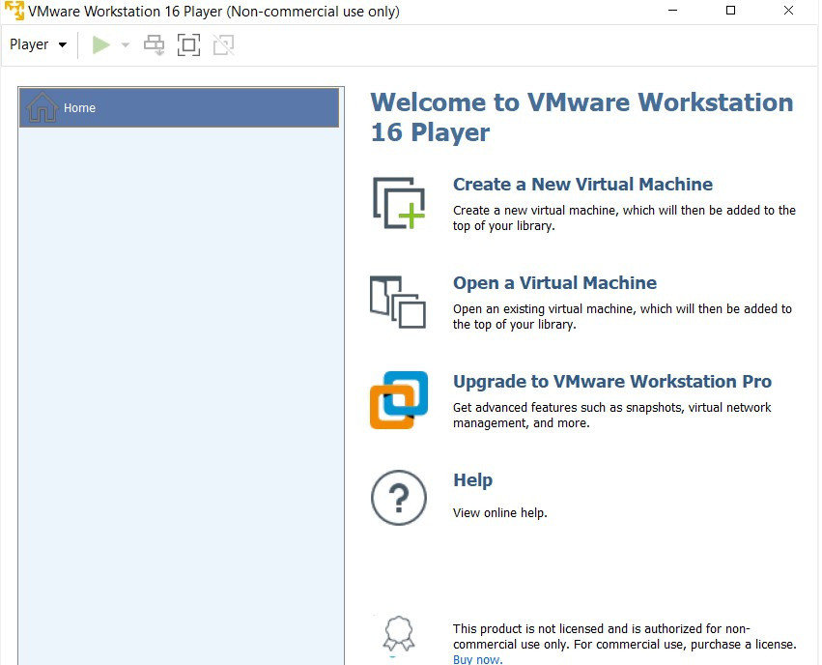

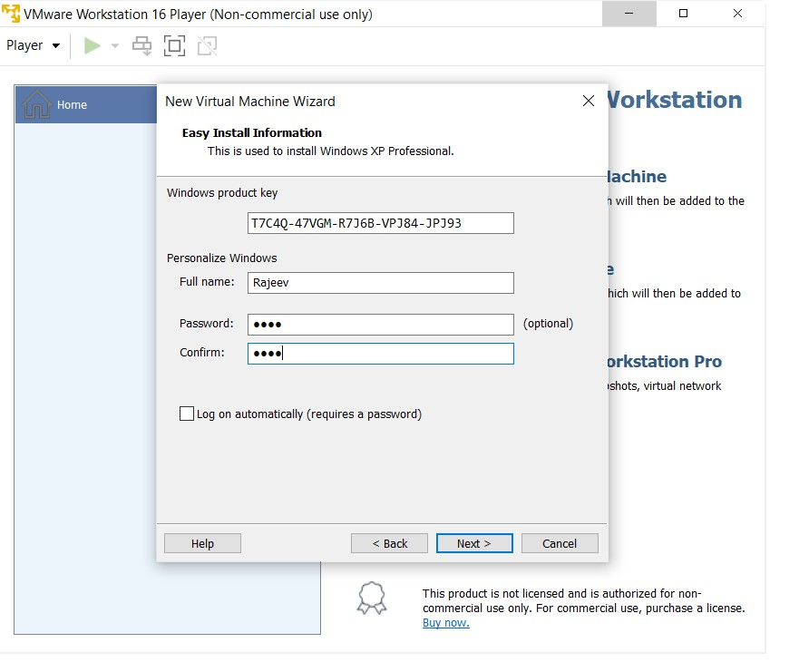

Now select the default setting and click on next button.

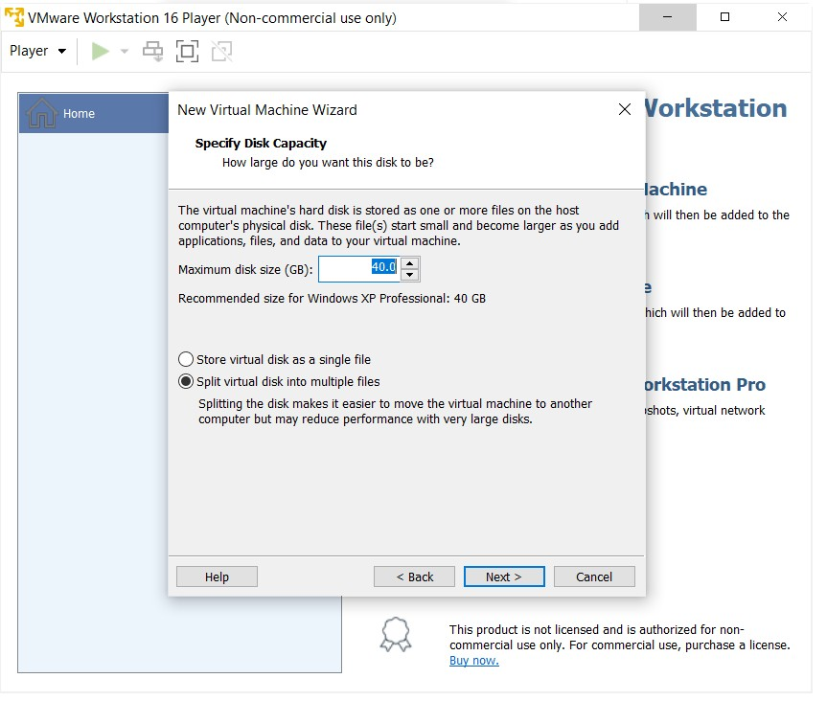

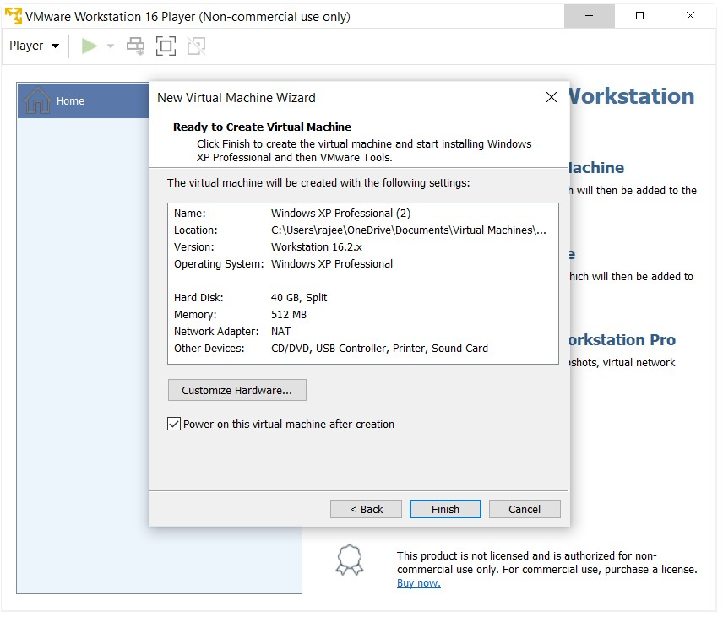

Now a Wizard will open where in you need to enter the product key for Windows XP.

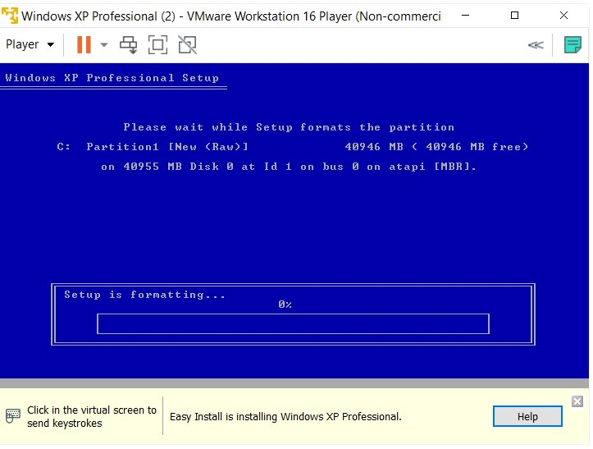

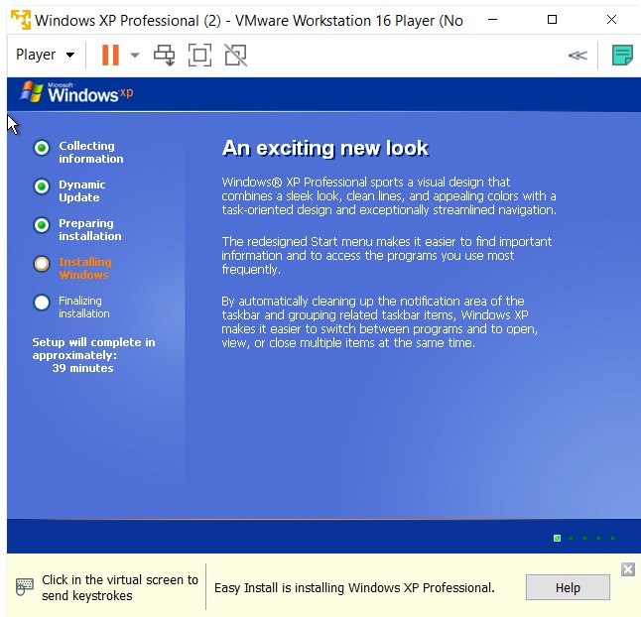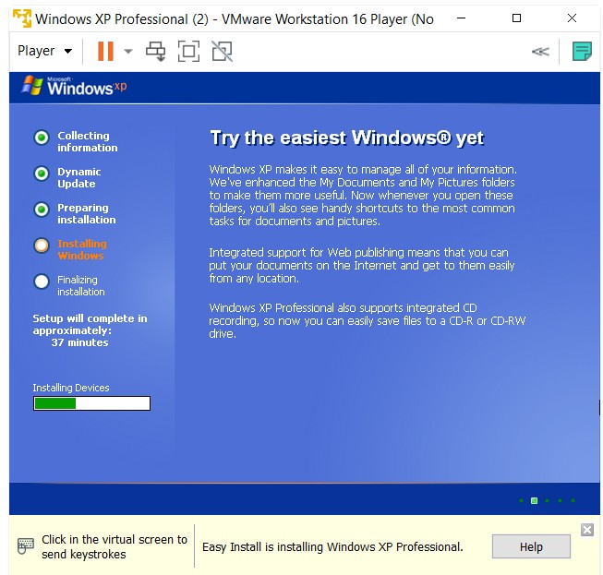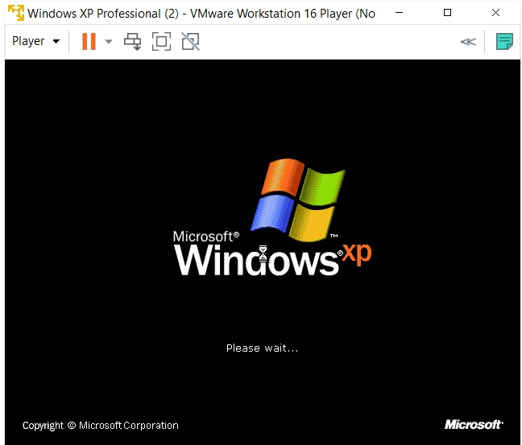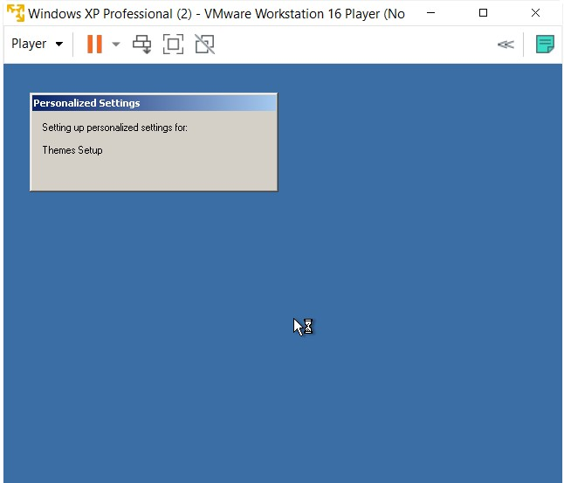

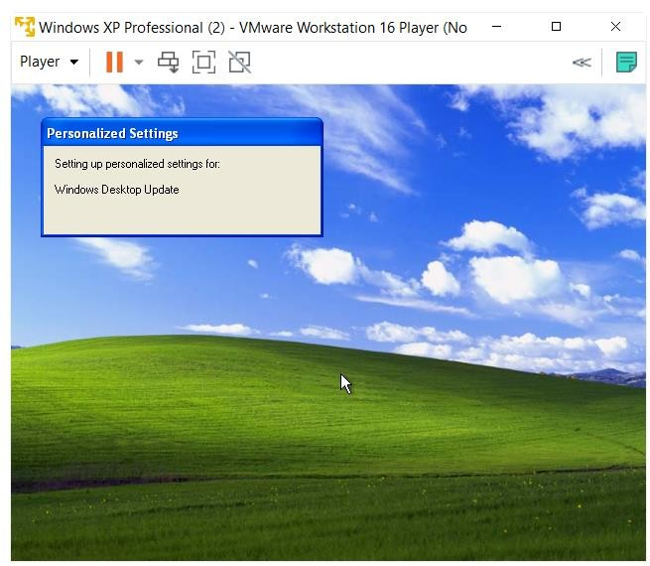

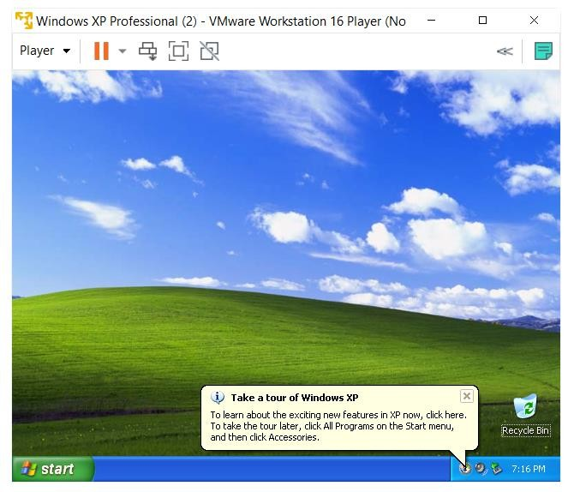

Kali Linux Installation: After successfully installation of Windows XP. We need to now install Kali license by following the same process.

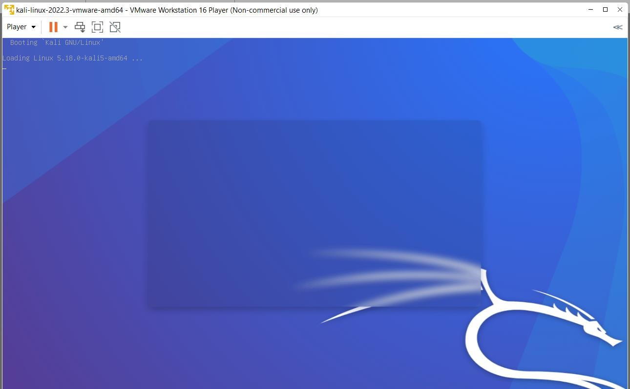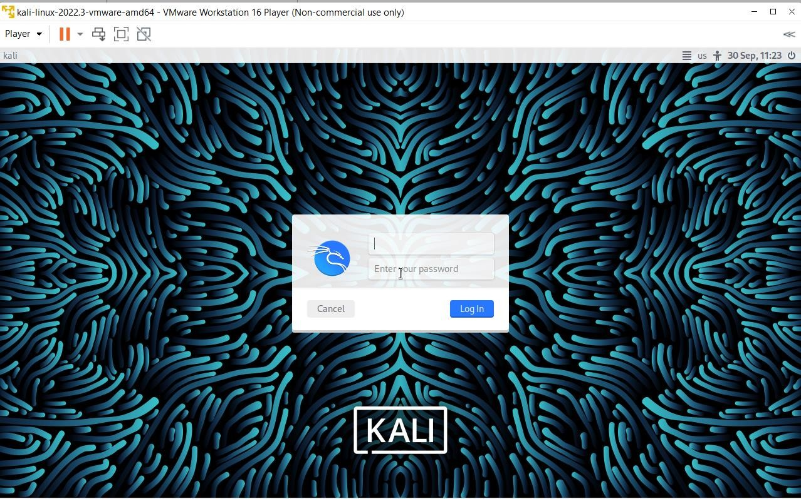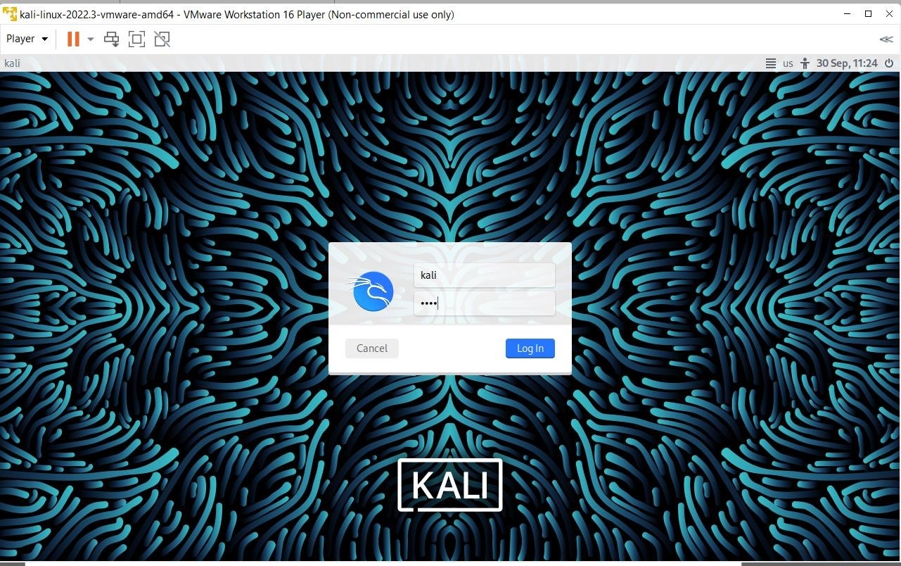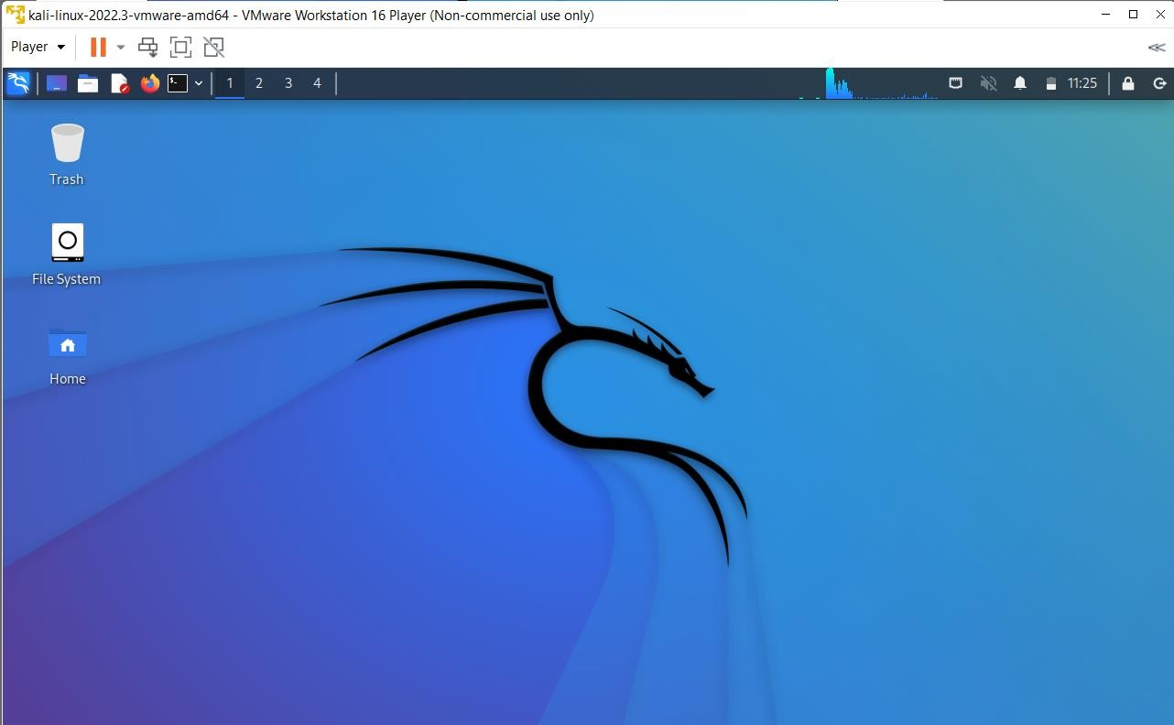

Metasploit: After successfully installation of Kali Linux. We need to now install Kali license by following the same process.

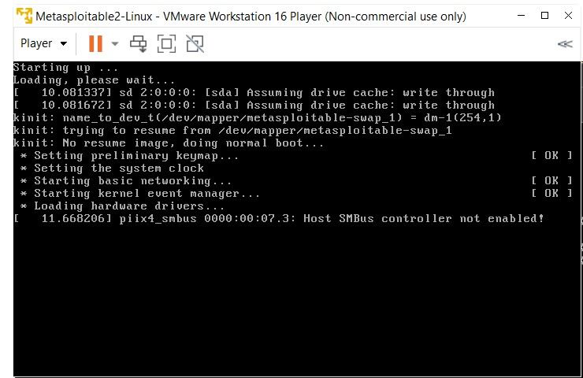

Enter the login id as msfadmin and password msfadmin.

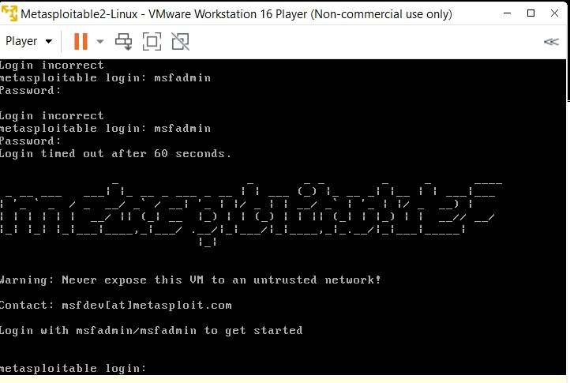

**Practical No.: 02**

**Aim: Use of open-source intelligence and passive reconnaissance**

1. **Installing Sublister:**

**What is Sublister?**

Sublister is a tool designed in python and uses OSINT in order to enumerate subdomains of websites. It helps pen-testers in collecting and gathering subdomains for a domain which is their target. In order to fetch accurate results, Sublister uses many searches engines like Google, Yahoo, etc., and even tools like Netcraft, Virustotal, etc.

**Steps to install Sublister:**

* + 1. Clone the GitHub repository via “git clone https://github.com/aboul3la/Sublist3r.git”.

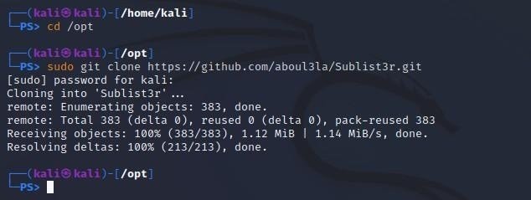

* + 1. Once the process is done move to the Sublist3r directory. Once that is done we have to check for the various dependencies like dnspython and argparse python modules. These dependencies are available in the requirements.txt file which can be installed using : “pip install -r requirements.txt”.

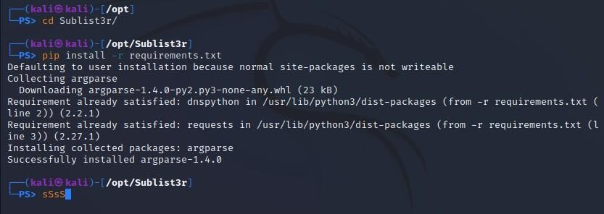

* + 1. You can also manually install those dependencies: Request module:

“sudo pip install requests”.

Dnspython module: “sudo pip install dnspyhton”. Argparse module: “sudo pip install argparse”.

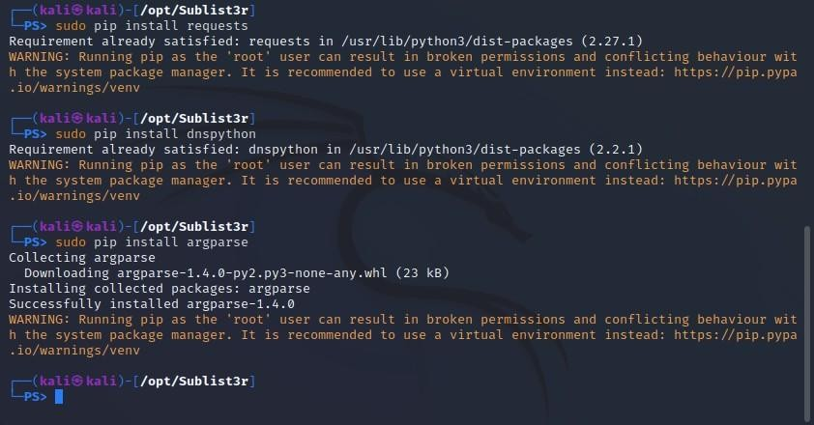

* + 1. To run the tool, use the following command in the terminal “./sublist3r.py”.

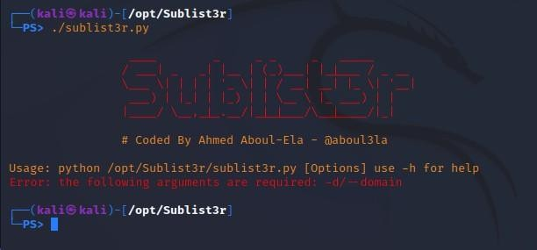

* + 1. Now that the tool is working in the current directory and every time that it needs to be run, we have to access it via the same directory. So now we will make a symbolic link so that we can access it from any directory we are in. Use the command: “sudo ln -sfv /opt/Sublist3r/sublist3r.py /usr/bin/sublist3r”.

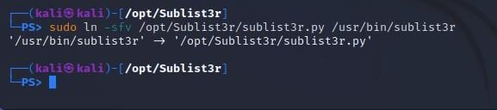

* + 1. The usage of Sublister:

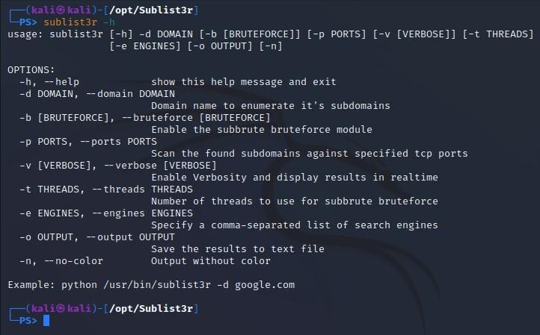

For example:

To list the subdomains of a domain, we can enter the following command on Linux.

“sublist3r -v -d ‘Website-url’ -t 5 -e bing -o -/Desktop/sublist3r.txt”.

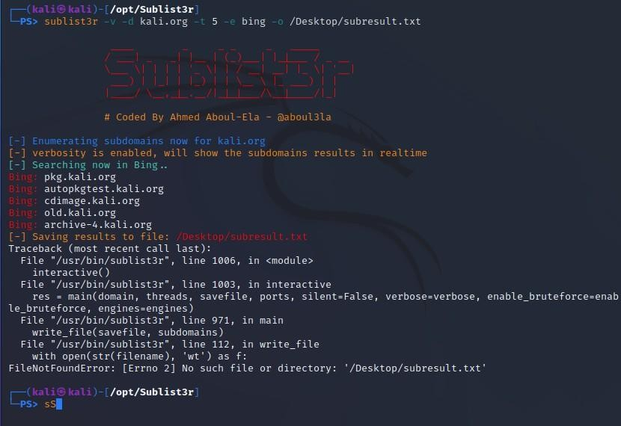

1. **Installing Maltego:**

**What is Maltego?**

* + Maltego is a comprehensive tool for graphical link analyses that offers realtime data mining and information gathering, as well as the representation of this information on a node-based graph, making patterns and multiple order connections between said information easily identifiable.
  + With Maltego, you can easily mine data from dispersed sources, automatically merge matching information in one graph, and visually map it to explore your data landscape.
  + Maltego offers the ability to easily connect data and functionalities from diverse sources using Transforms. Via the Transform Hub, you can connect data from over eighty data partners, a variety of public sources (OSINT) as well as your own data.
  + The different editions of the Maltego Desktop Client, data integrations, deployment and infrastructure options, support services and learning and training formats enable you to tailor Maltego to your specific needs in terms of capabilities, data access, and other requirements.

**Steps to install Maltego:**

* 1. In order to access Maltego, you will need to create an account by visiting [https://www.maltego.com/ce-registration/.](https://www.maltego.com/ce-registration/) Once you have successfully registered, open Maltego on you Linux system, if it has not been installed, run the following command “sudo apt install maltego”.

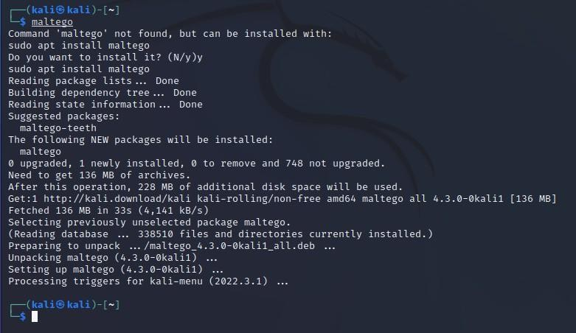

* 1. Once that is done, run Maltego via the application launcher on Linux. On your initial run of Maltego, you will be required to agree to some agreements. One of them involves signing into your verified maltego account.

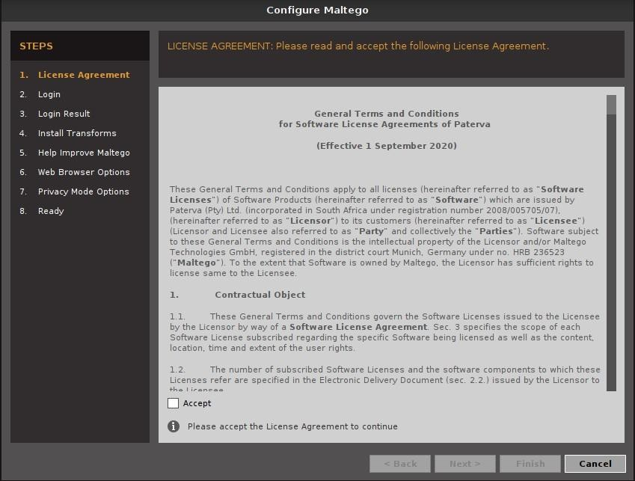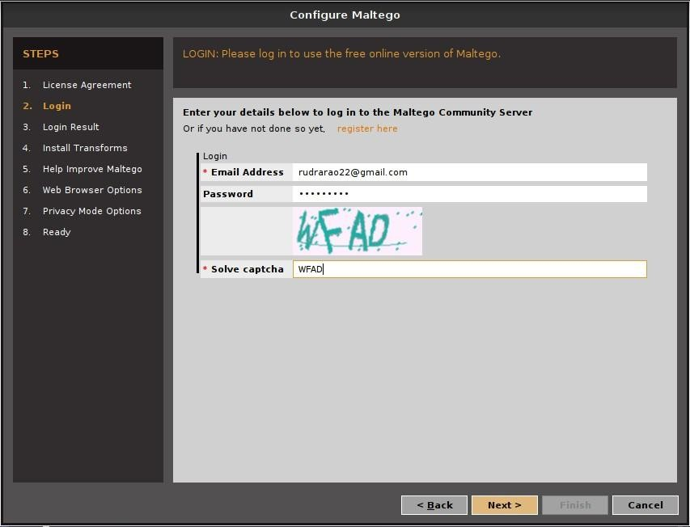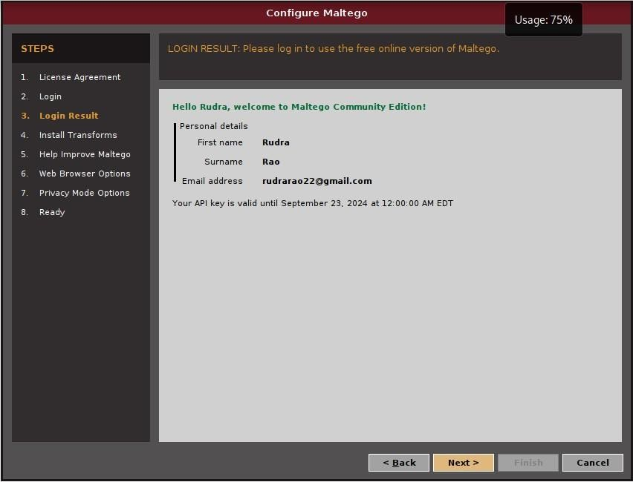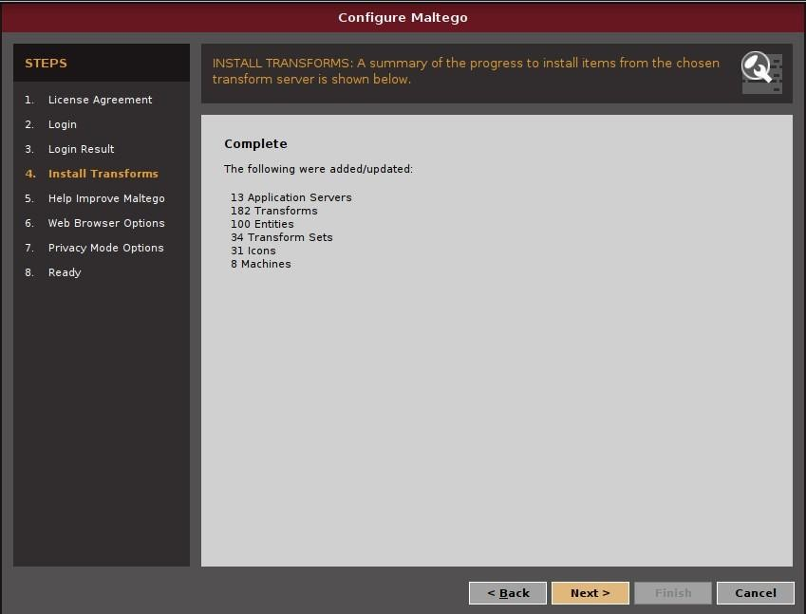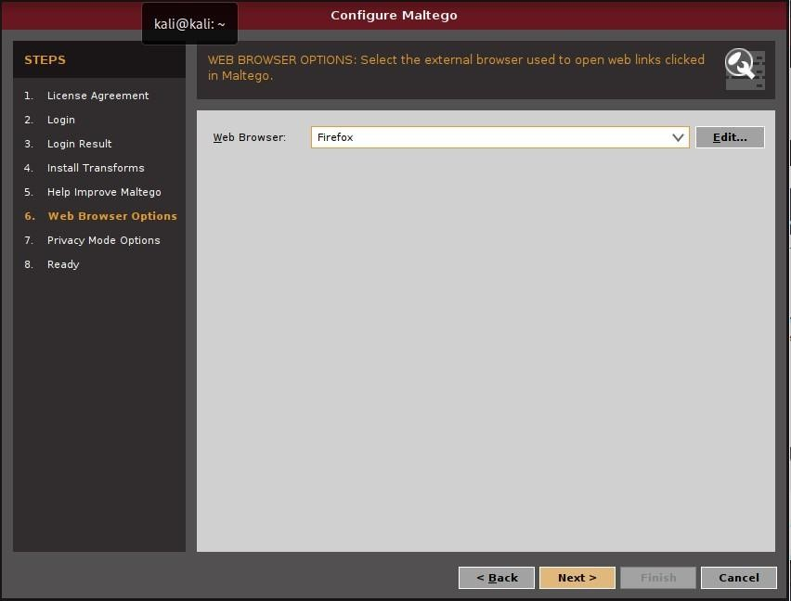

* 1. Once you have successfully signed in, you will have to create a new “Machine”. You will have to select the “Footprint L1” machine followed by the name of the website that you want to data mine.

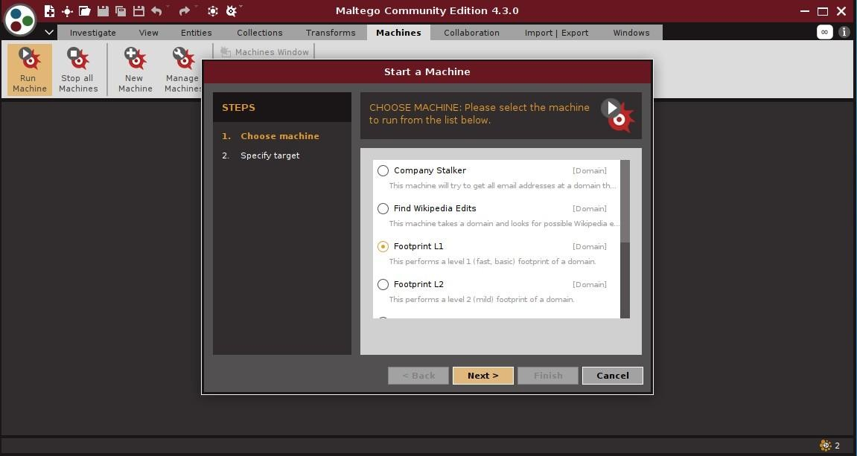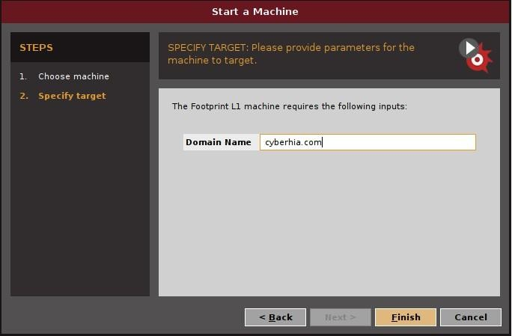

* 1. This is what the final output will look like after the website has been data mined by Maltego. It will provide a comprehensive tree structure that will explain the structure as well as the data that is used by the website.

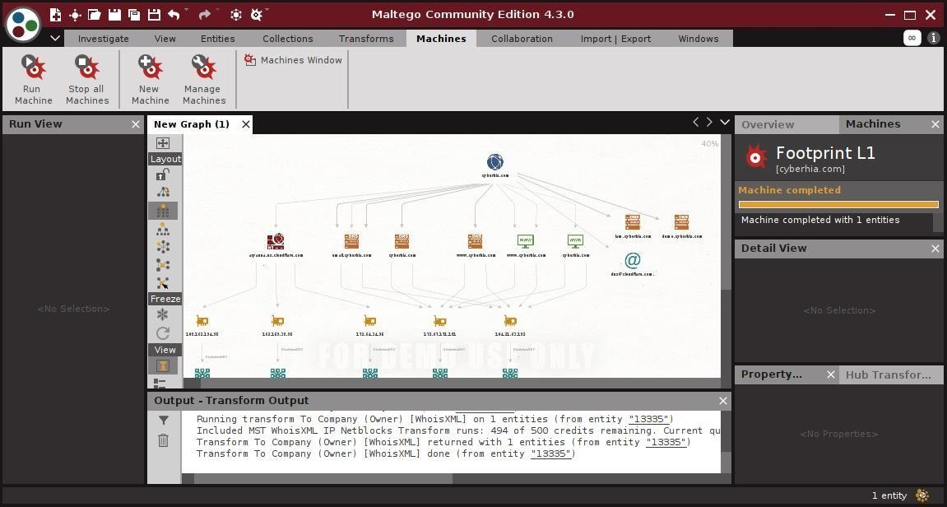

1. **Installing OSRFramework:**

**What is OSRFramework?**

* OSINT is the most common method or technique for collecting information about the target domain or employee of the organization from open-source or publicly available data.
* Mostly malicious hackers use this technique in the attacks of Social Engineering, Phishing, etc.
* But on the good side, we can use this OSINT technique or understanding the scope and getting familiar with our target domain.
* OSRFramework or the Open-Source Research Framework is an automated tool designed in the Python language, which is open-source and free to use.
* OSRFramework is the collection of various sub tools that can help the tester get information about the target domain or victim person.

**Steps to install and use OSRFramework:**

* 1. The first step will be to install the python pip. We can use the following command: “sudo apt install python3-pip”.

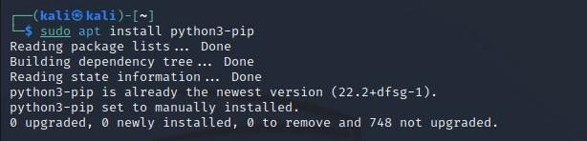

* 1. Next we will install the OSRFramework using pip. The command is: “sudo pip3 install osrframework”.

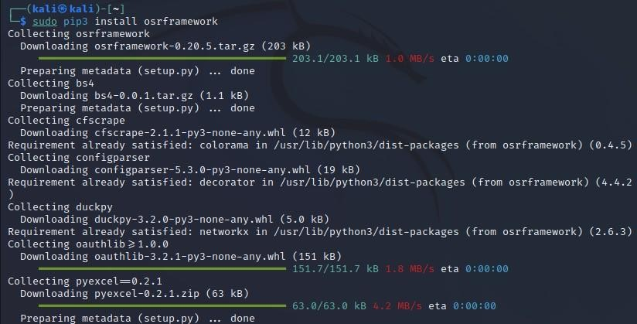

* 1. After the OSRFramework has been successfully installed, we check for registered accounts with a given nickname with the help of the usufy tool in the OSRFramework. We can use the following command: “sudo usufy -n cyberhia”.

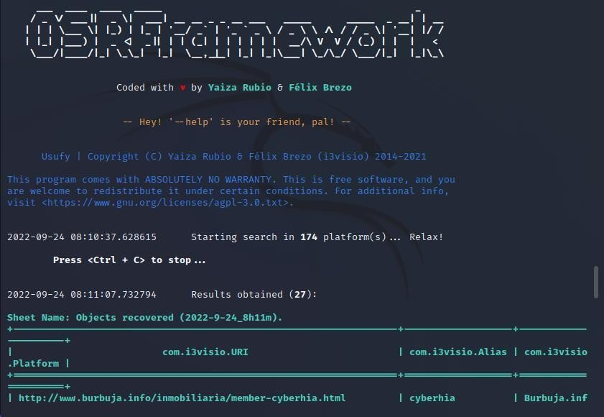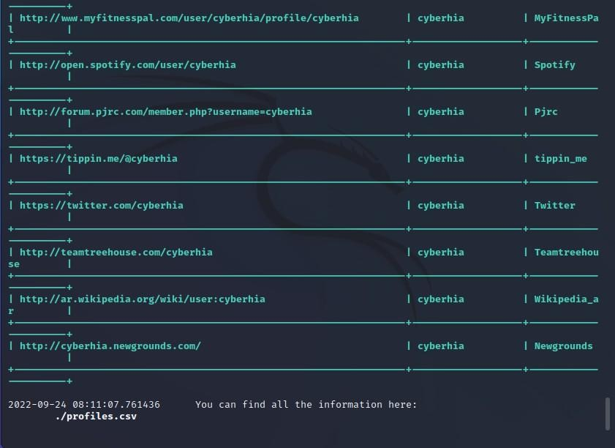

* 1. Next, we will use the mailfy tool to get information about email accounts that have the given nickname. We can use the command:

“sudo mailfy -n cyberhia”.

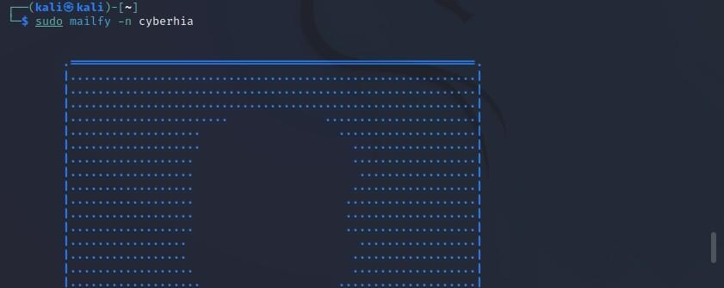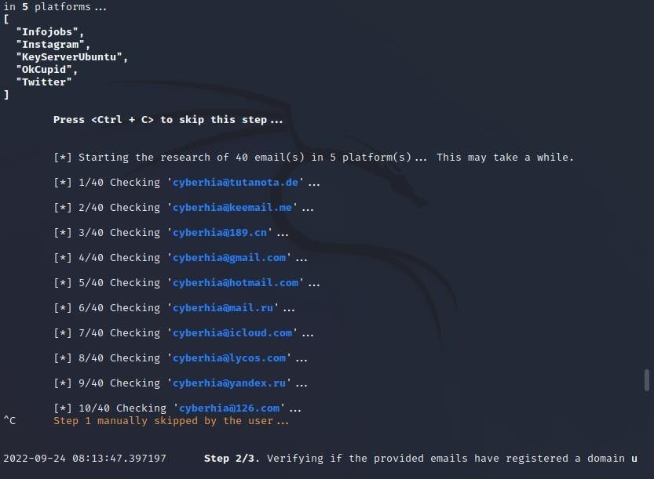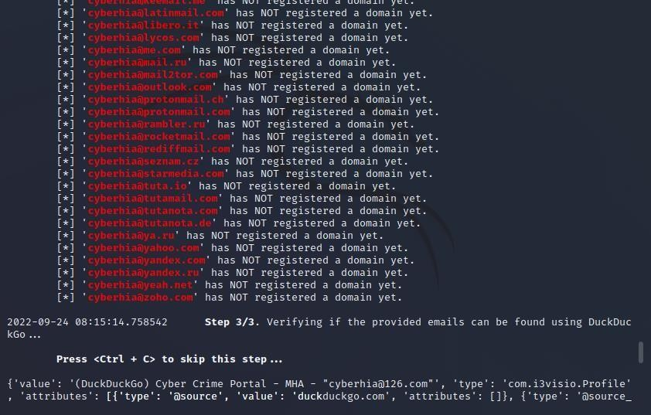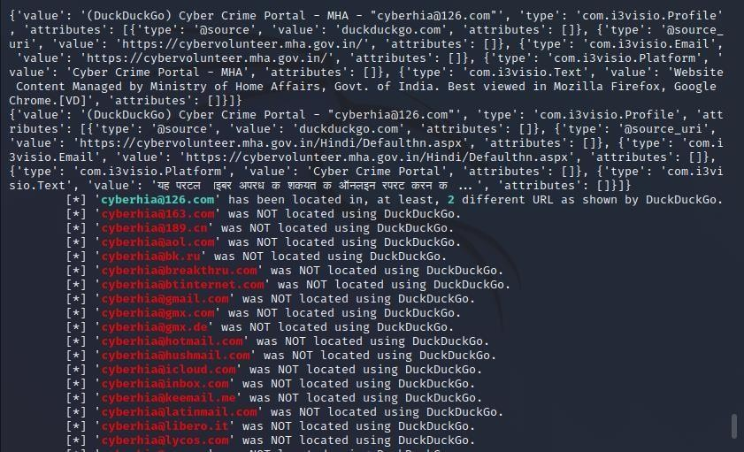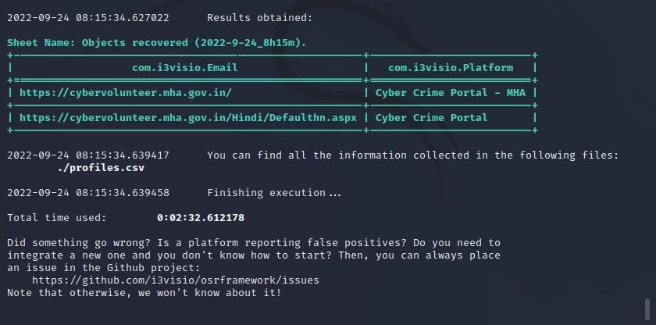

**4. Web Archives:**

* Web archiving is the process of collecting portions of the World Wide Web to ensure the information is preserved in an archive for future researchers, historians, and the public.
* Web archivists typically employ web crawlers for automated capture due to the massive size and amount of information on the Web.
* Web Archives are websites that can access the preserved archives of the World Wide Web.



**a.**



**Cached**



**View**



**s**



**.com**

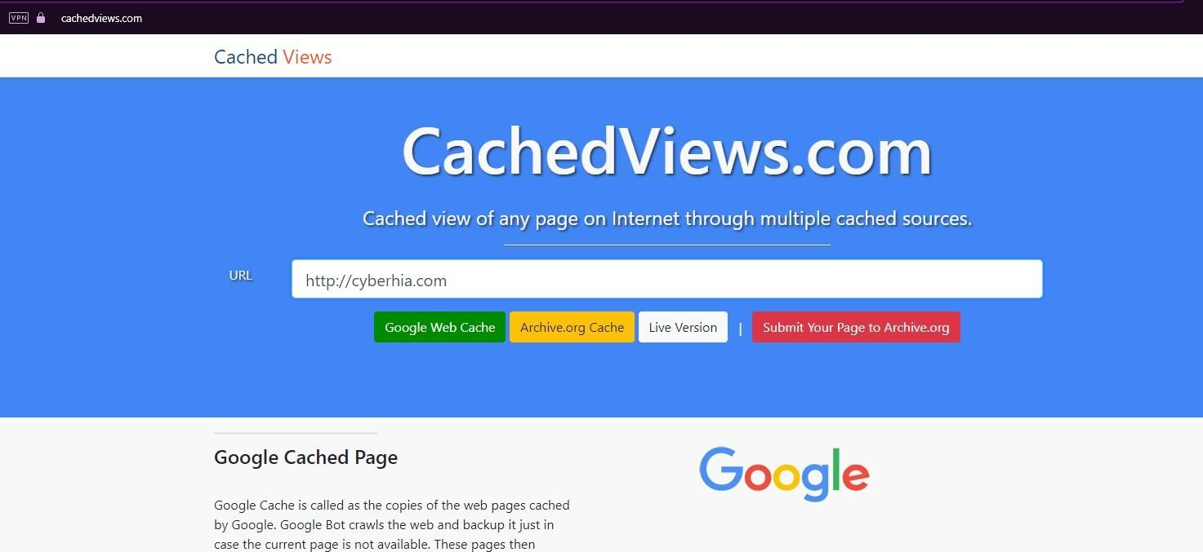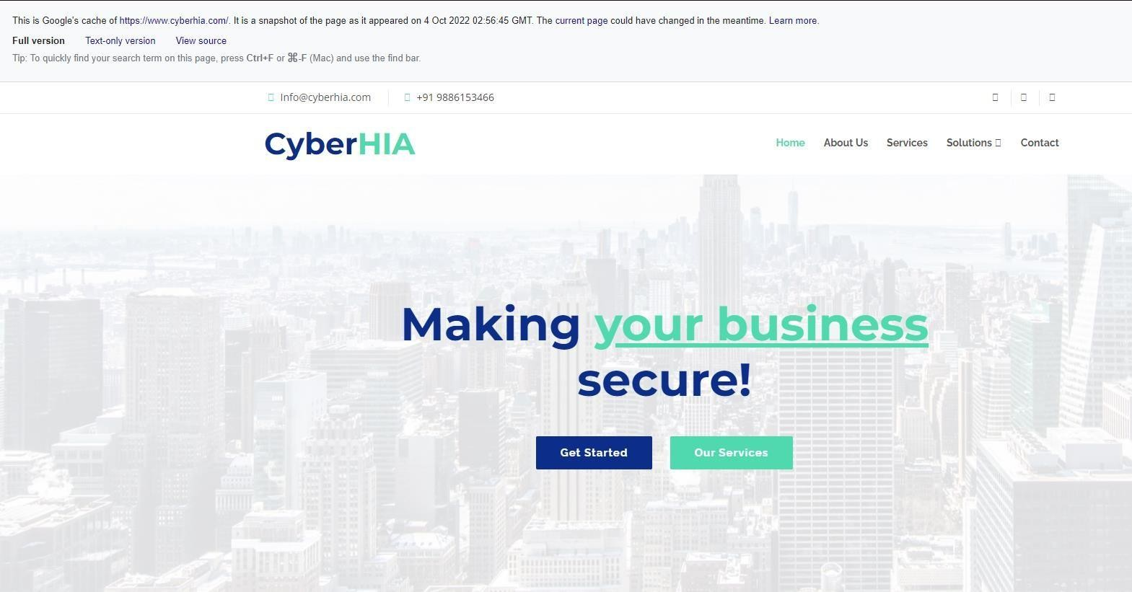

**b. WayBack Machine**



**5.**



**P**



**assi**



**ve Total:**

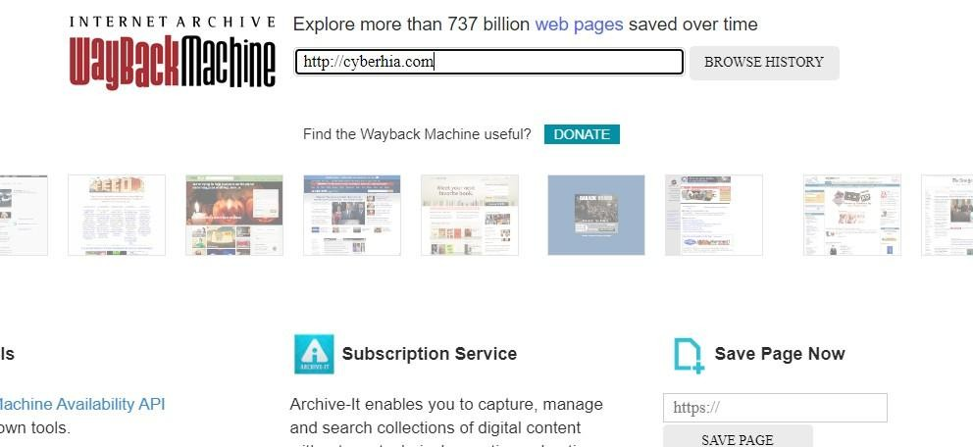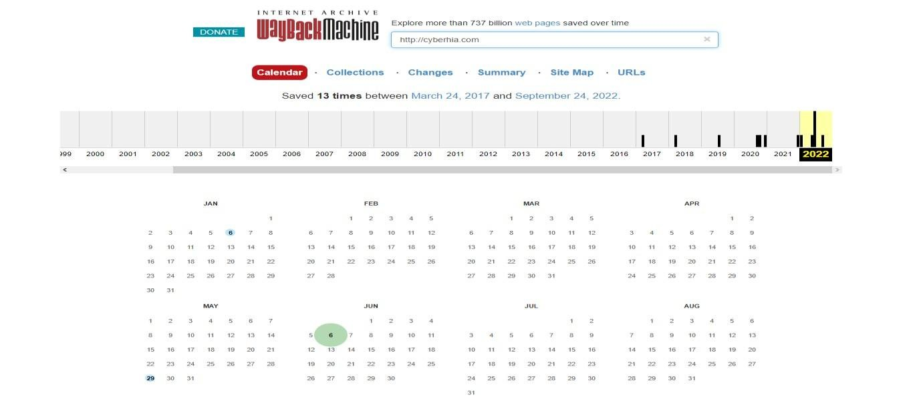

**a.**



**R**



**ISKIQ**

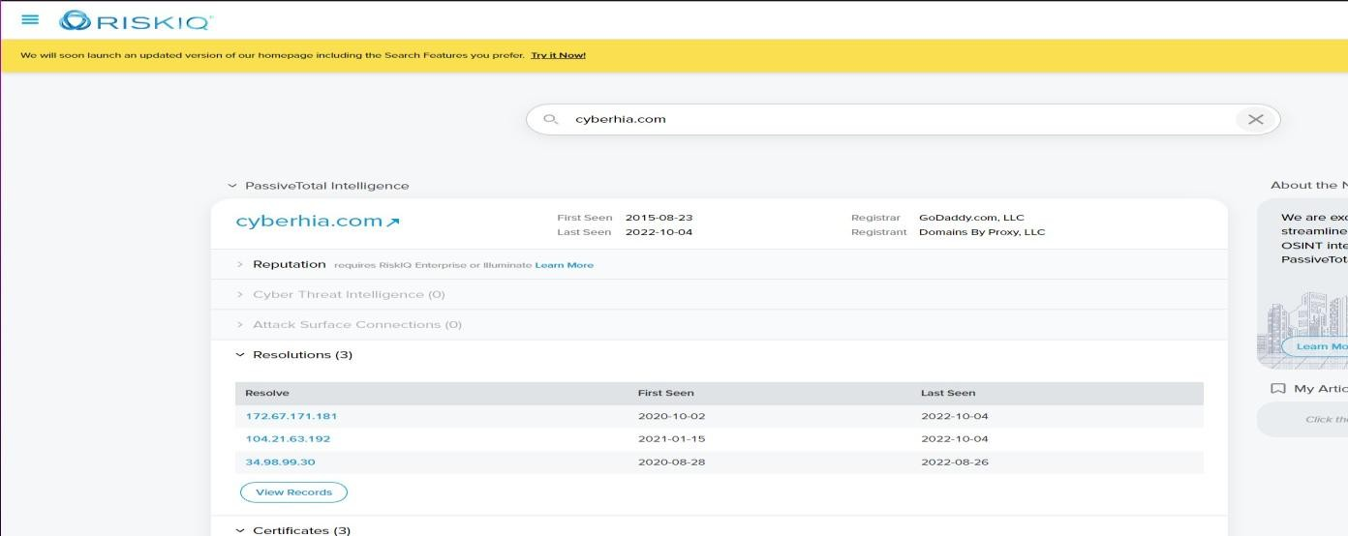

**6. Web Scraping:**

* Web scraping, web harvesting, or web data extraction is data scraping used for extracting data from websites.
* Web scraping software may directly access the World Wide Web using the Hypertext Transfer Protocol or a web browser.

**a. The Harvester:**

“theHarvester” is a python script that searches through search engines and other sites for email addresses, hosts, and sub-domains. Using theHarvester is simple, as there are only a few command switches to set.

The options are as follows:

* -d: This identifies the domain to be searched, usually the domain or targets website.
* -b: This identifies the source for extracting the data; it must be done on one of the following: Bing, BingAPI, Google, Google-Profiles, Jigsaw, LinkedIn, People123, PGP, or All.
* -l: This limiting option instructs theHarvester to only harvest data from a specified number of returned search results.
* -f: This option is used to save the final results onto an html and xml file.

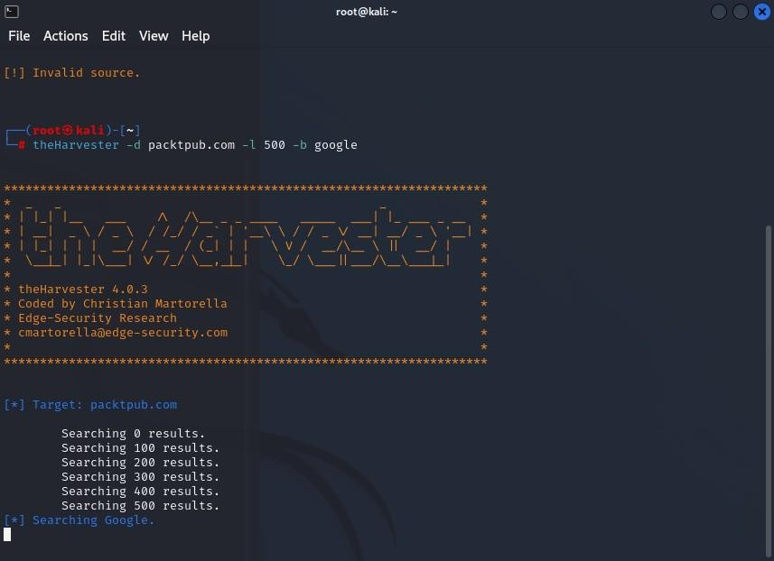

1. **Obtaining User Information:**



**a.**



**TinEye:**

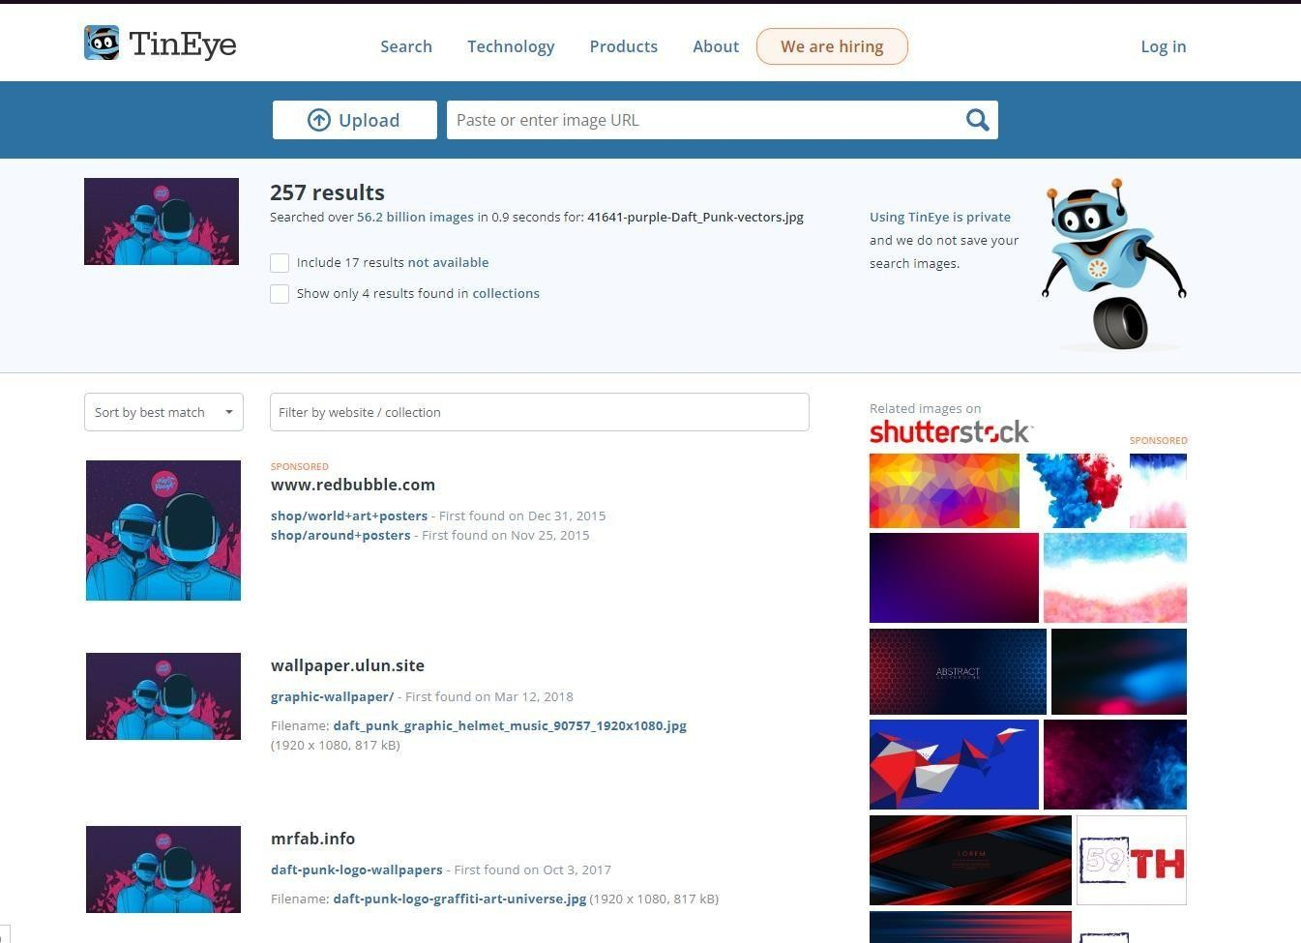

1. **Online Search Portals:**

**a. Shodan.io:**

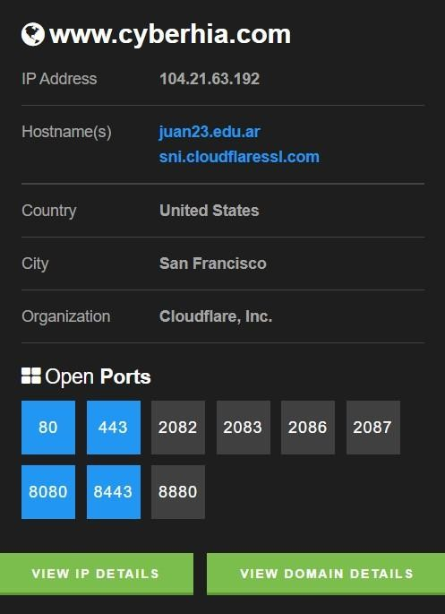

**a.**



**Cen**



**s**



**ys**



**.com**



**:**

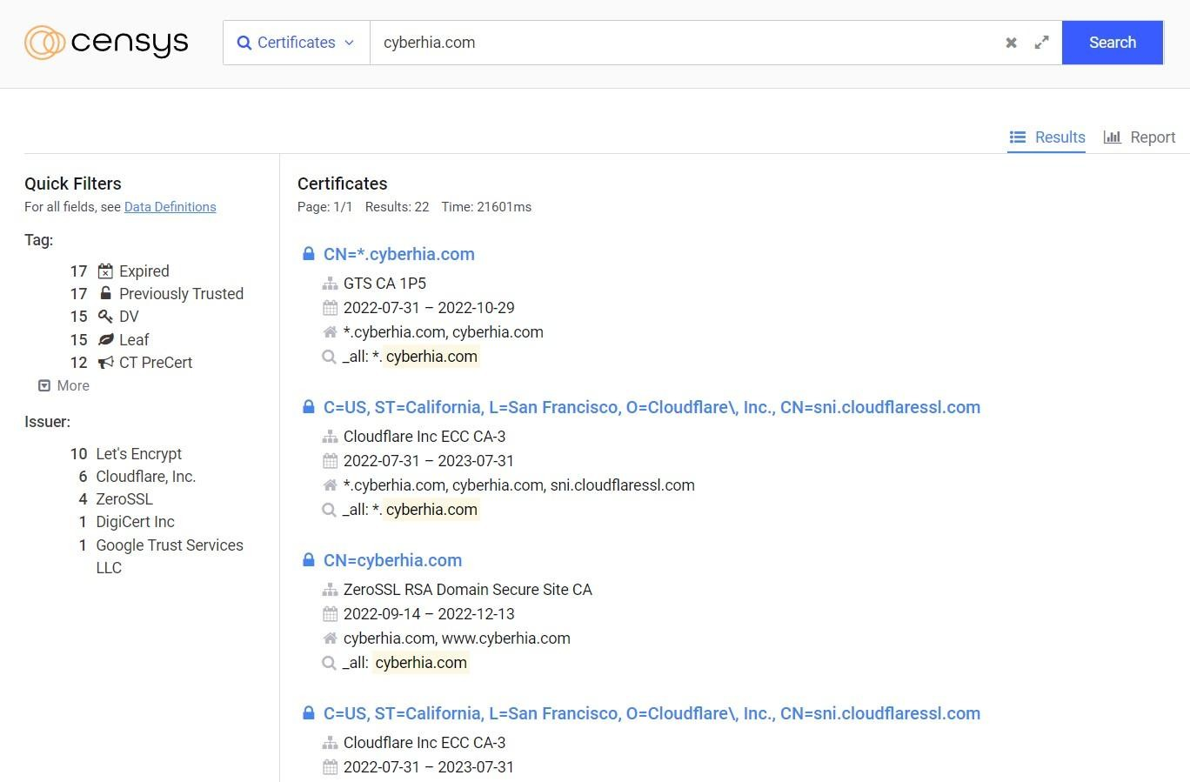

**9. Google Hacking Database:**

* The Google Hacking Database (GHDB) is a compendium of Google hacking search terms that have been found to reveal sensitive data exposed by vulnerable servers and web applications.
* The GHDB was launched in 2000 by Johnny Long to serve penetration testers.
* In 2010, Long turned the database over to Offensive Security and it became part of exploit-db.com.
* It was also expanded to include not only the Google search engine but also other search engines like Microsoft’s Bing as well as other repositories such as GitHub.

1. **To search for any plaintext passwords or poorly configured WordPress sites:** “inurl:/wp-content/uploads/ ext:txt “username” AND “password” | “pwd” | “pw”.

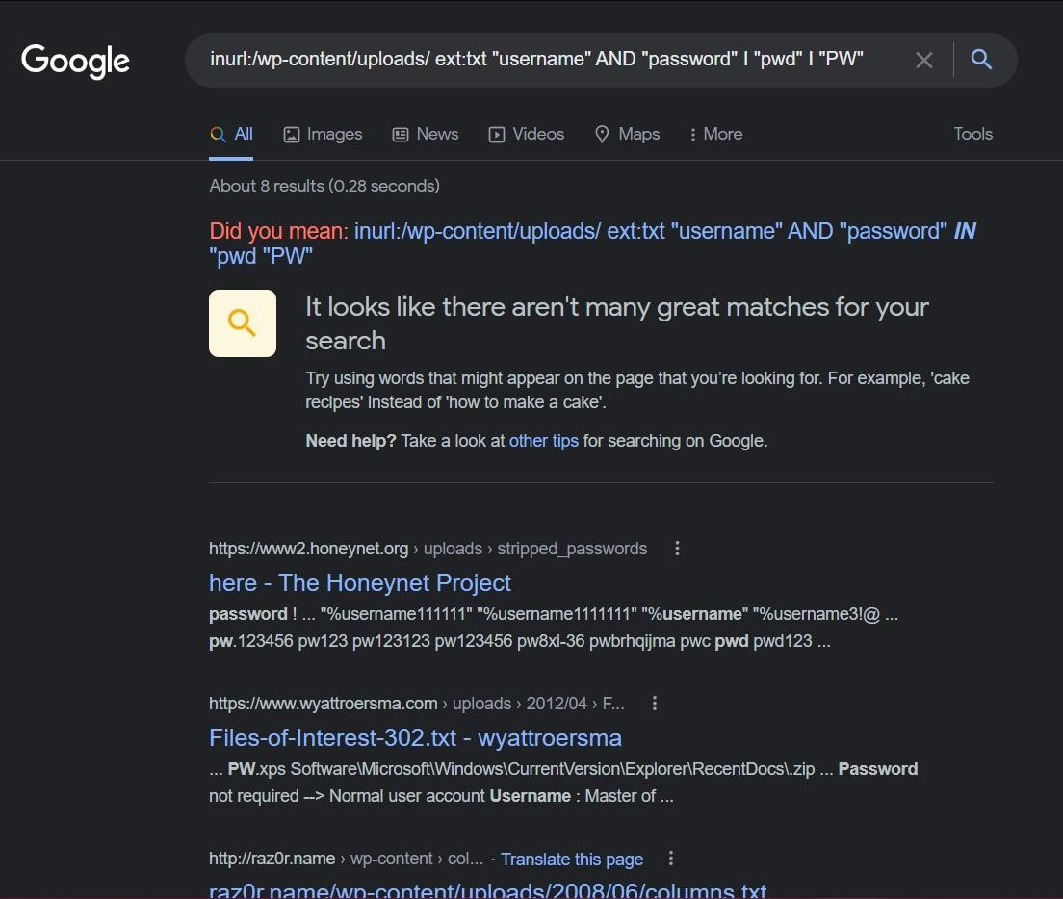

1. **To search for any vulnerable web servers:**

“inurl:/proc/self/cwd”



**c.**



**To searc**



**h for any**



**Open FTP Servers:**

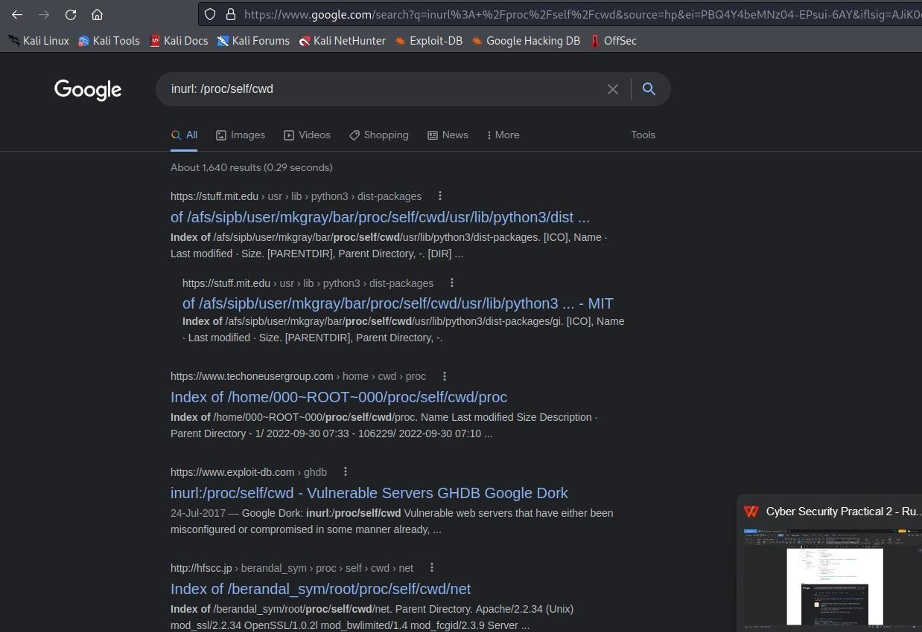

‘



intitle



:



”



index of



”



inur



l:ftp



‘

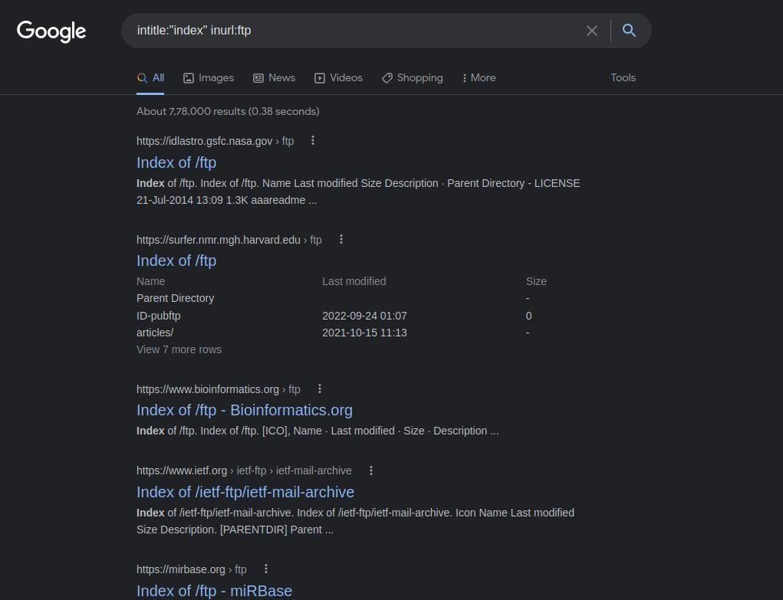

**d. To search for any Email Lists:**



“



filet



ype:xls in



url:



”



email.xls



”



”

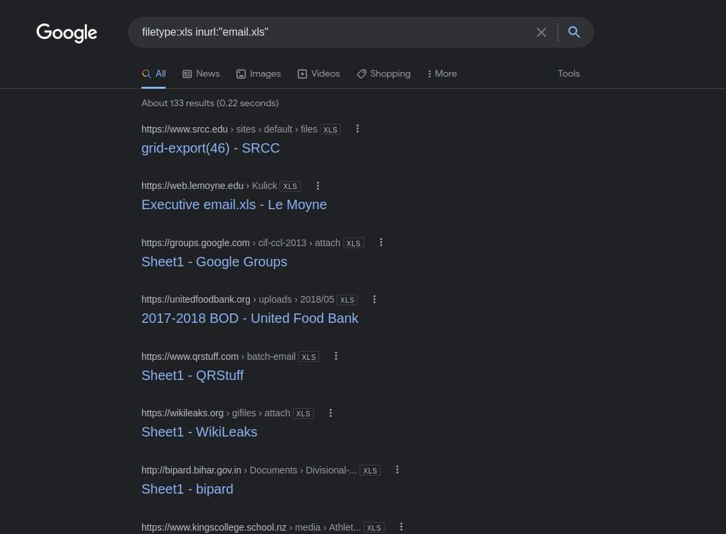

**e.**

**To search for any Live Cameras:**



For various IP based Cameras:



“



inurl:top.htm i



n



url:



currenttime



”

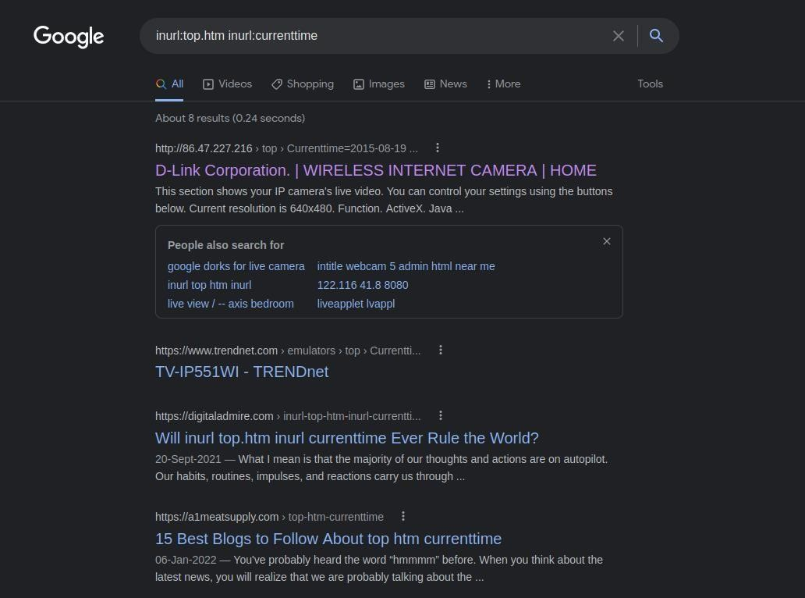

For various Webcam

-

XP based

transmissions: “ intitle:”webcamXP 5” ”

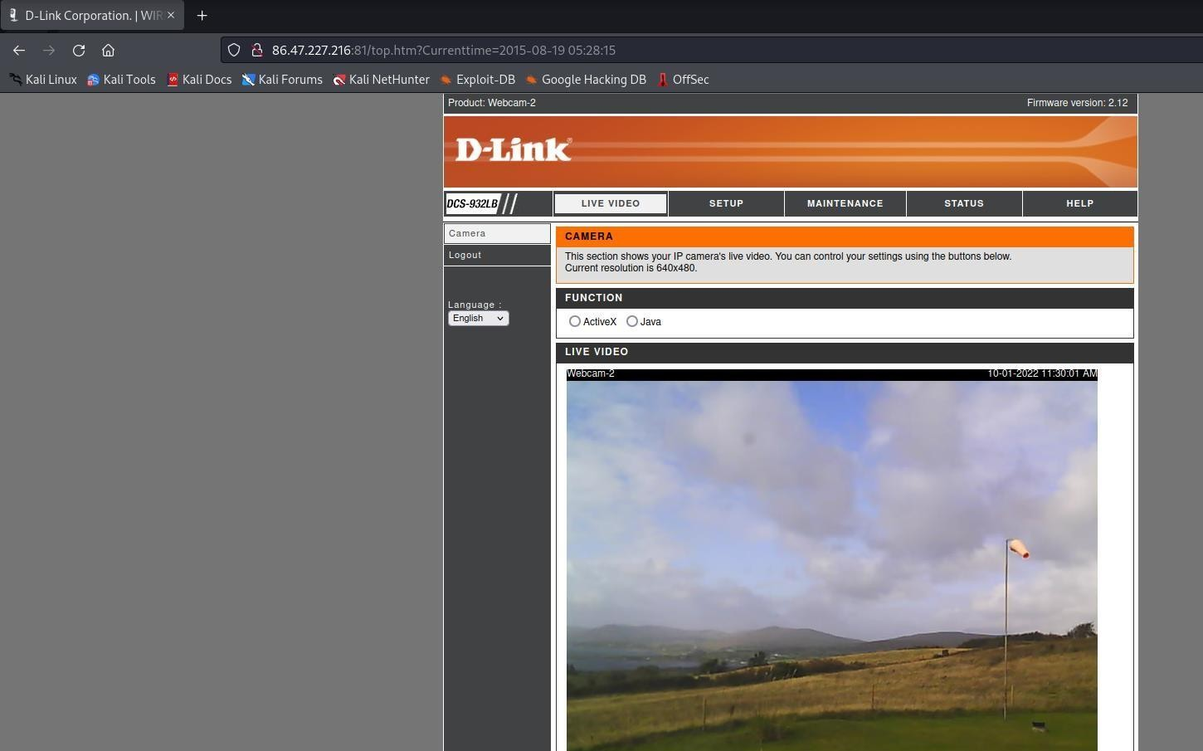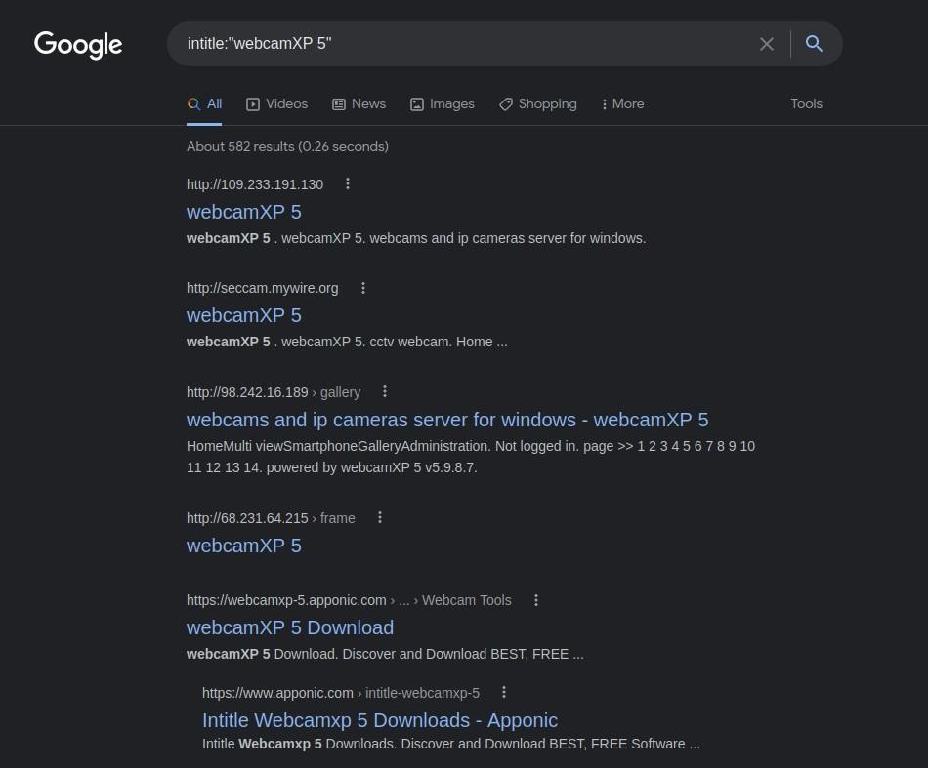

“ inurl:”lvappl.htm” ”



For var



ious



general



l



ive cameras:

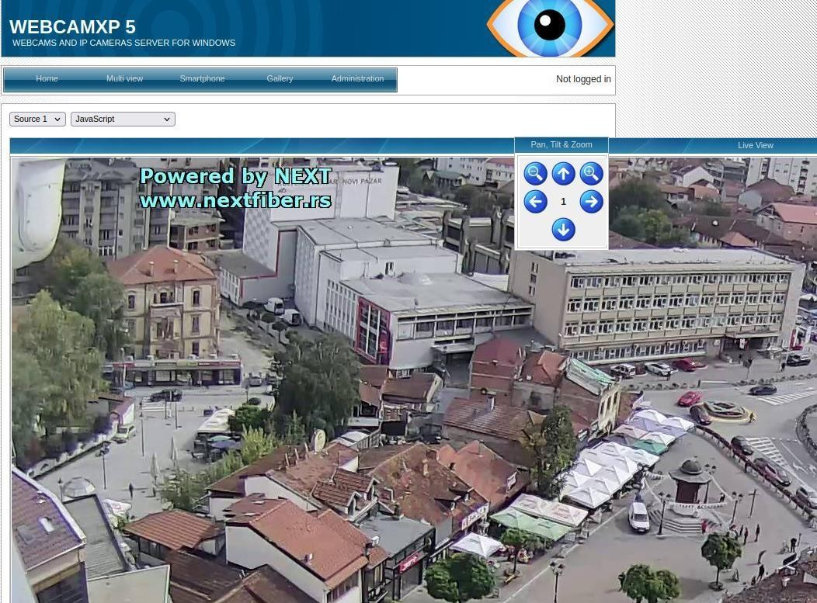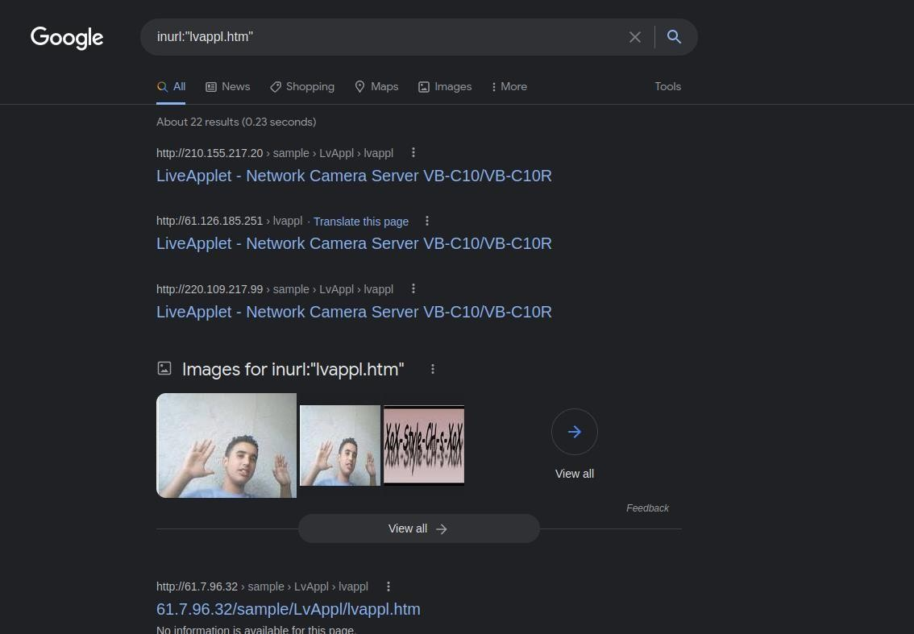

**f.**

**To search for any MP3, Movie, and PDF Files:**

For various MP3 files:

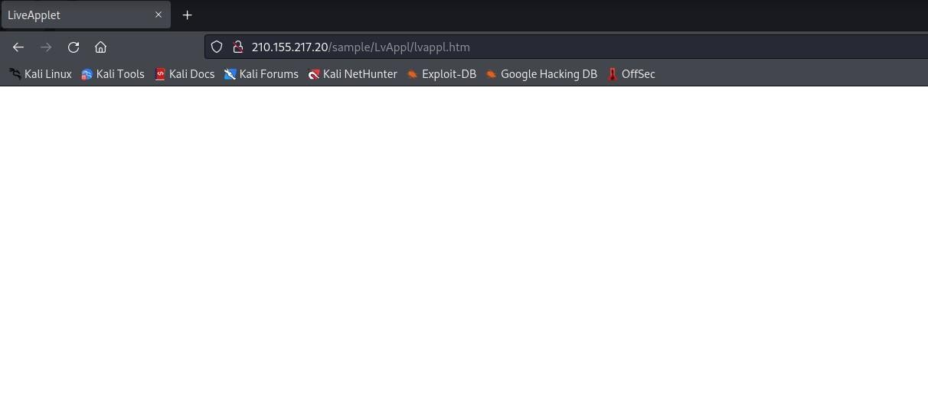

“



intitle: index of mp3



”

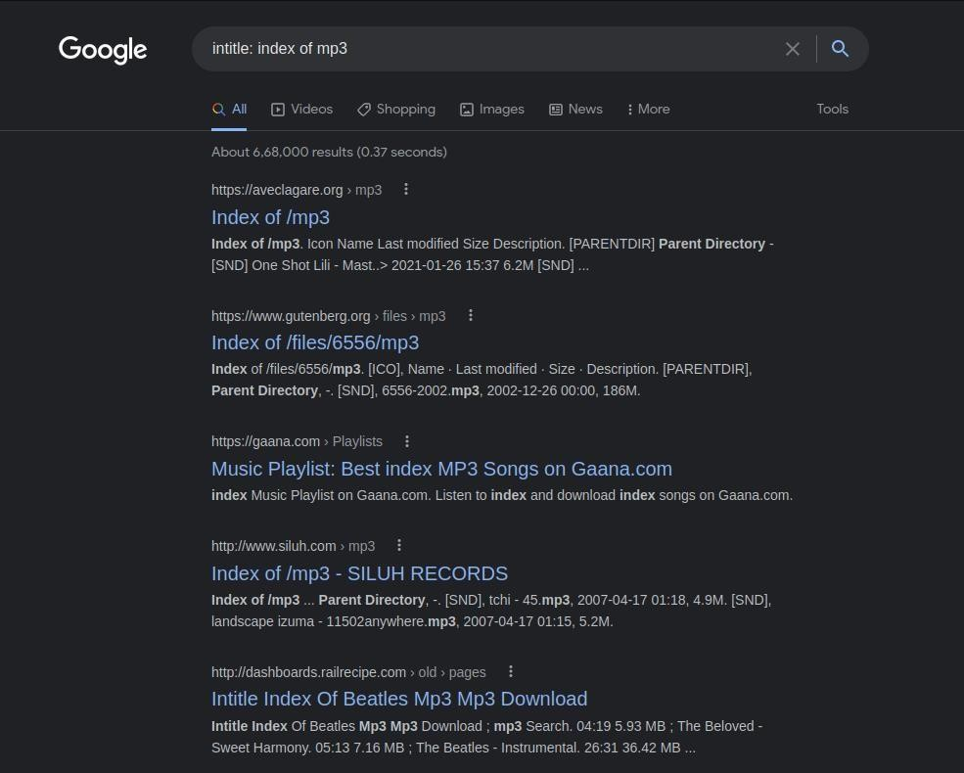

“ intitle: index of mp4 ”



For



various



MP4 files:

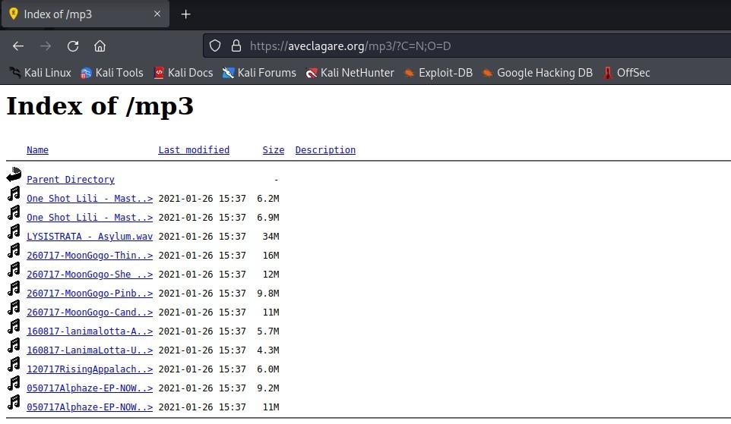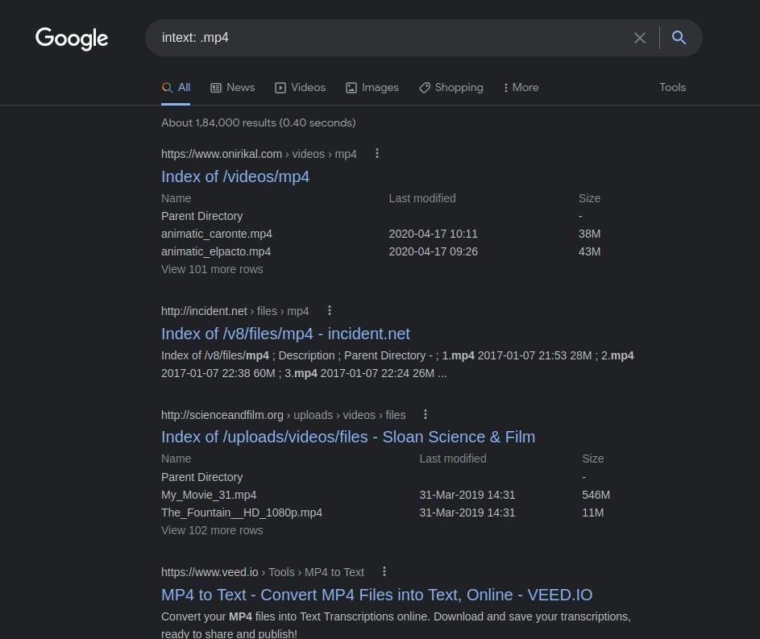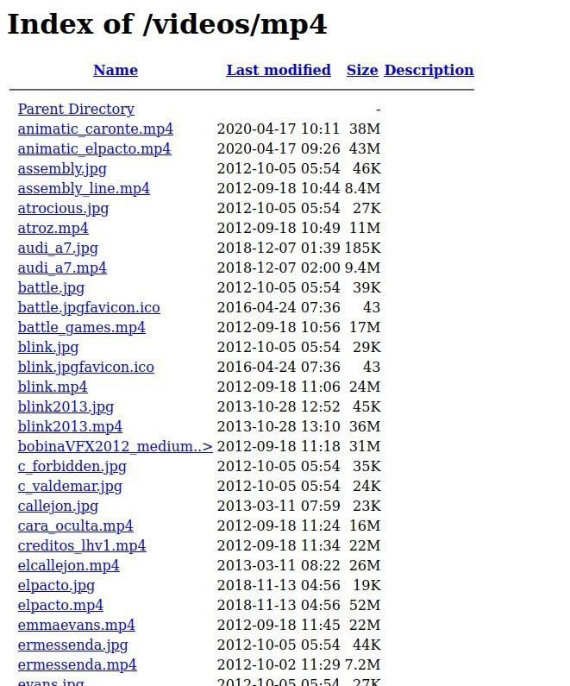

For various PDF files:



“



intitle: index of



pdf



”

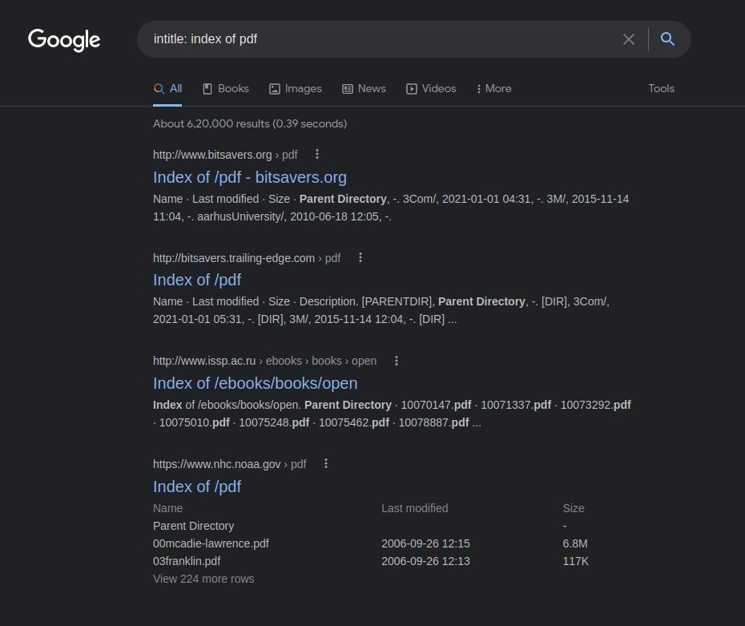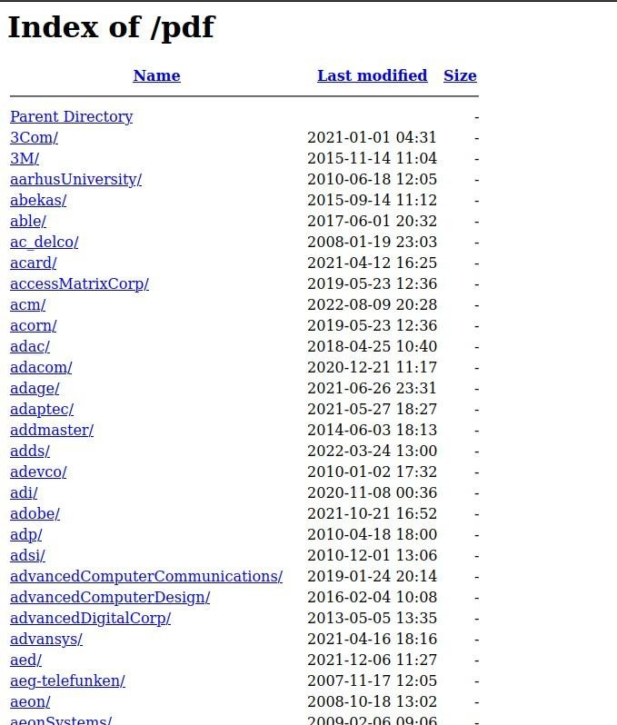

**g. To search for any Government Documents:**

“ Alli title: restricted filetype:doc site:gov ”

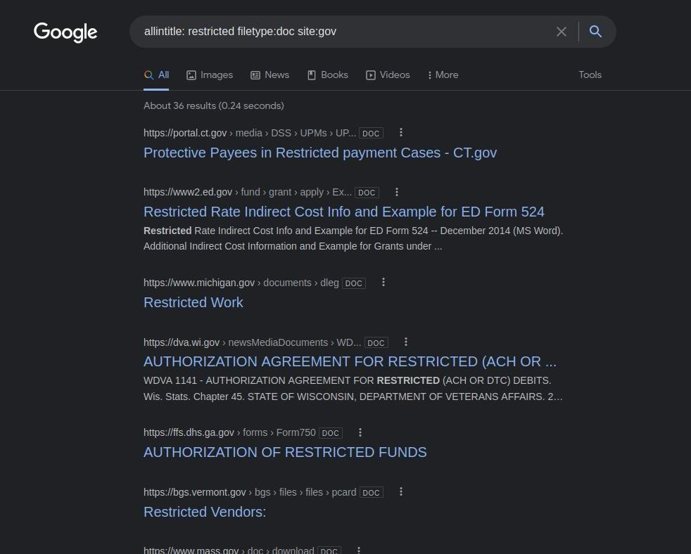

1. **Security Breaches:** 
   * A security breach is any incident that results in unauthorized access to computer data, applications, networks, or devices.
   * It results in information being accessed without authorization. Typically, it occurs when an intruder is able to bypass security mechanisms.
   * Technically, there is a distinction between a security breach and a data breach. A security breach is effectively a break-in, whereas a data breach is defined as the cybercriminal getting away with information. Imagine a burglar; the security breach is when he climbs through the window, and the data breach is when he grabs your pocketbook or laptop and takes it away.
   * There are various websites that can check if your account or phone number has been a victim of a security breach.

**a.**

[**https://haveibeenpwned.co**](https://haveibeenpwned.com/)

[**m**](https://haveibeenpwned.com/)

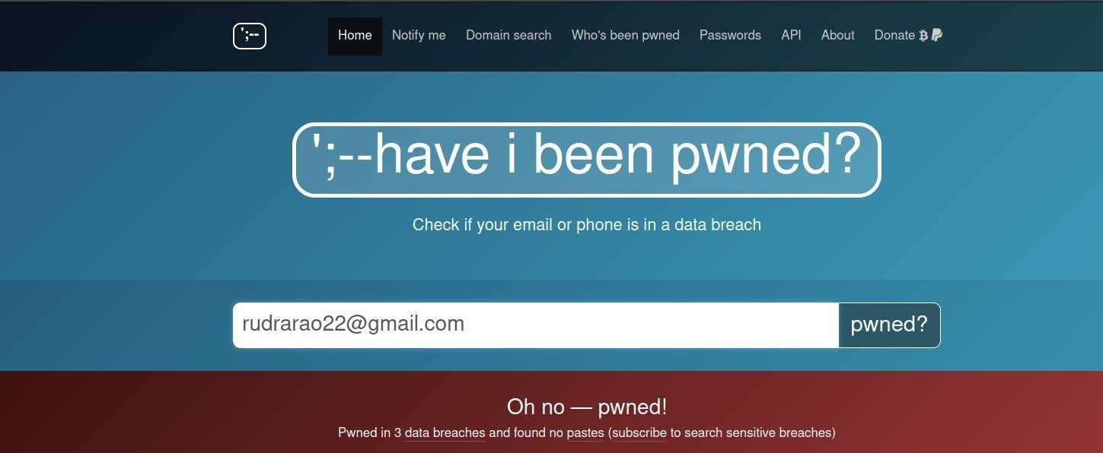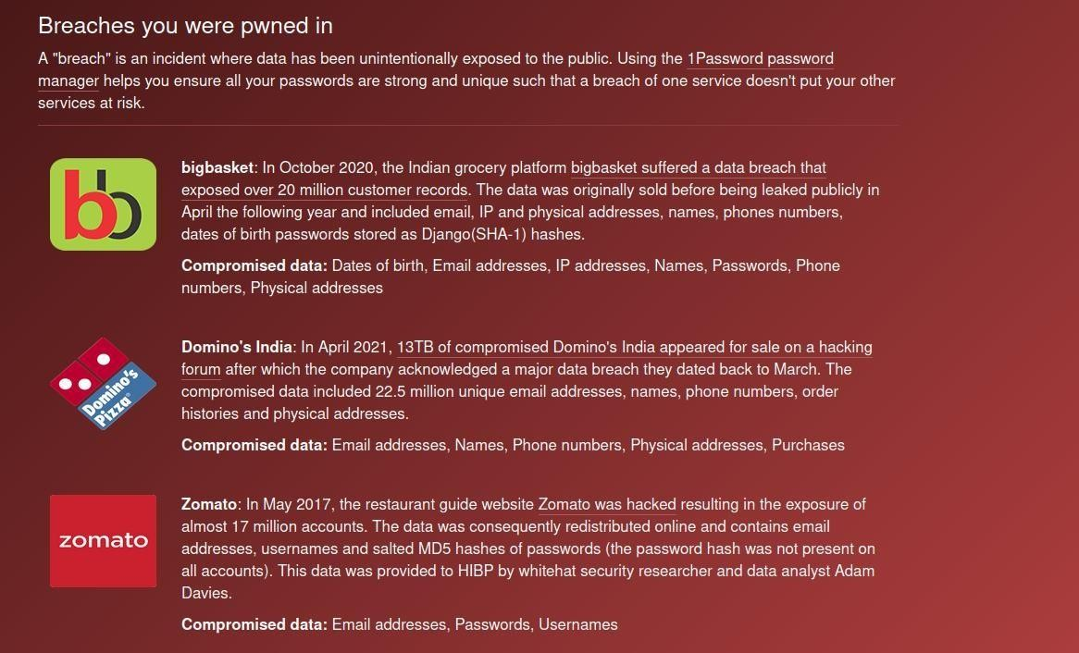

**b.**



[**https://haveibeenzuckered.co**](https://haveibeenzuckered.com/)

[**m**](https://haveibeenzuckered.com/)



[**/**](https://haveibeenzuckered.com/)

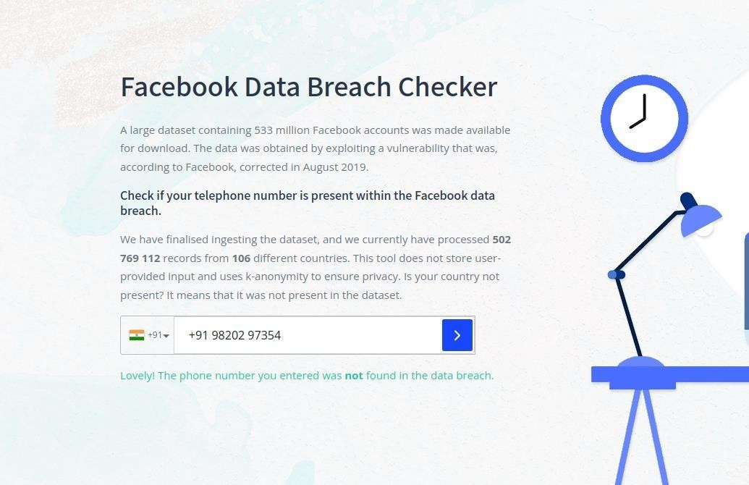

1. **Profiling for password lists:** 
   * Lists of commonly used passwords.
   * The Common User Password Profiler (CUPP) allows the penetration tester to generate a wordlist that is specific to a particular user.
   * It is not installed by default on Kali Linux. It need to be installed: “ sudo apt install cupp”

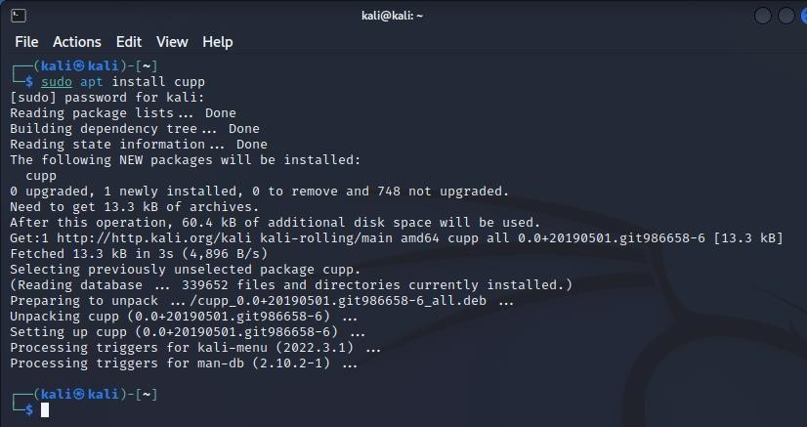

* + It can be invoked using: “ cupp -i ”.
  + This will launch CUPP in the interactive mode, which will prompt the tester for the specific elements of the wordlist.

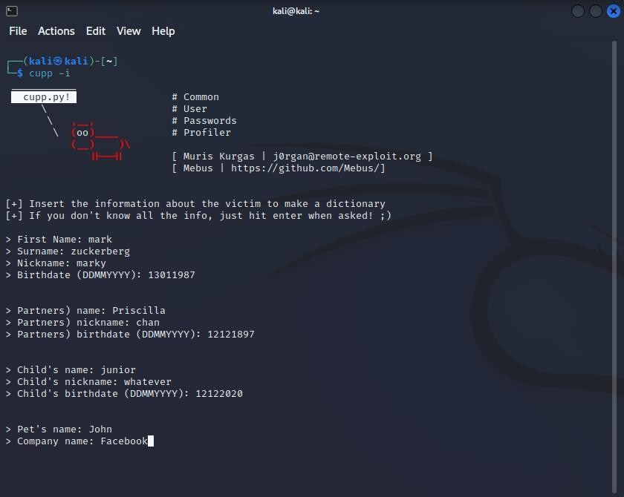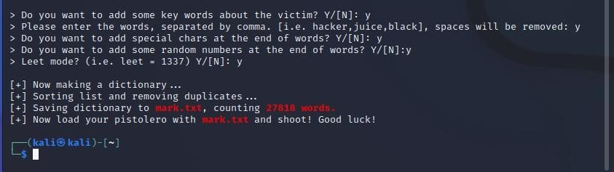

* + You can view the wordlist depending on where you have stored it.

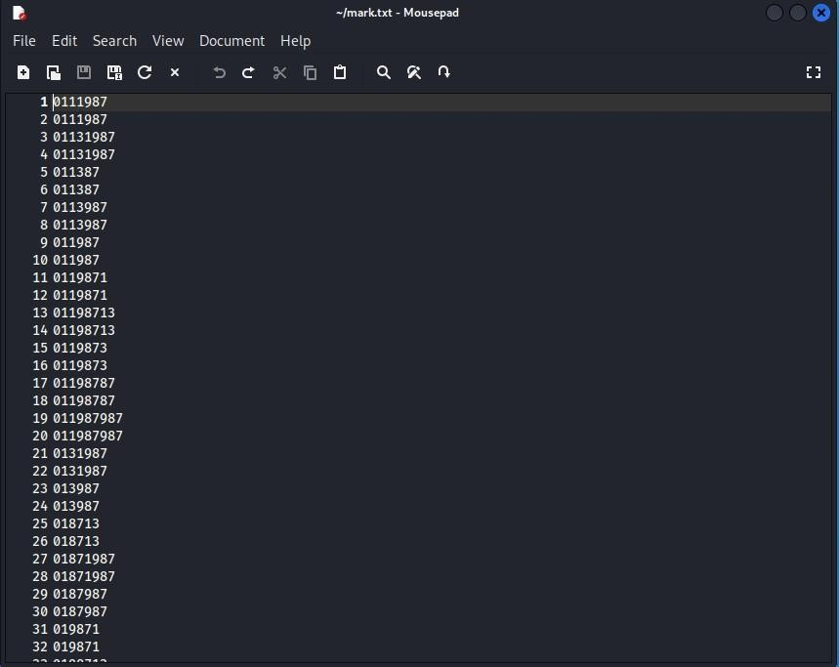

1. **Creating Custom wordlists for cracking passwords:** 
   * We can use CeWL to create the custom wordlist.
   * CeWL (Custom Word List generator) is a ruby app which spiders a given URL, up to a specified depth, and returns a list of words which can then be used for password crackers such as John the Ripper.
   * Optionally, CeWL can follow external links.
   * CeWL can also create a list of email addresses found in mail to links. These email addresses can be used as usernames in brute force actions.

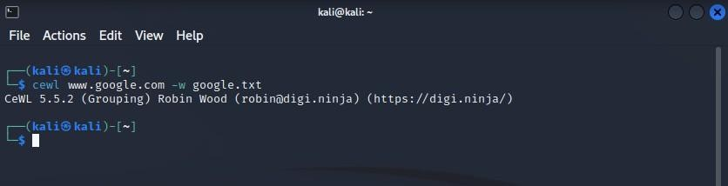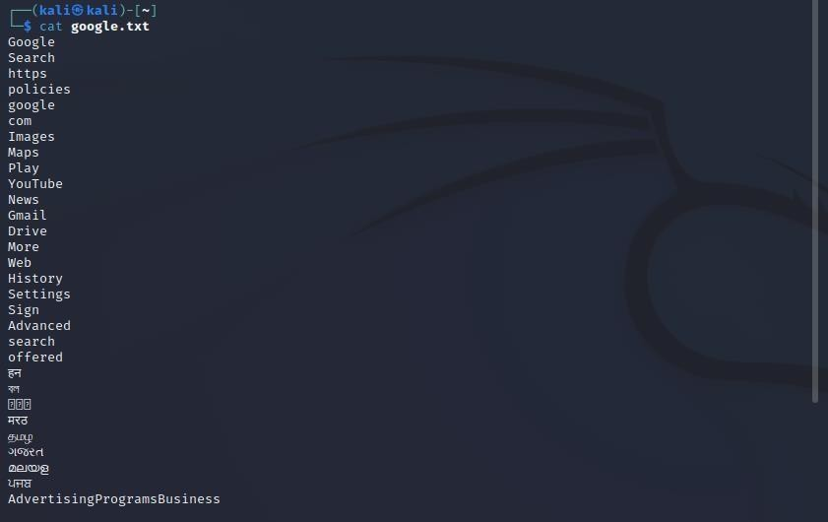

1. **Nmap:** 
   * Nmap is a network scanner created by Gordon Lyon.
   * Nmap is used to discover hosts and services on a computer network by sending packets and analyzing the responses.
   * Nmap provides a number of features for probing computer networks, including host discovery and service and operating system detection.
   * First we use Metsploitable2 to find the ip address of the target machine.

•

Then we perform NMAP.

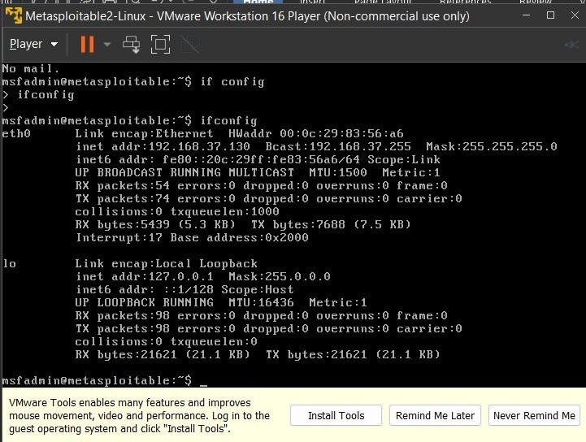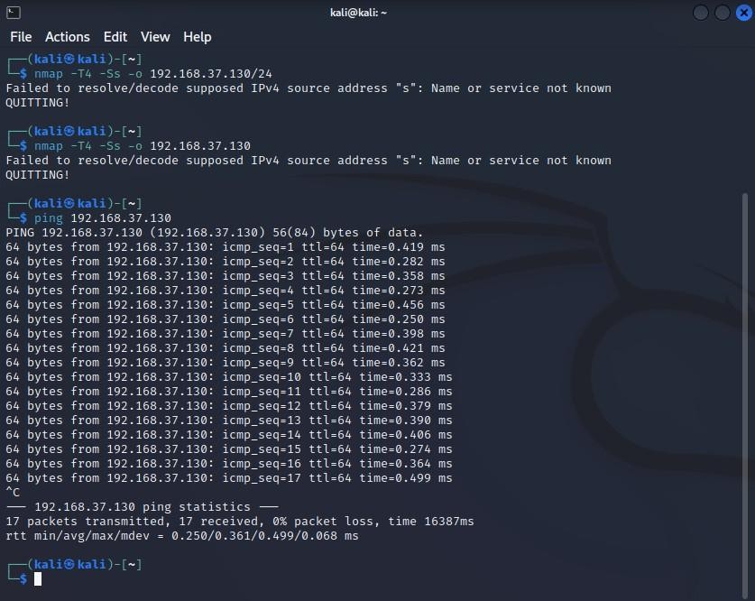

* + Then we use the MSF Console. This is the Metasploit Framework console that allows the penetration tester to run exploits on the target machine.

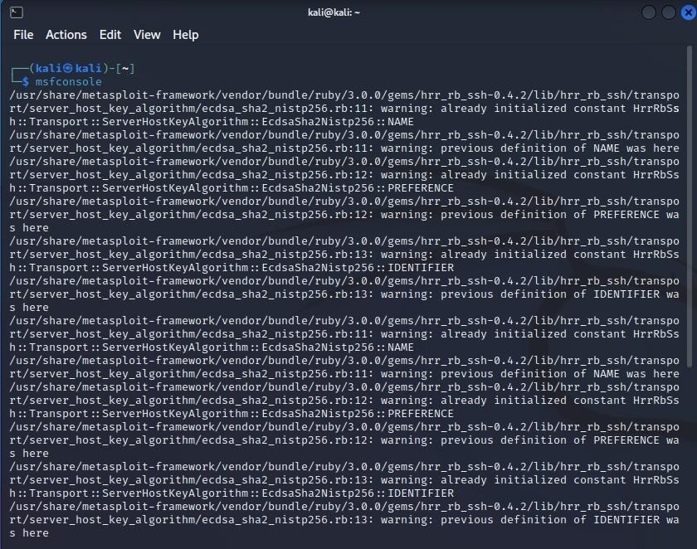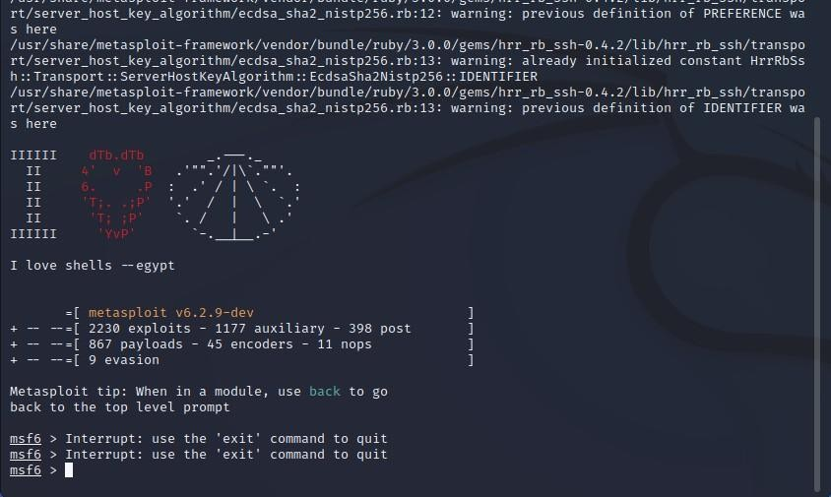

* + Then we search for ms08_067.

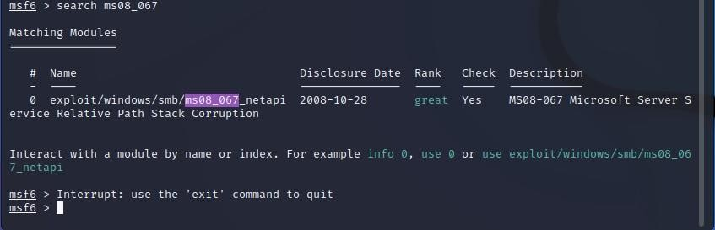

**Practical 3:**

**Aim: Practical on enumerating host, port, and service scanning**

**Note:**

* The tool being used for port scanning, data enumeration, and service scanning is

NMAP.

* Nmap is a network scanner created by Gordon Lyon.
* Nmap is used to discover hosts and services on a computer network by sending packets and analyzing the responses.
* Nmap provides a number of features for probing computer networks, including host discovery and service and operating system detection.

**Port Scanning:**

* A port scanner is an application designed to probe a server or host for open ports.
* Such an application may be used by administrators to verify security policies of their networks and by attackers to identify network services running on a host and exploit vulnerabilities.

1. To see the help/ manual of Nmap we can use the command “man nmap” (OS used kali linux).

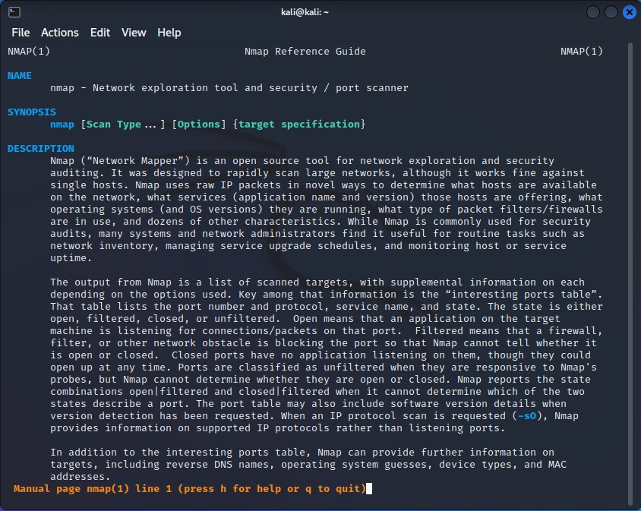

1. You will need to run the target machine metasploitable2 and check the ip address of the machine using the command “ifconfig”.

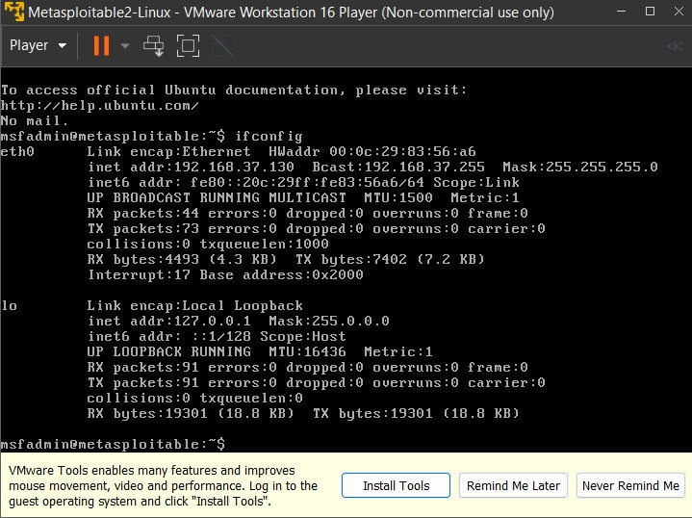

1. Using Kali perform port scanning using nmap on the target machine by running the given command shown below.

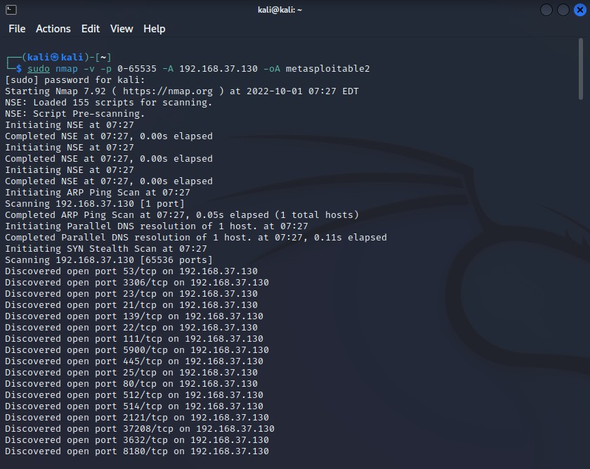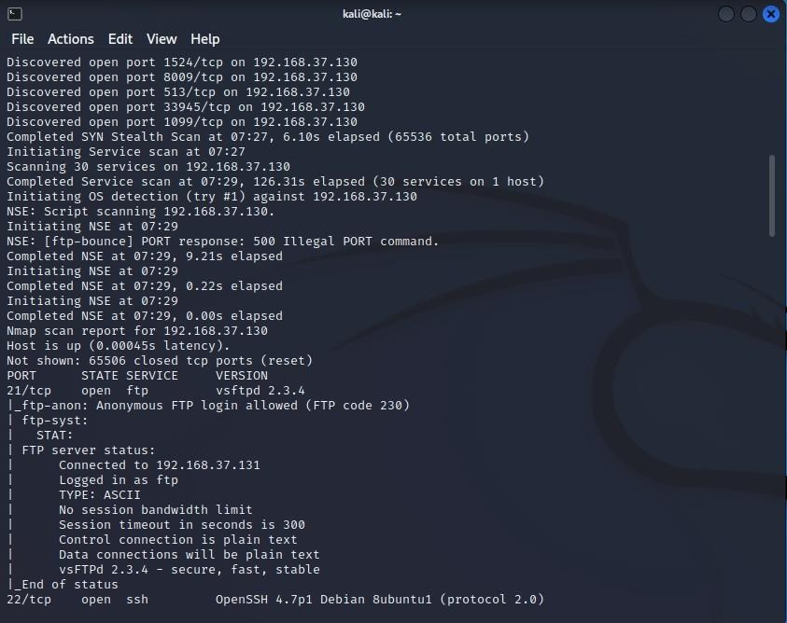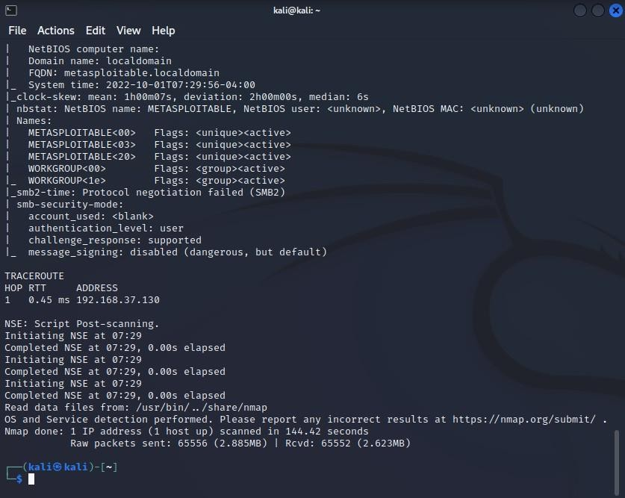

1. You will be able to identify the operating system and the target machine’s open port details.

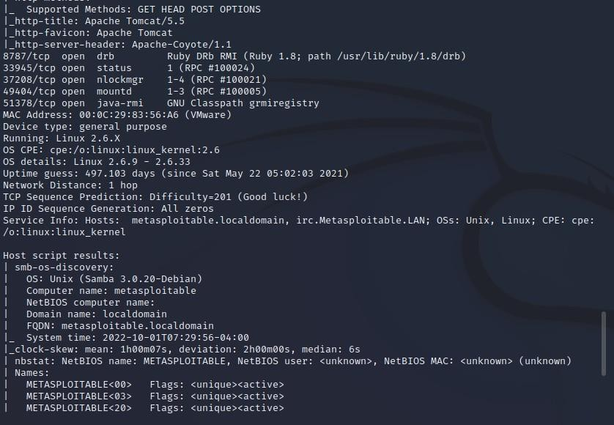

1. View the output file created which stores all the scan results in “metasploitable.nmap”.

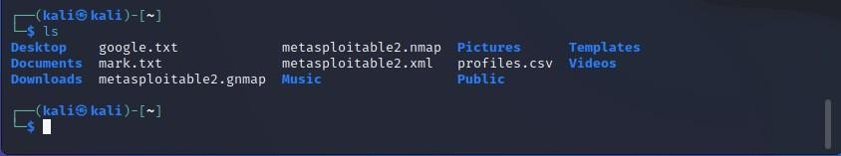

1. Using the cat command you can display the contents of the file.

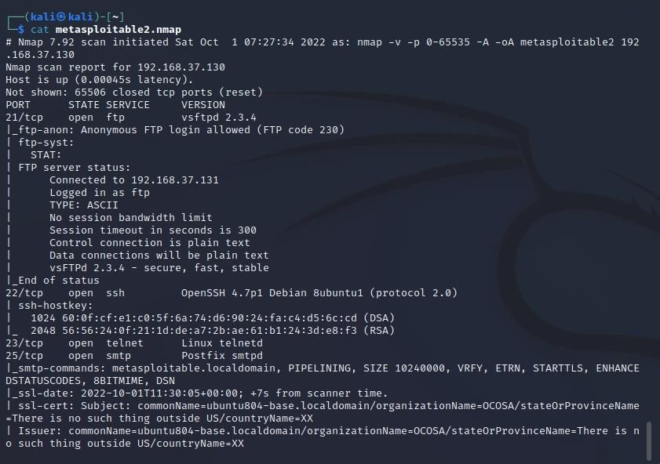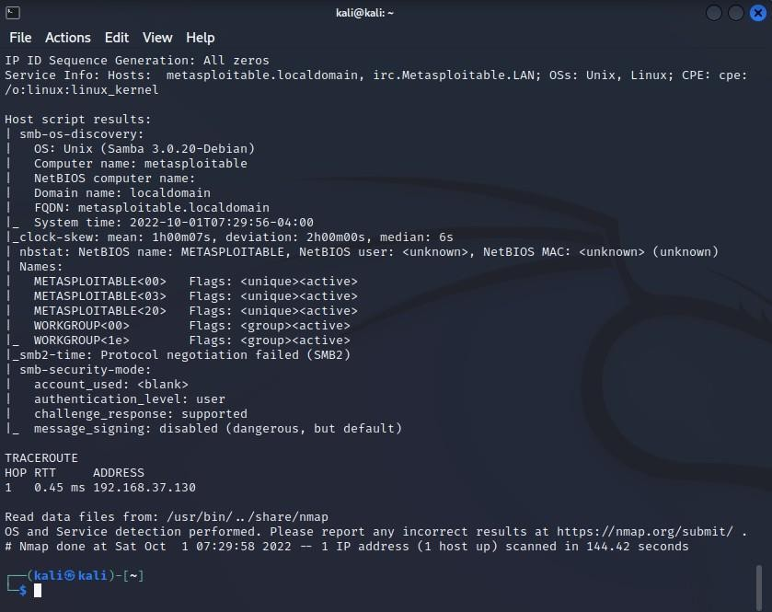

**Enumerating Hosts:**

* Enumeration is defined as a process which establishes an active connection to the target hosts to discover potential attack vectors in the system, and the same can be used for further exploitation of the system.
* Enumeration is used to gather the following:
  + Usernames, group names
  + Hostnames
  + Network shares and services
  + IP tables and routing tables
  + Service settings and audit configurations
  + Application and banners
  + SNMP and DNS details

1. Find out the operating system of the target metasploitable2. (Running: Linux 2.6.X)

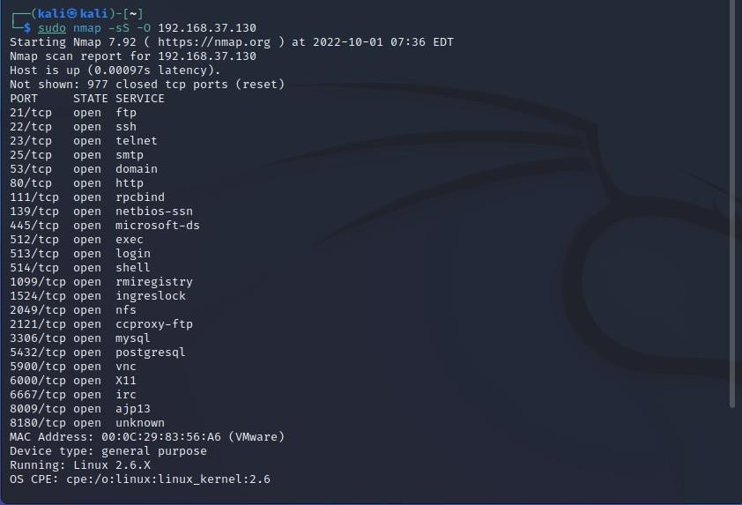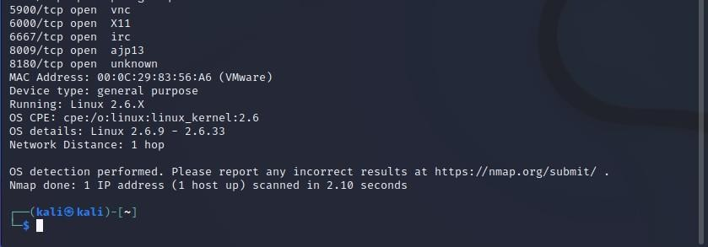

1. Find out all the host services and their ports by using –sV.

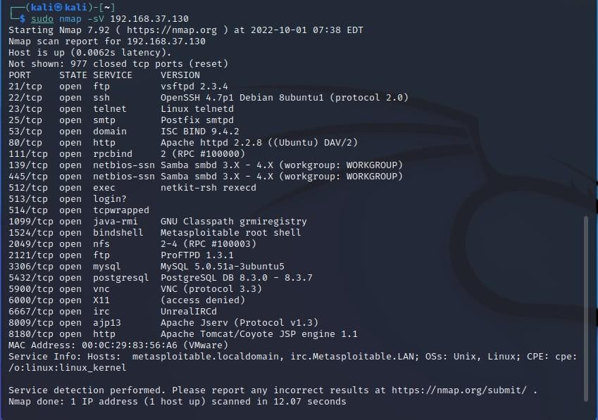

1. Using Legion, we can also perform enumeration and search for open service ports.

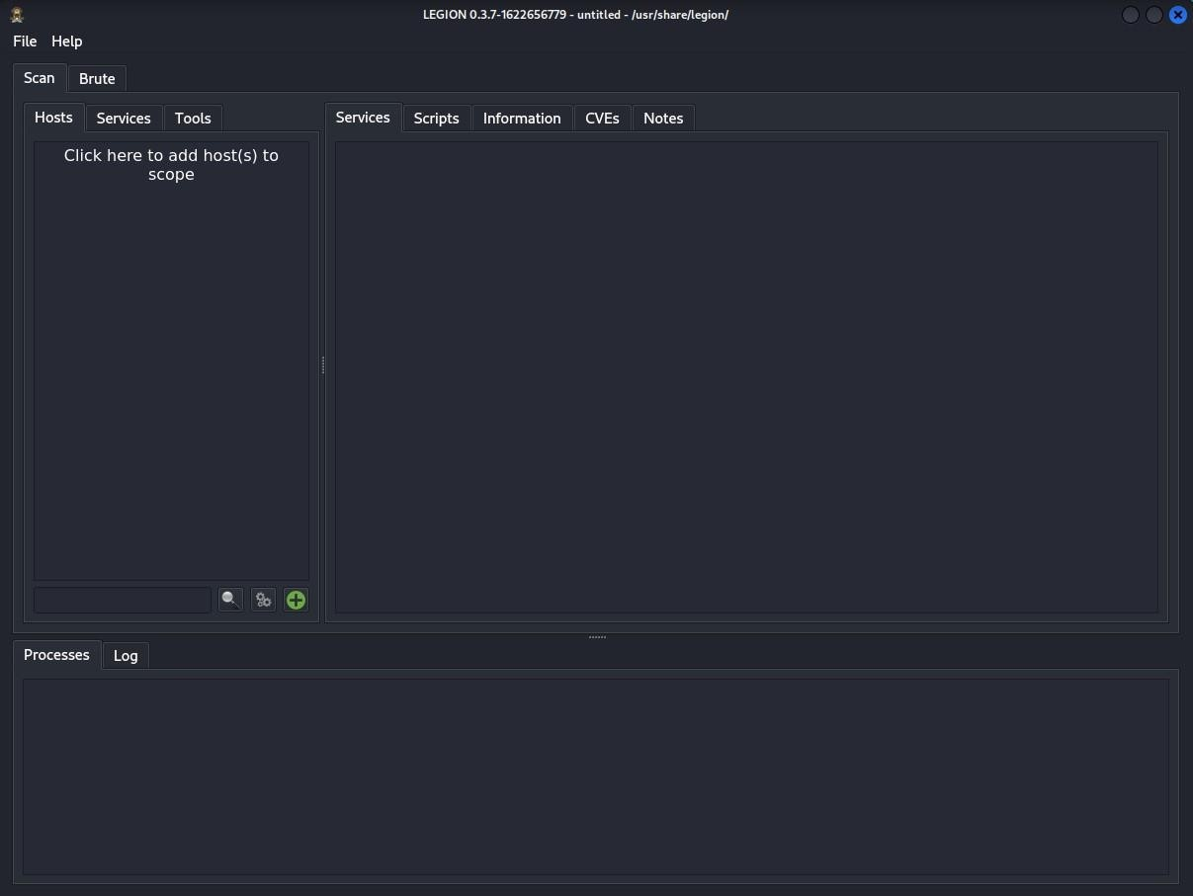

1. Specify the IP Subnet and Bits as shown and click on submit.

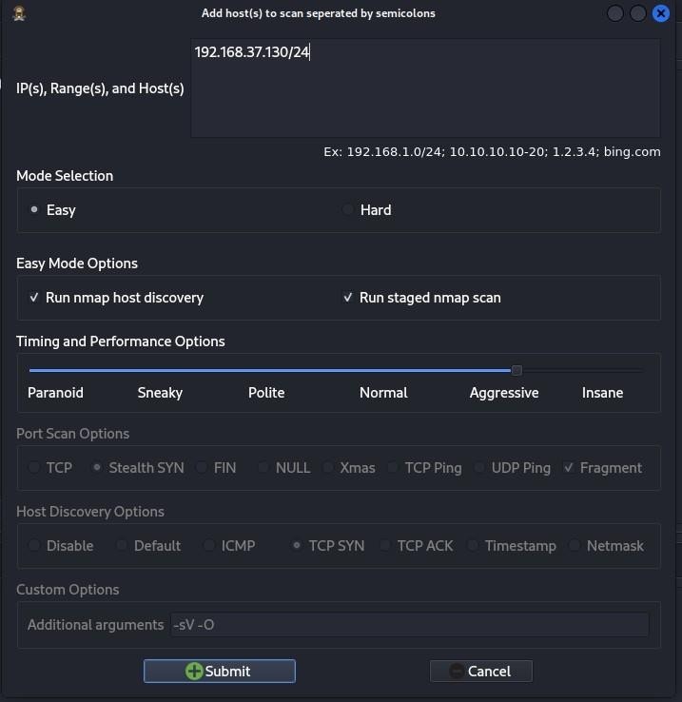

1. After submitting it will start scanning all the available hosts in that subnet and you will see the Windows XP and Metasploitable2 Operating systems also displayed in the scan.

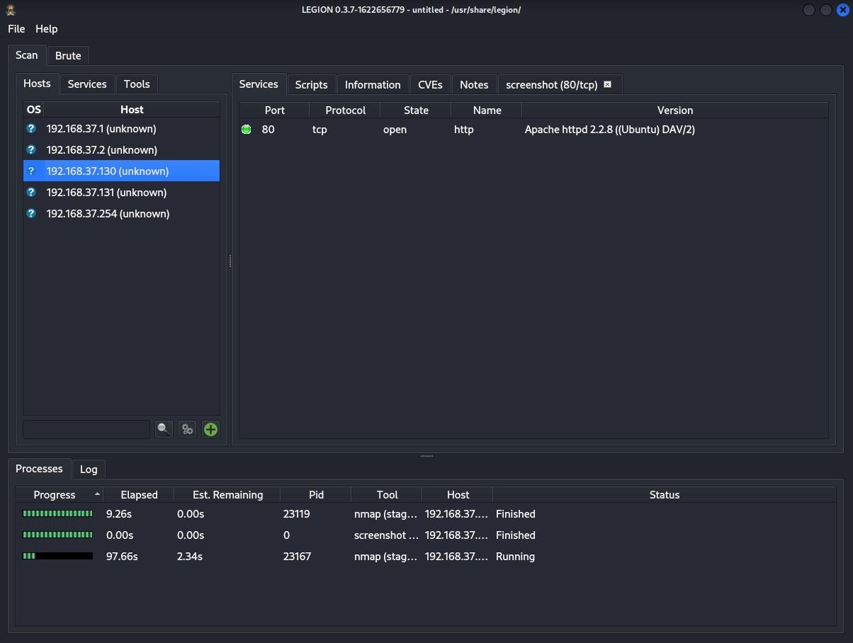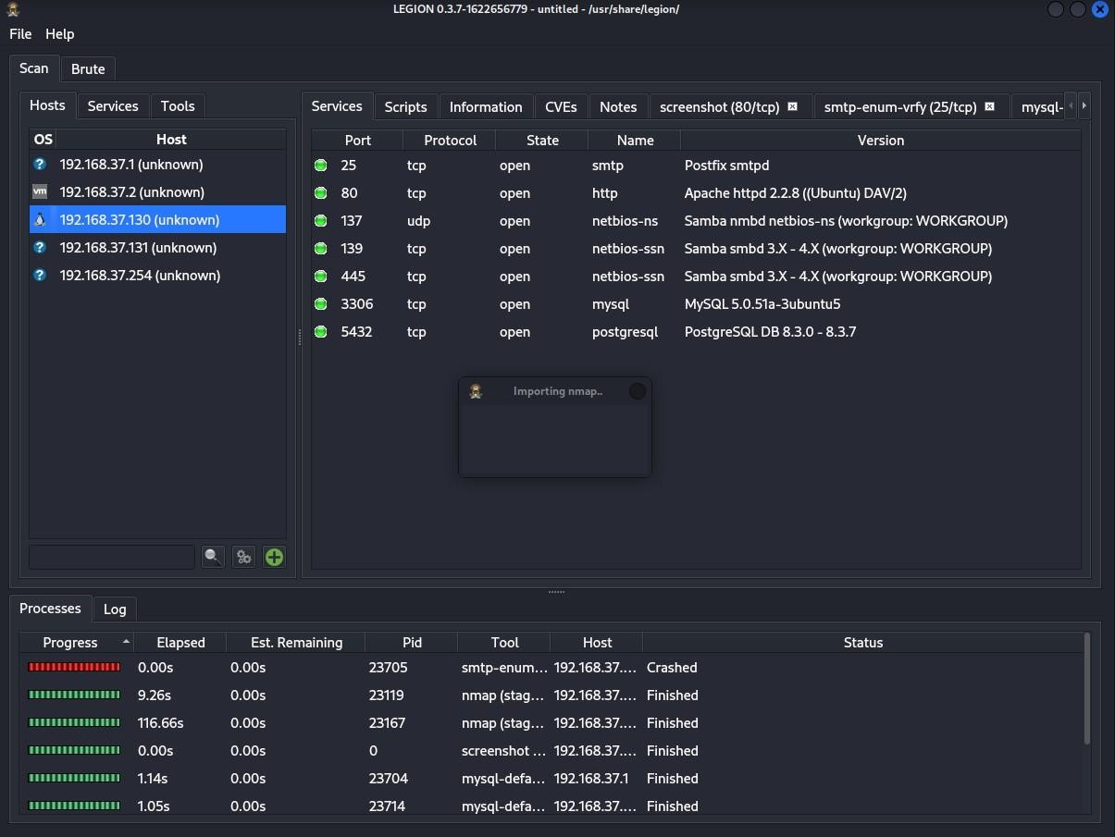

**DNS Enumeration:**

* + - The process which locates all DNS servers and records of an organization is DNS enumeration.
    - Domain Name System can be utilized as a source of information by an attacker to exploit and gain access to internal resources and systems of a specific organization.
    - DNS enumeration will yield usernames, computer names, and IP addresses of potential target systems.

**Note:** DNS Enumeration needs to be performed while Legion runs in the background.

* 1. To find out the host IP Address, IPv6 address and Mail Servers

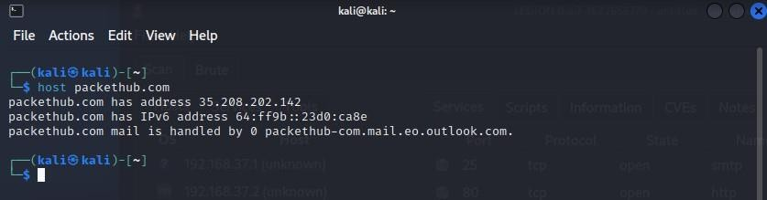

* 1. To find out the host name servers and mail servers

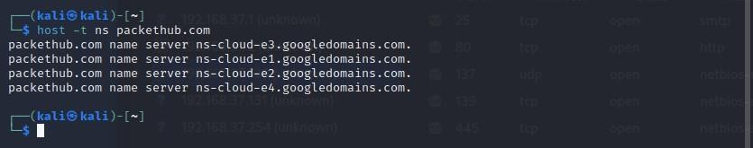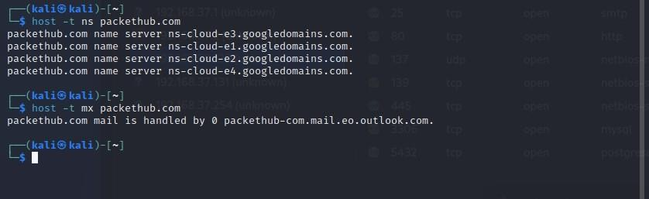

* 1. To find the Name Servers by setting the type=ns using nslookup

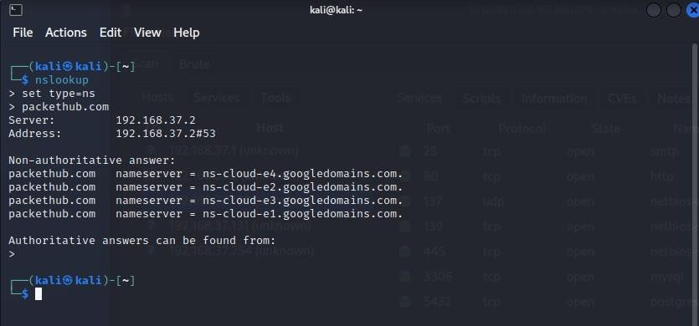

* 1. The dig command can be used for advanced dns enumeration.

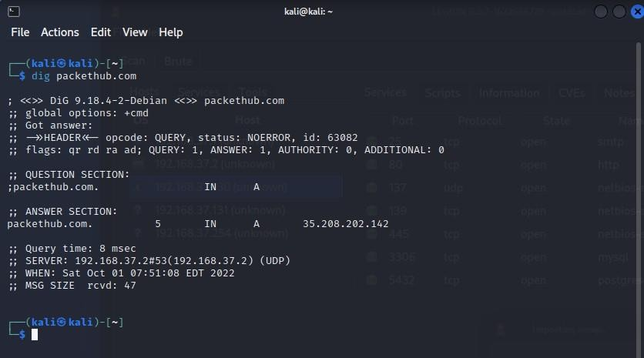

* 1. Use dig command to get detailed info of mail servers of the target

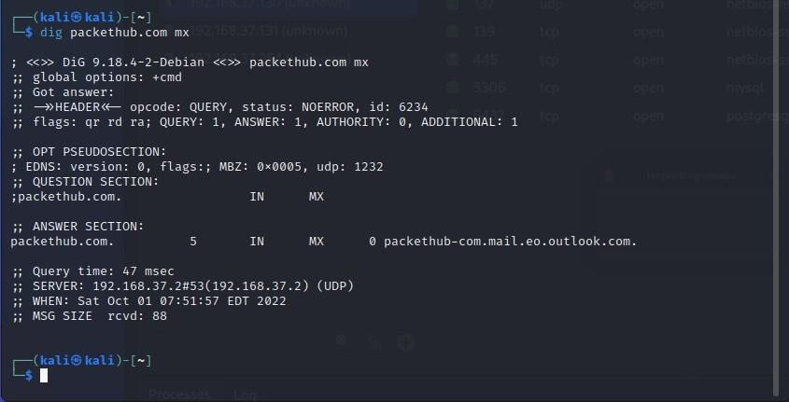

1. Enter the keywords “dig packtpub.com <record>” to get the details about the target host

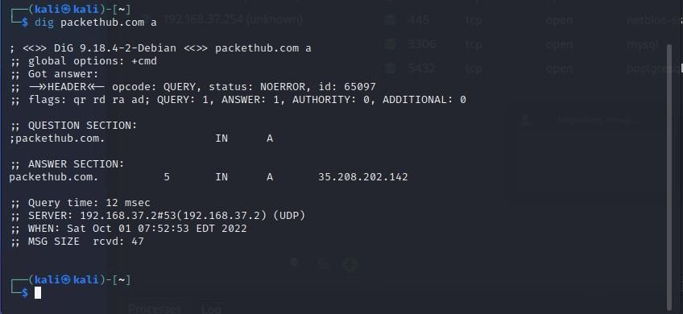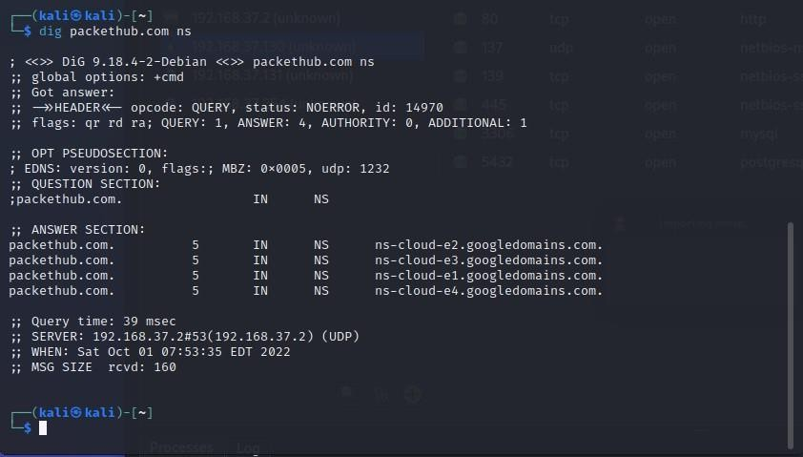

Various functional keywords for the “dig” command:

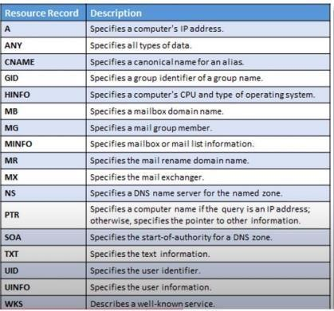

Using whois to enumeratate domain details

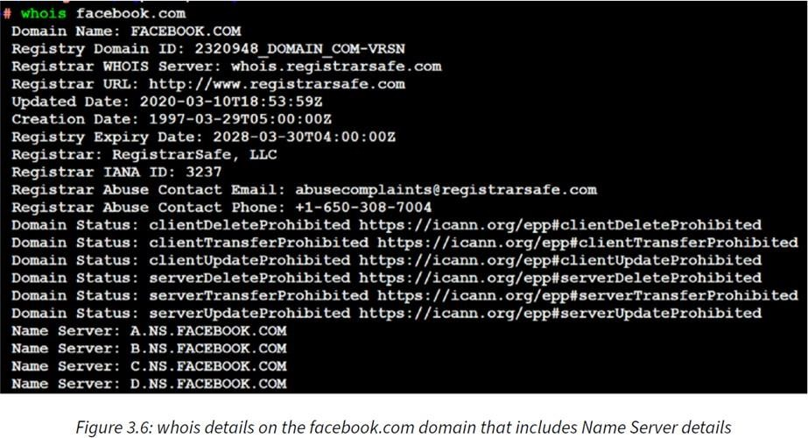

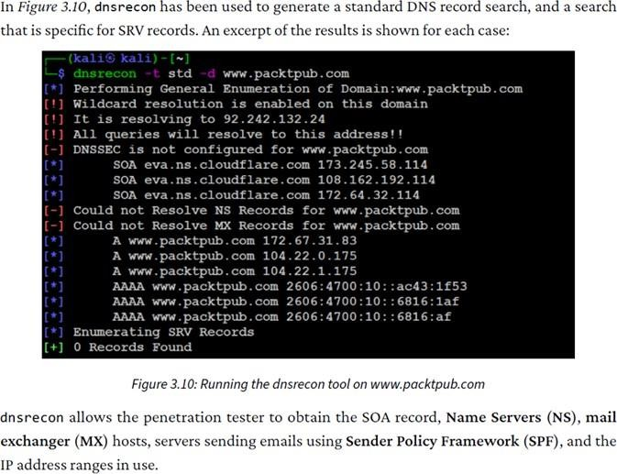

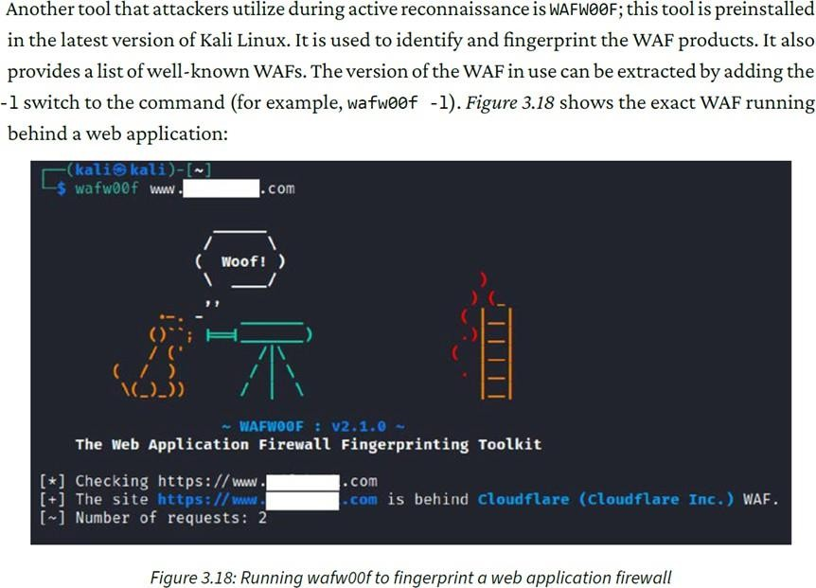

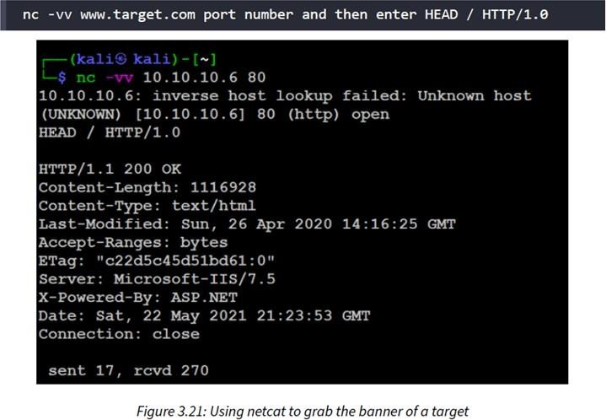

**Practical 4**

**Aim: Practical on vulnerability scanning and assessment**

**Vulnerability Scanning using Nmap:**

1. Navigate to nmap scripts folder and view all the scripts in that folder

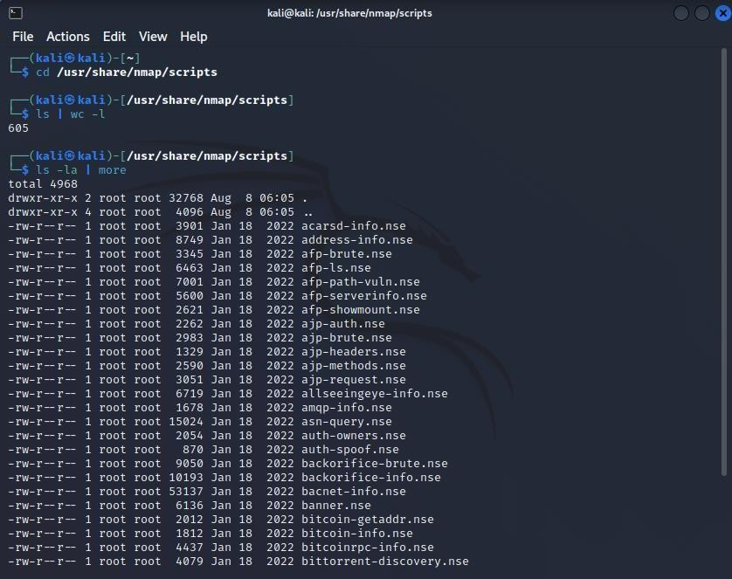

1. Update scripts

Before Nmap can be used to perform a vulnerability scan, penetration testers must update the Nmap script database to see whether there are any new scripts added to the database, so that they do not miss the vulnerability identification.

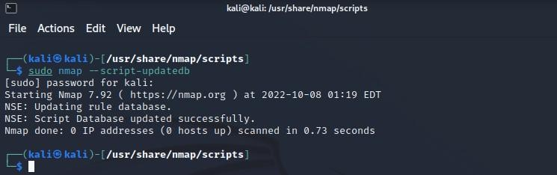

1. Run Nmap to check vulnerability services running on metasploitable2.

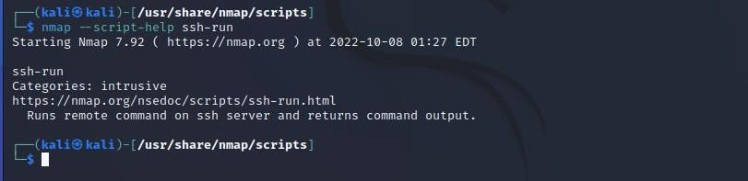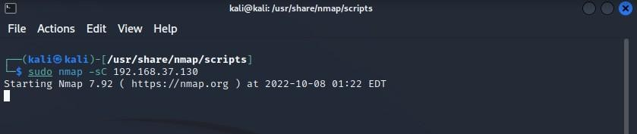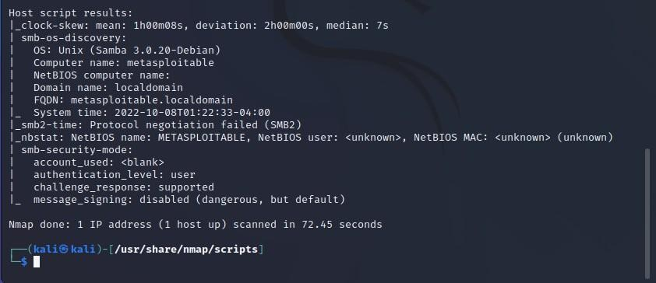

1. Let us find available scripts to find vulnerability for ssh.

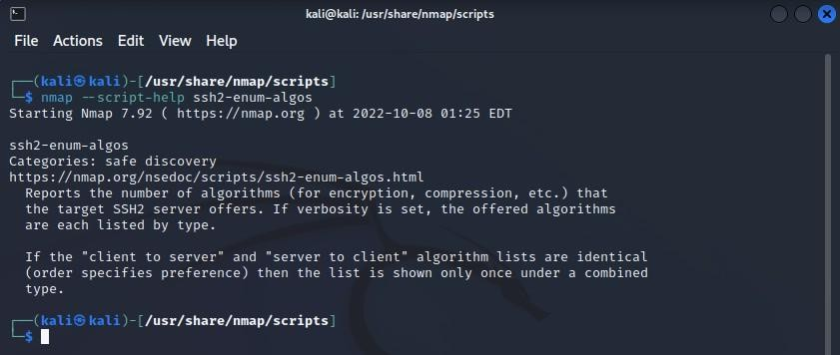

1. Get more info on ssh-run script
2. Let’s run the ssh-run script on our target (metasploitable2 IP Address)

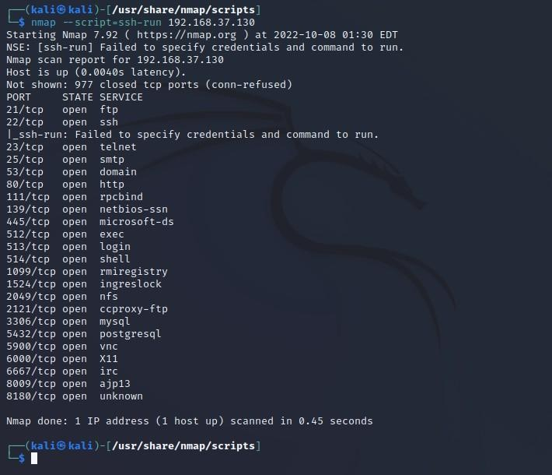

1. Get available scripts for http

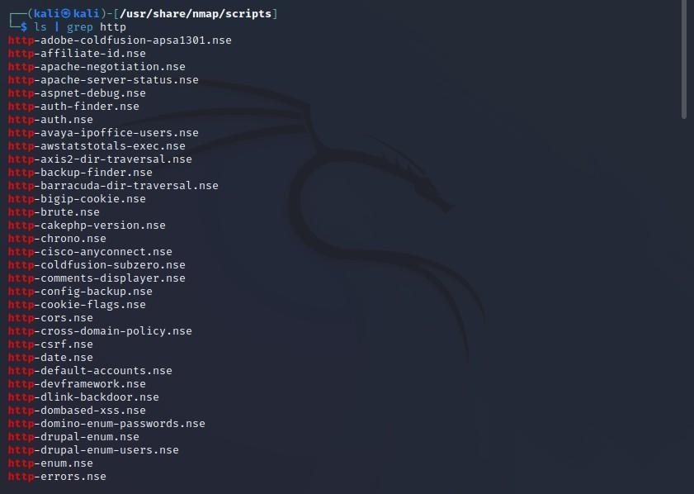

1. Run a http script

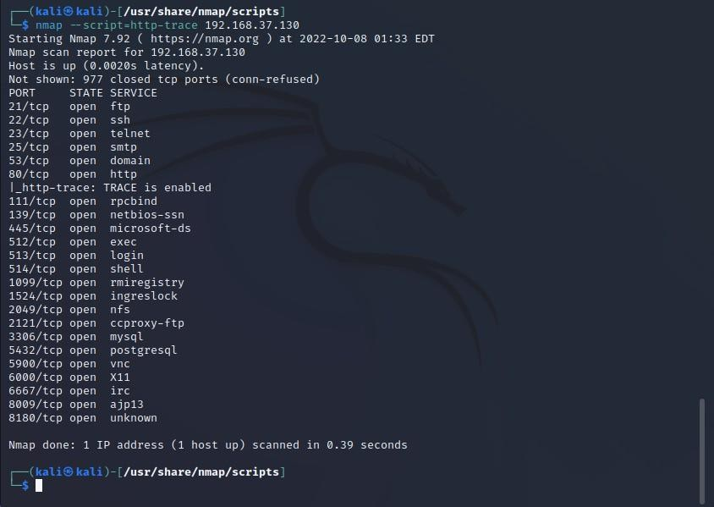

**Web Server Vulnerability Scanning:**

1. Run metasploitable2 website on Firefox in kali linux

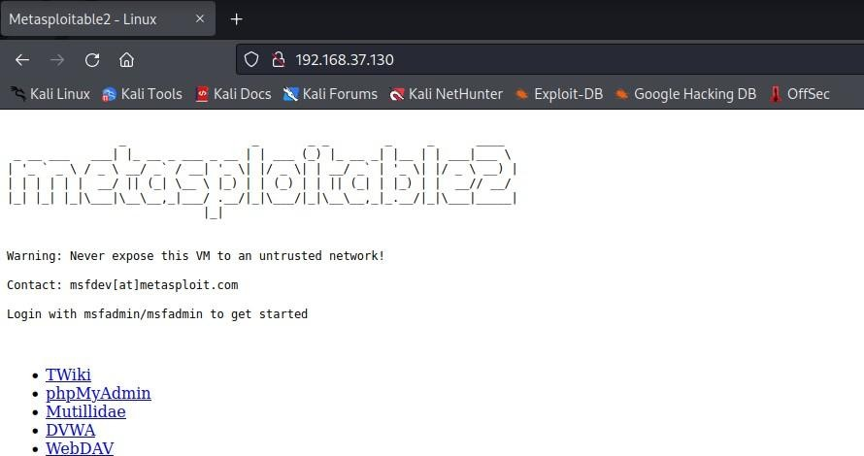

1. Using Nikto tool scan the target for vulnerabilities

“ nikto -host 192.168.37.130 ”

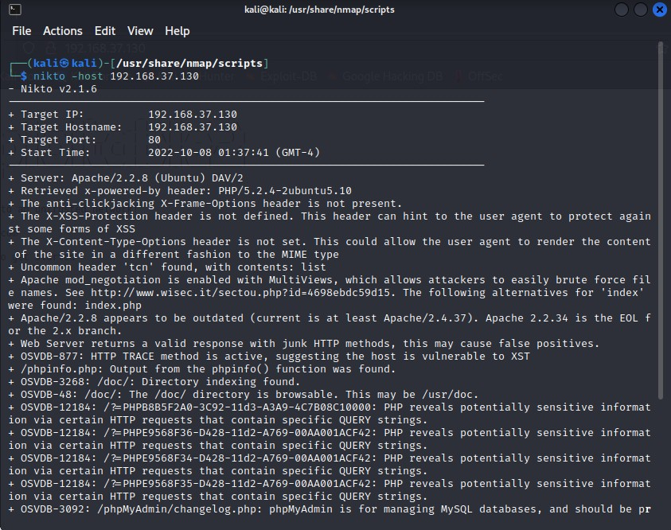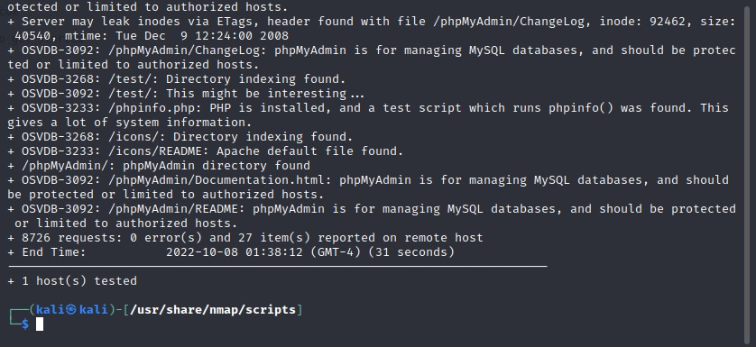

As you can see, PHP5 has many vulnerabilities when installed on a server.

1. By running <targetIP>/phpinfo.php you can get information about the php version

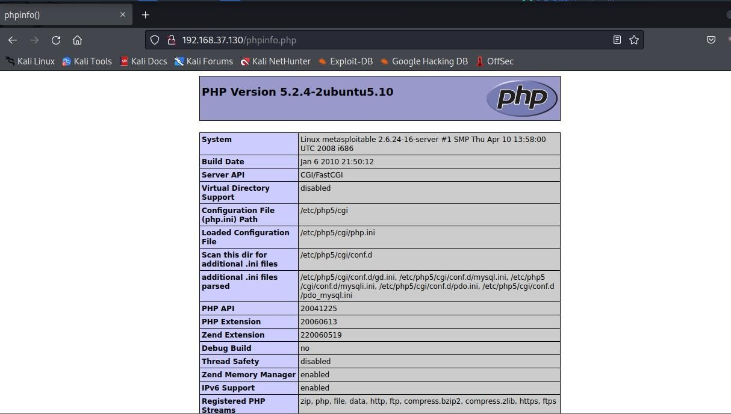

**Customizing Nikto:**

1.

List

all the plugins in the

Nikto

tool.

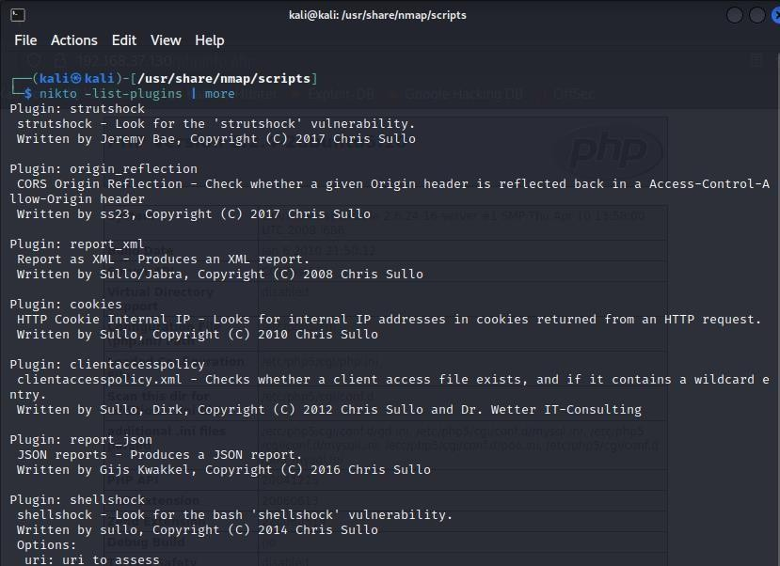

2. Running Nikto with specific plugin to find active users on the target server

“ sudo nikto -h 192.168.37.130 -p 80 -Plugins

"apacheusers(enumerate,dictionary:users.txt);report_xml" - output apacheusers.xml

”

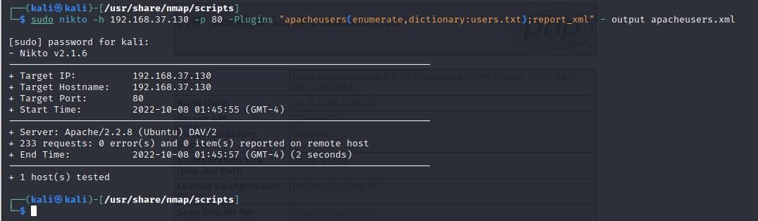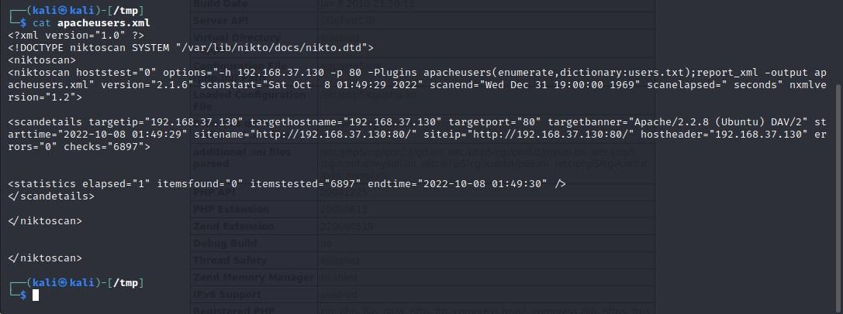

**OWASP ZAP:**

It is one of the most effective scanners based on the number of verified vulnerabilities that it has discovered.

1. Install the latest version of OWASP ZAP by

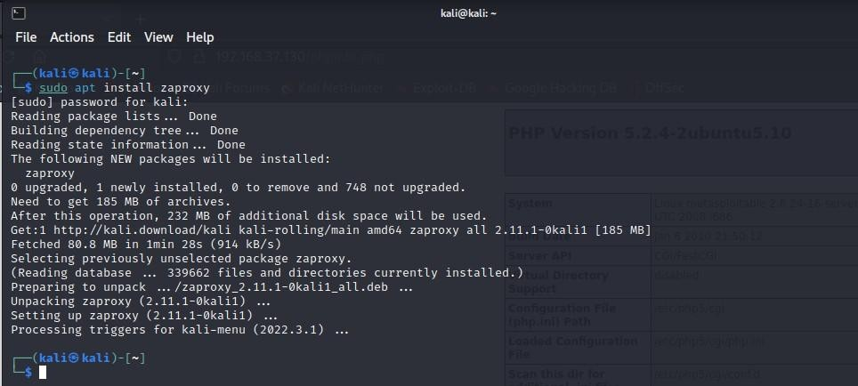

1. Run the tool

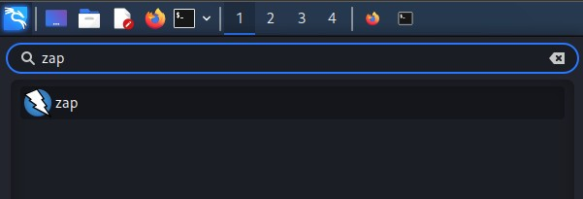

1. On start-up make the appropriate selections and update the plugins

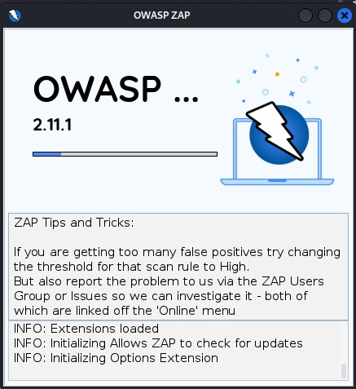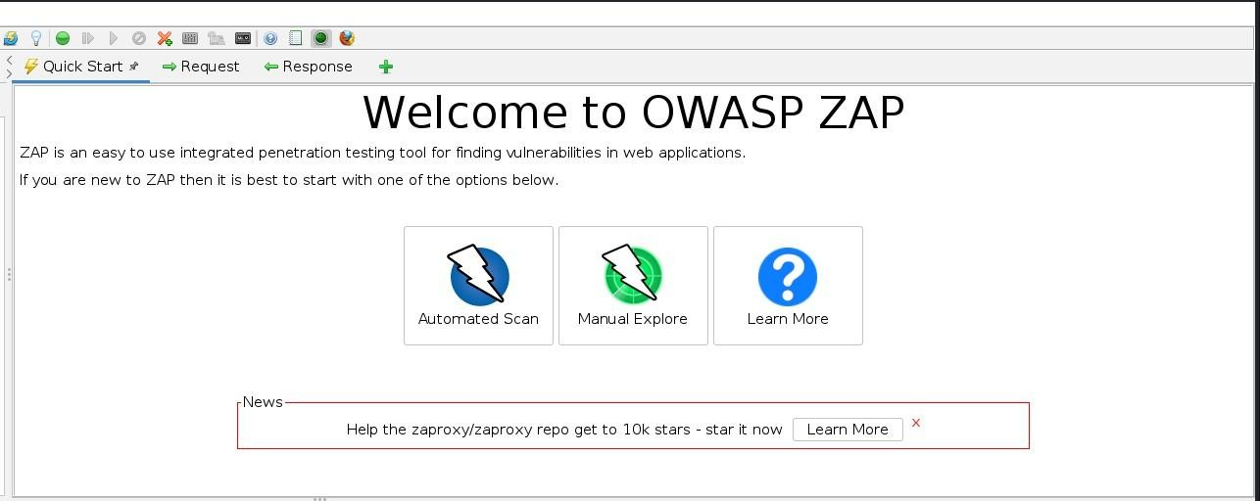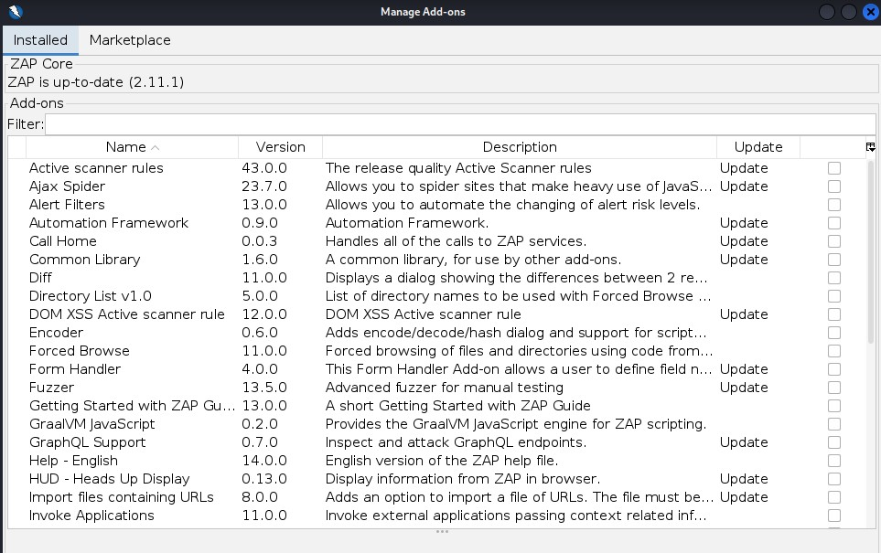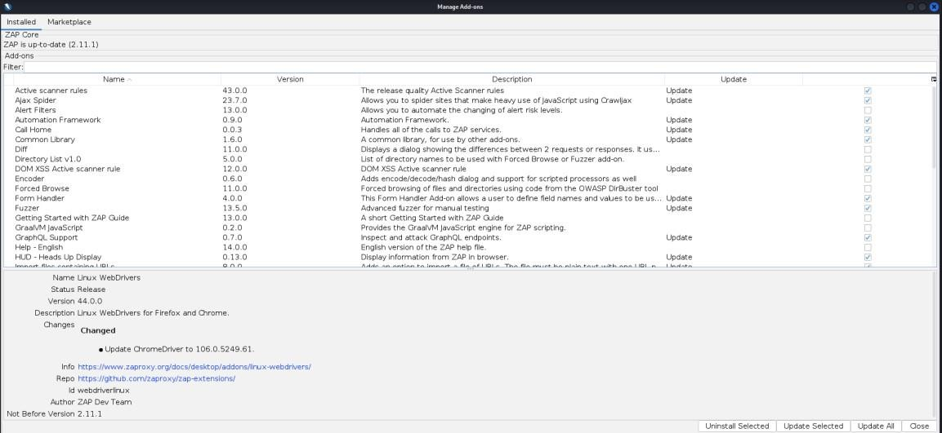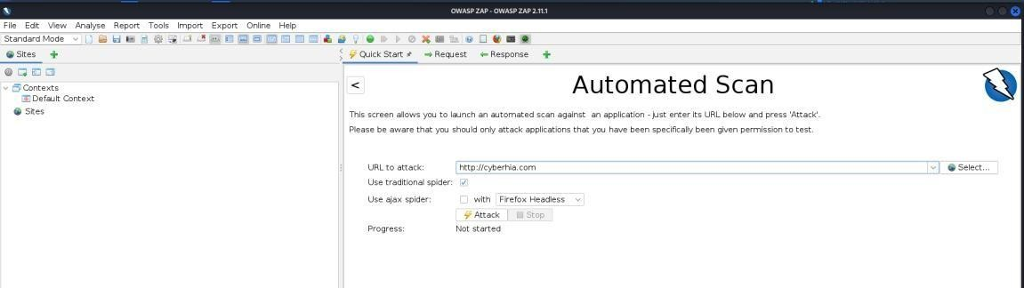

1. After the scan you can click on the identified results to drill down to specific findings. OWASP ZAP can help you find vulnerabilities such as reflected cross-site scripting, stored cross-site scripting, SQL injection, and remote OS command injection.

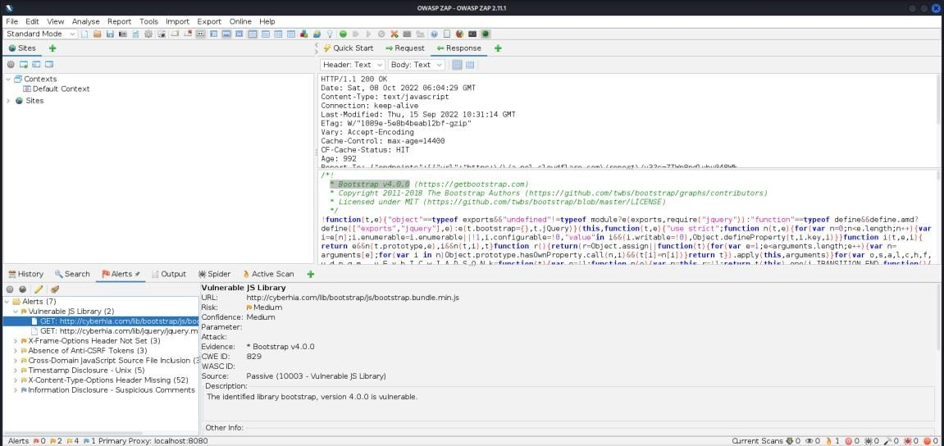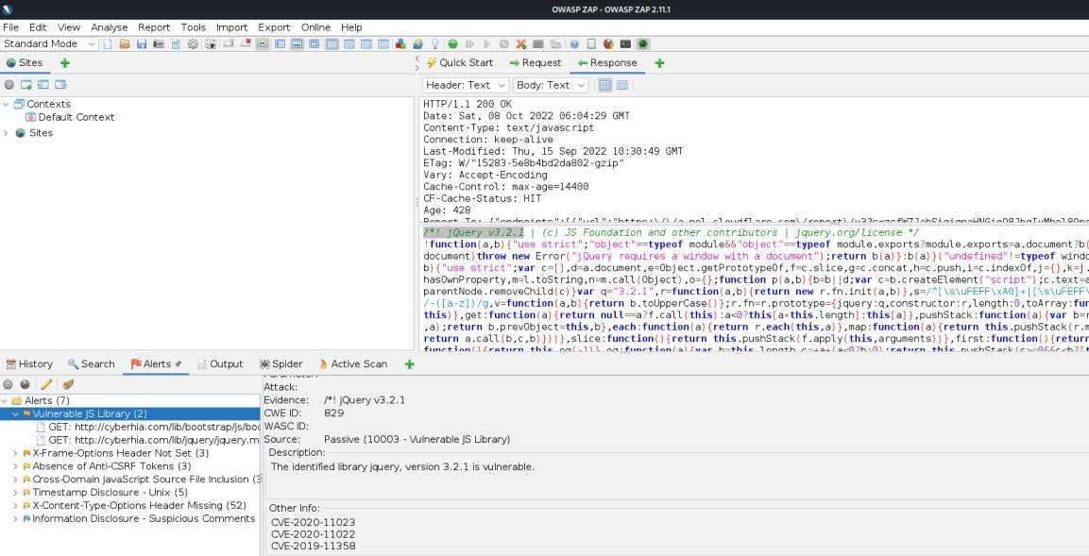

5.

WPScan

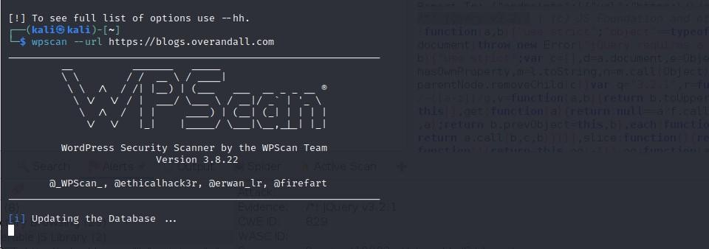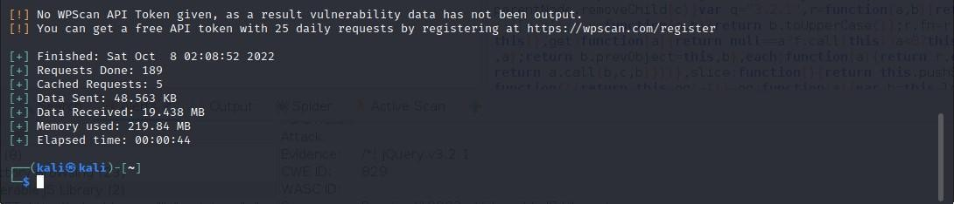

**Practical 5**

**Aim: Practical on the use of Social Engineering Toolkit**

# Credential Harvester Attack

Install the Social Engineering Toolkit

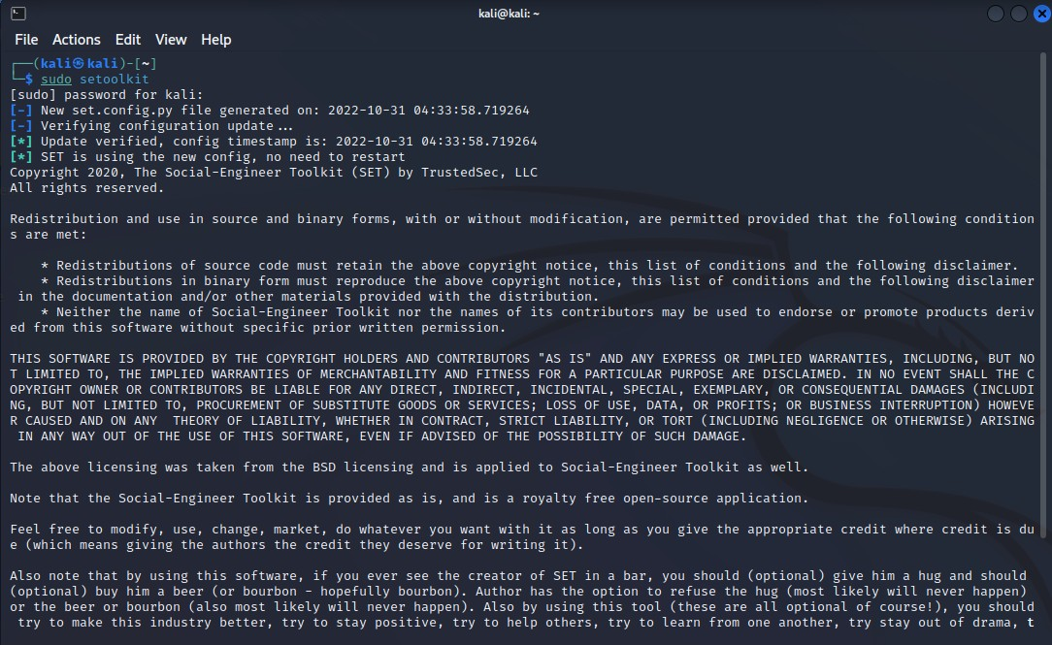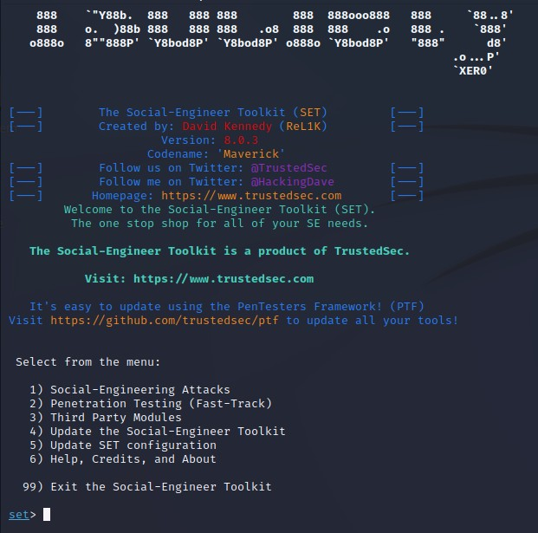

Select the 1st option Social Engineering Attacks and the Website Attack Vectors

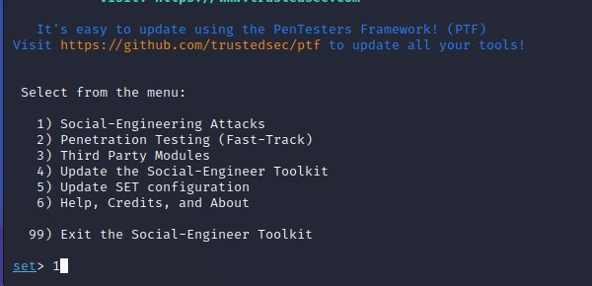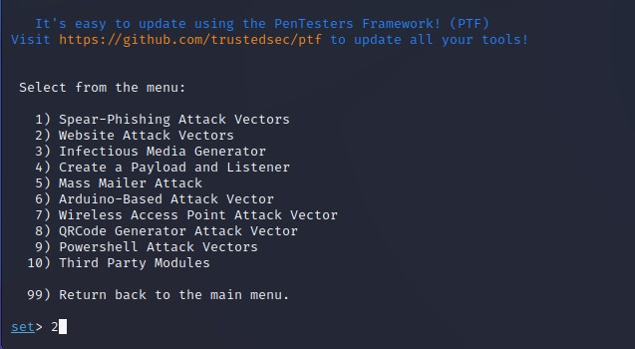

We will use Credential Harvester, so select option 3

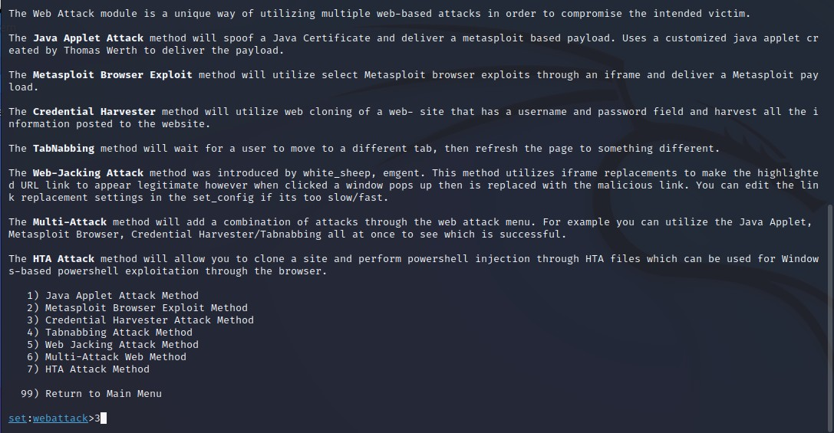

Using Existing Templates

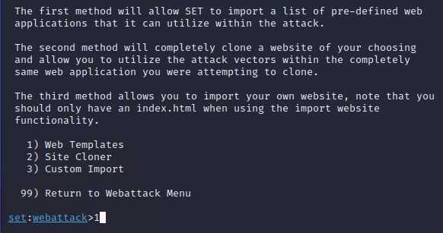

Add the listener IP Address, In this case it will be you Attacking systems’s IP Address

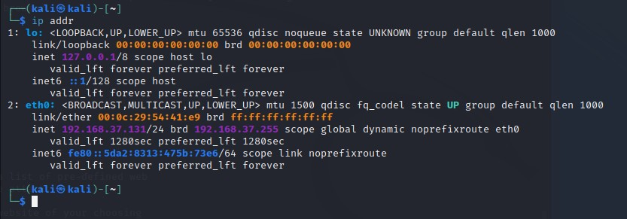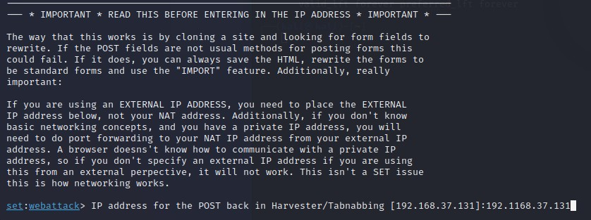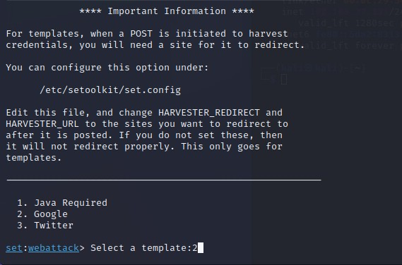

Select the Google Sign In Template page for harvesting credentials

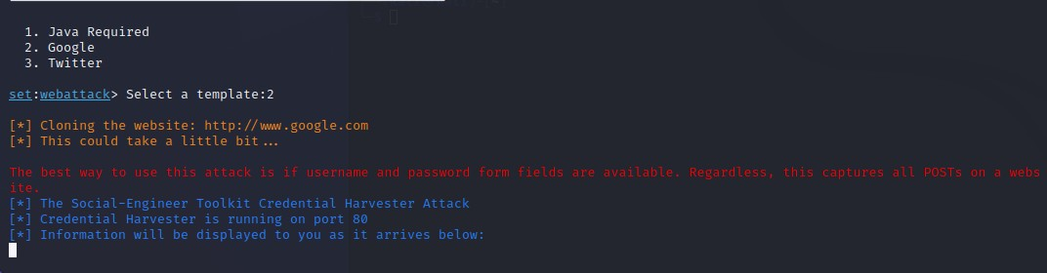

Now on the victim machine. Let us assume that you have shared a file to the victim which will contain the IP Address of the attacking machine which will get the credentials.

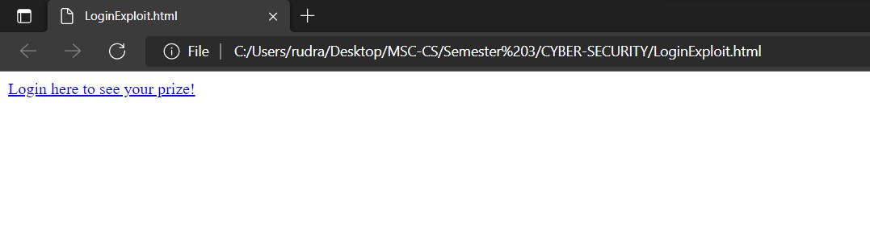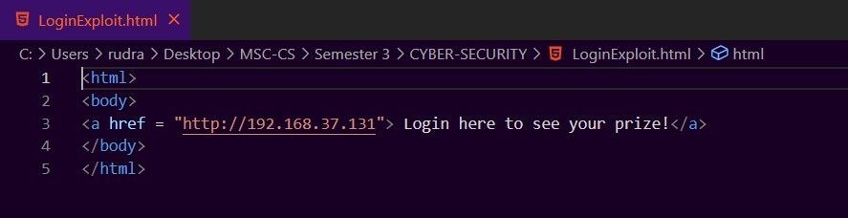

Create an html page with the Link which will attract the victim to click the link Once the user clicks the link, it will redirect it to the cloned google sign in page. If the victim enters any credential information and clicks on the sign in button, the credential harvester on the attacker’s machine will receive the credentials (Usernames. Email and passwords).

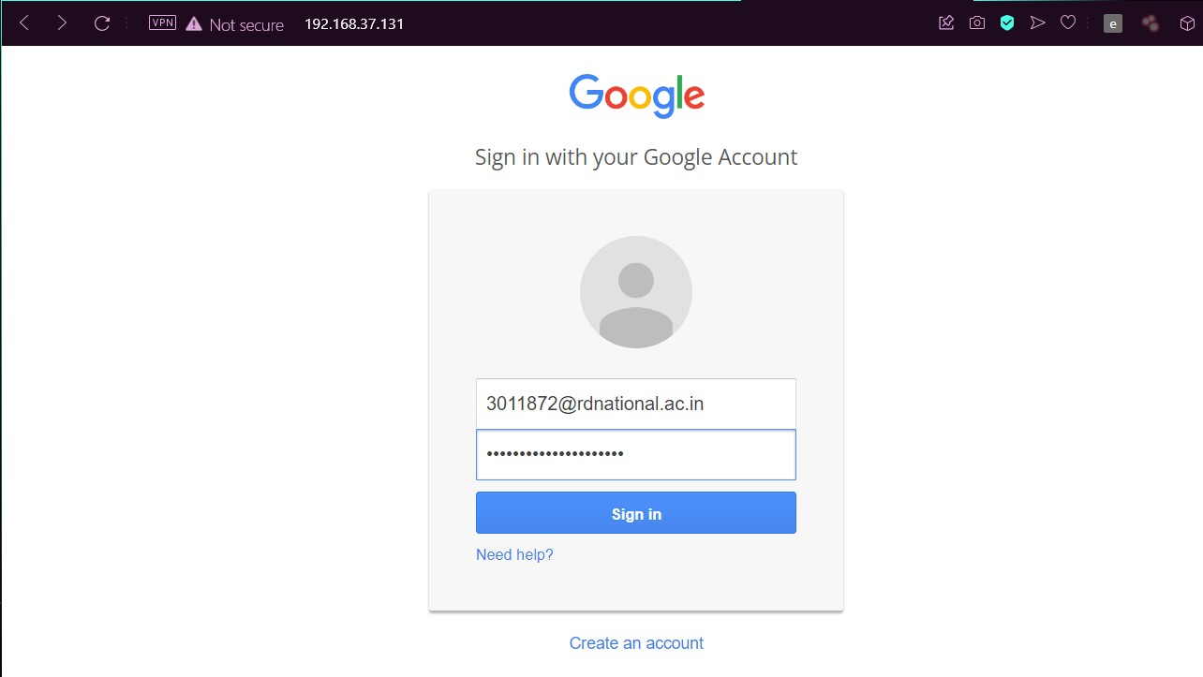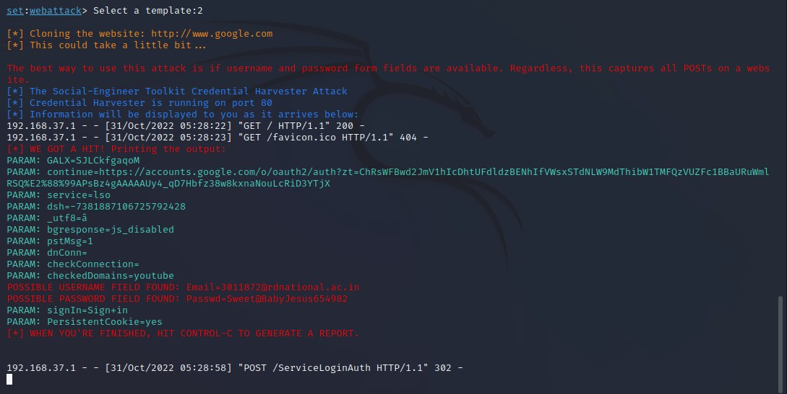

Try the same step by choosing Site Cloner to create a Facebook page

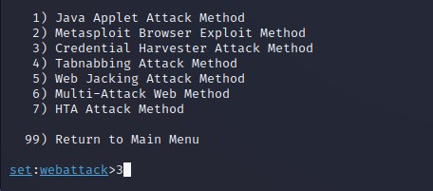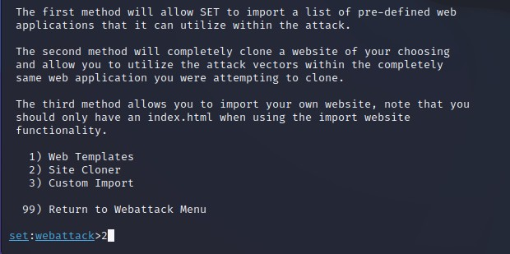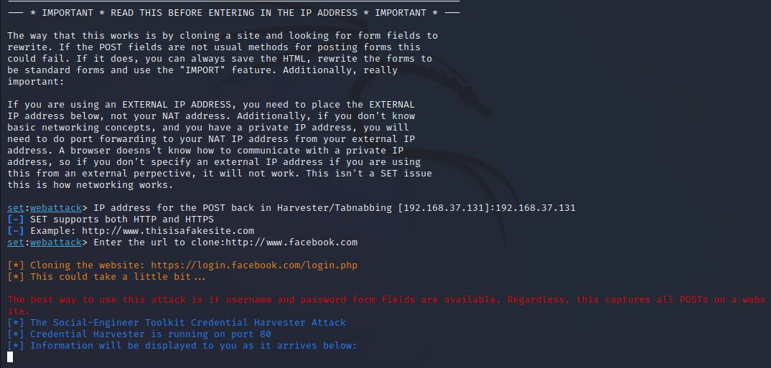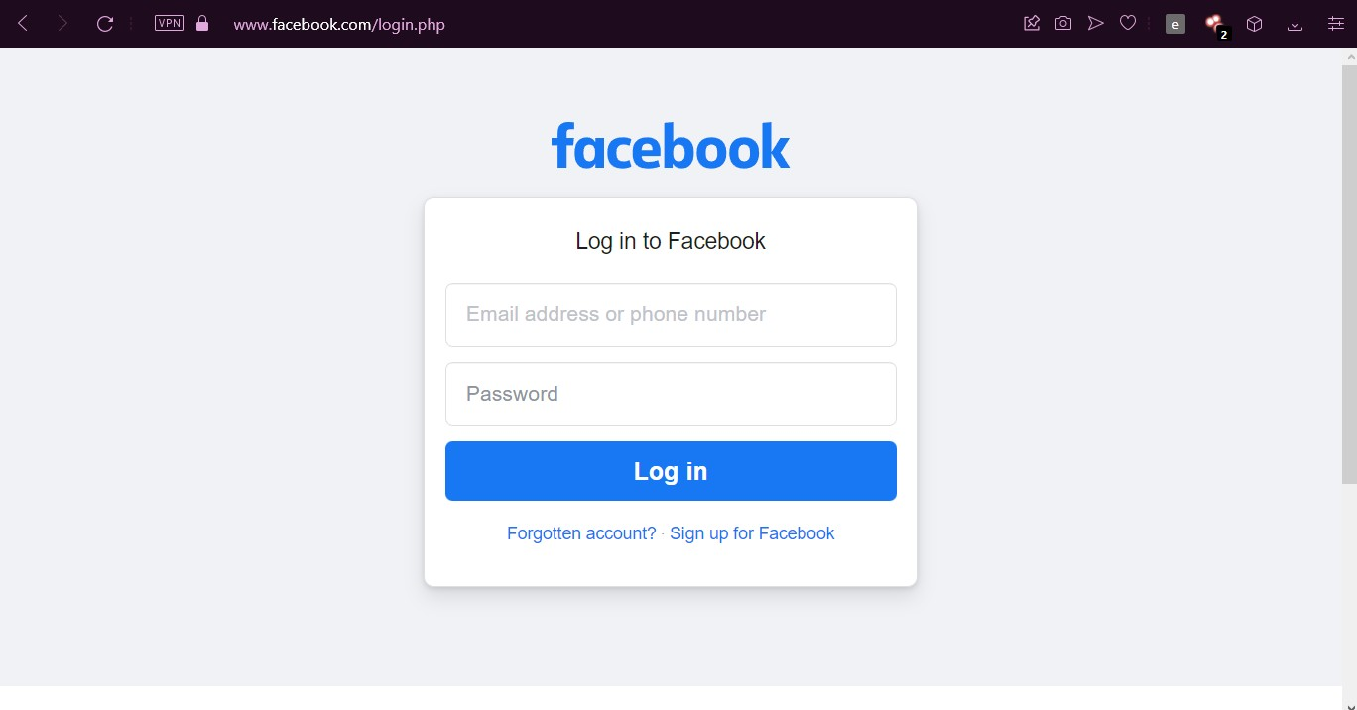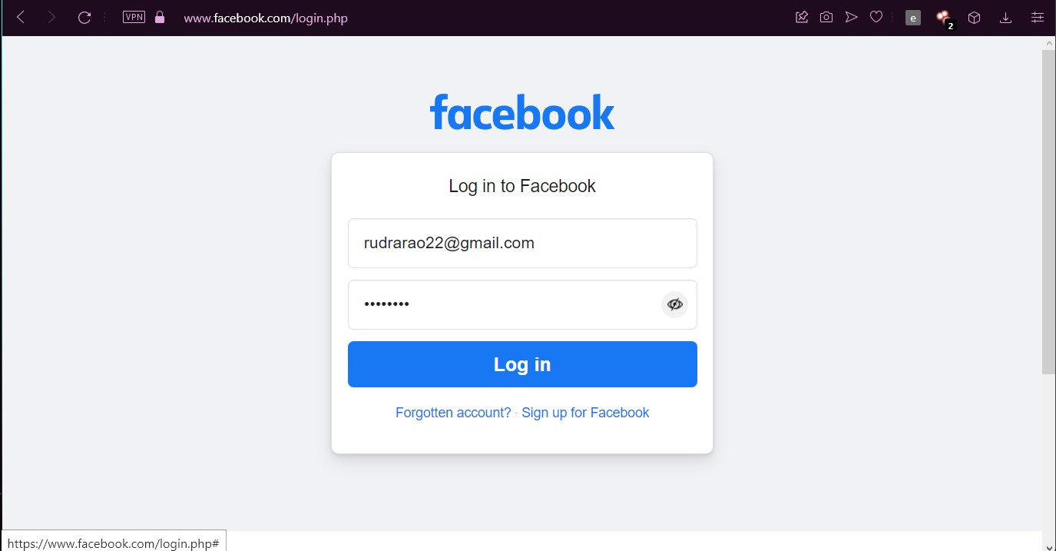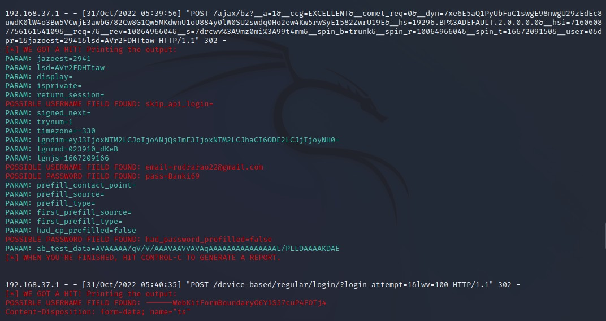

# HTA web attack method

Select Web Attack Vectors

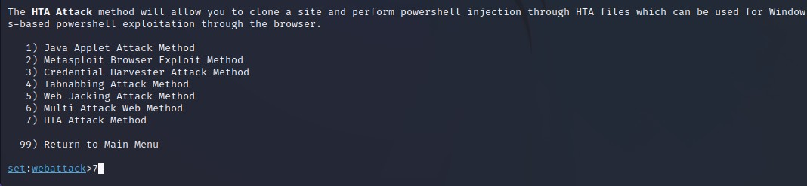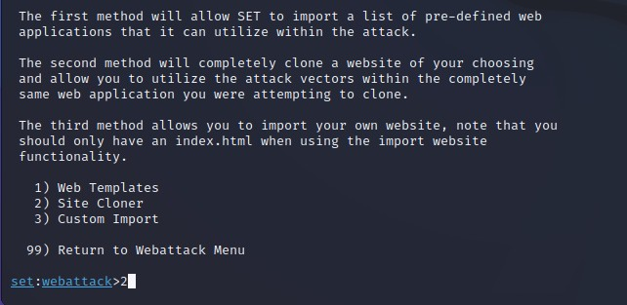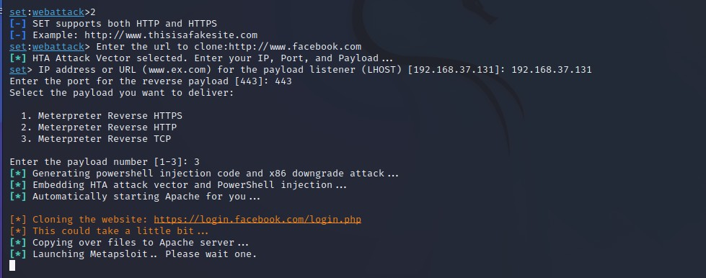

This will create a payload which will be sent to the victim machine and on downloading the payload it will create a reverse session to the attacking machine.

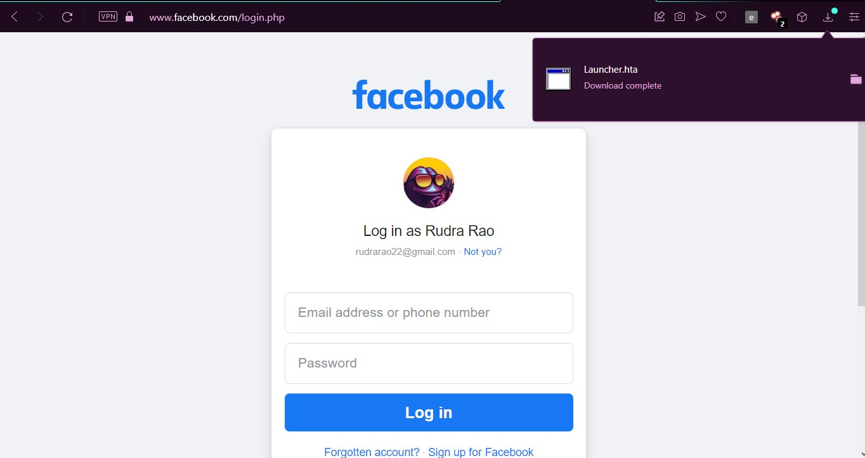

The Victim on downloading and running the file create a link with the attacker’s machine.

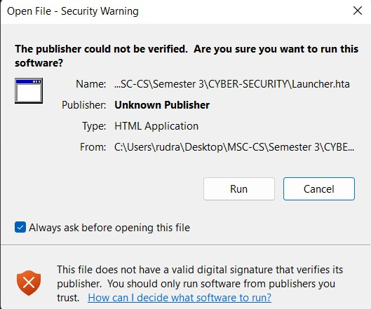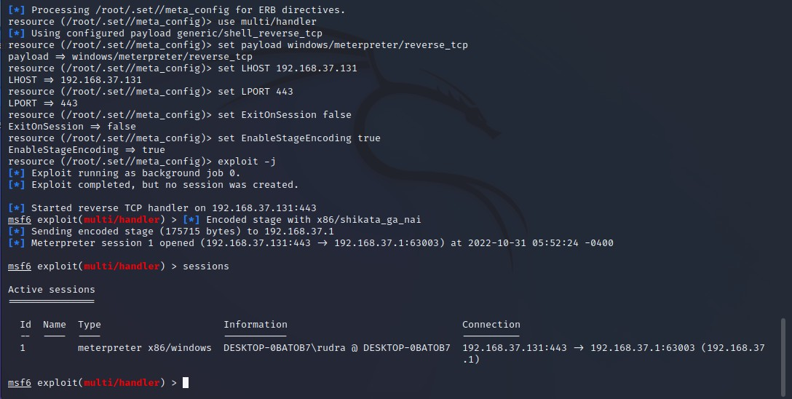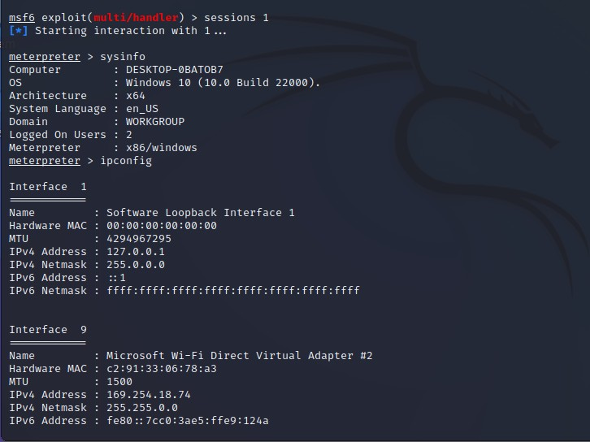

**Practical 6**

**Aim: Practical on Exploiting Web-based applications**

1. **Reconnaissance and Identification of Web applications**

Run the following commands to make sure that you Kali Linux distribution is up to date.

* 1. sudo apt update
  2. sudo apt upgrade
  3. sudo apt dist-upgrade

Then we will run the python tool WAFW00F to perform the identification and fingerprinting of a Web Application Firewall. In this case we will check the firewall of  [www.hdfcbank.com.](http://www.hdfcbank.com/)

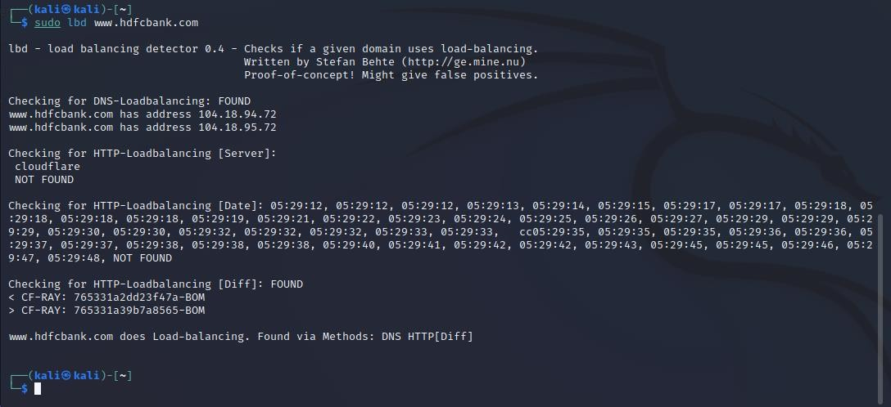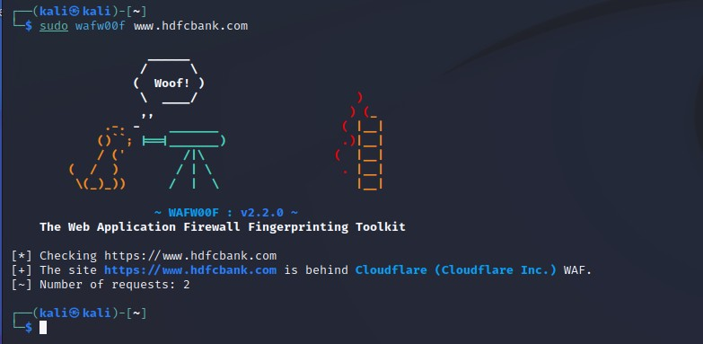

Then we will use a Load Balancing Detector on www.hdfcbank.com.

After that, we will perform a WordPress scan on <https://www.durhamcricket.co.uk/>to check for any WordPress vulnerabilities that we can exploit.

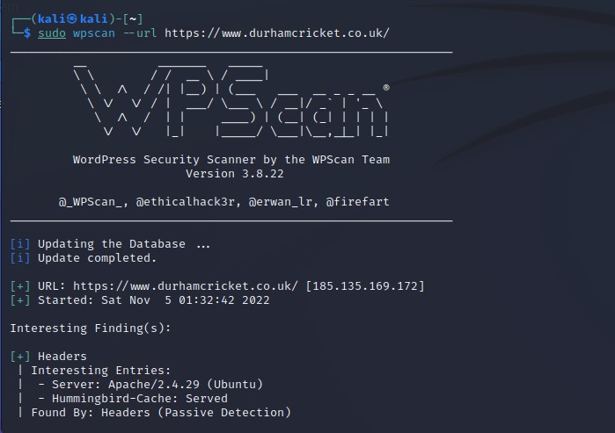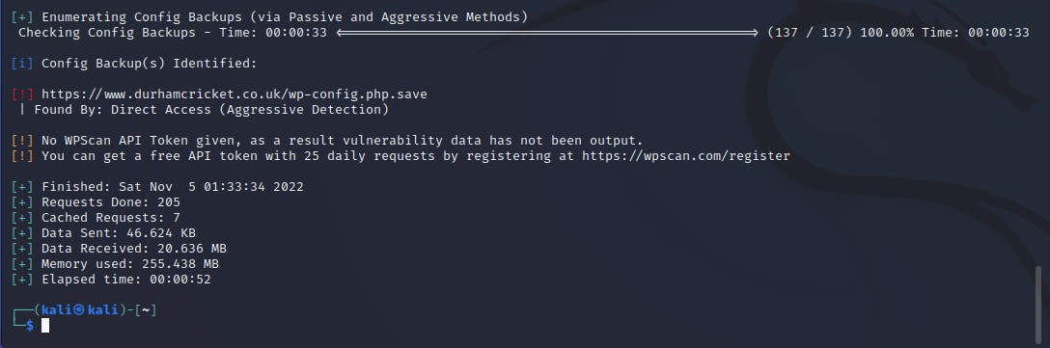

Then we will use the OWASP directory buster to brute force our way through the target website to get the websites directory structure. To use the OWASP directory buster, you can use the following steps. Here our target website will be “www.testfire.net:80/”.

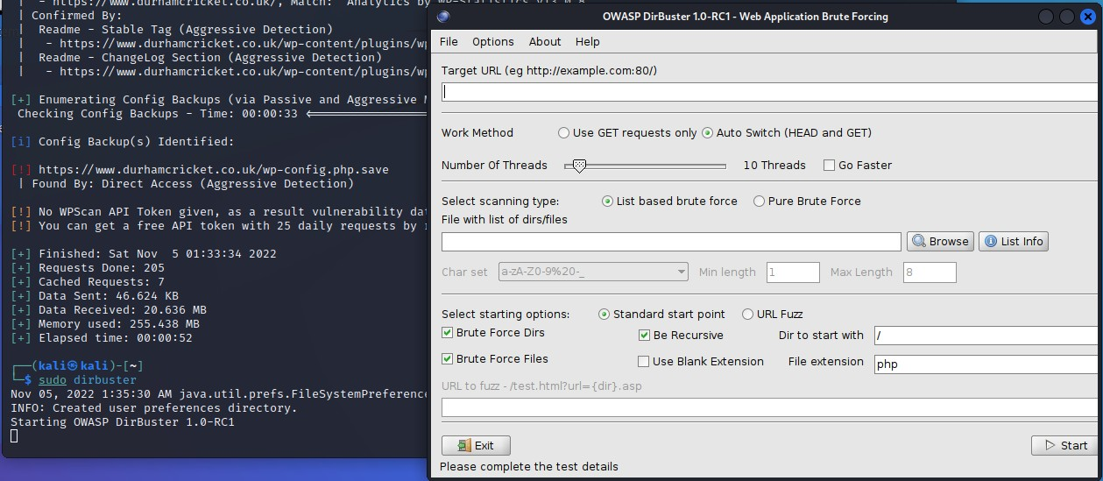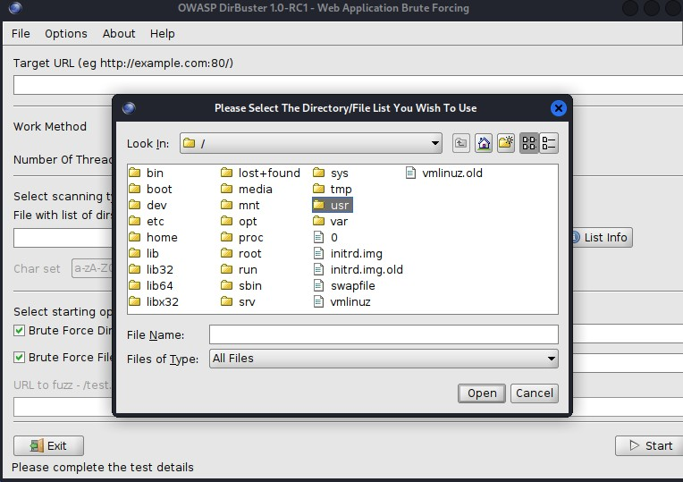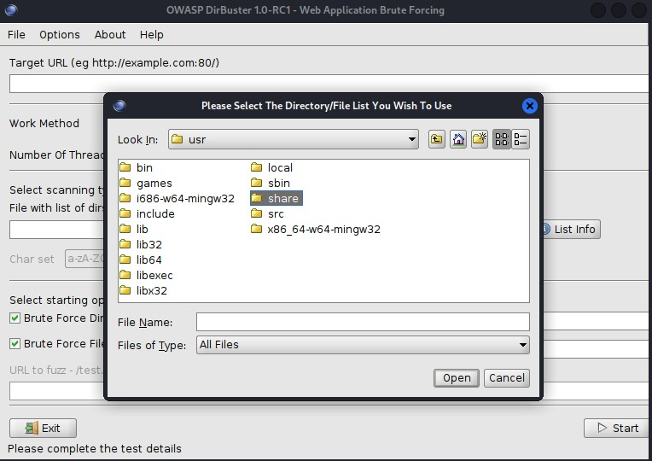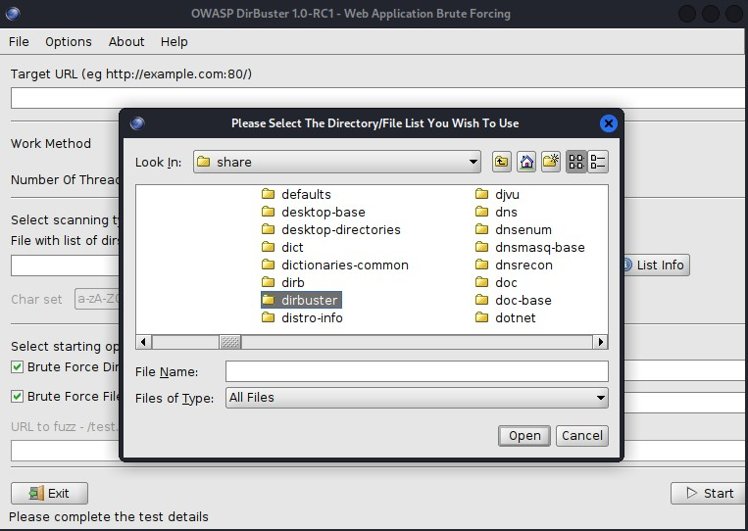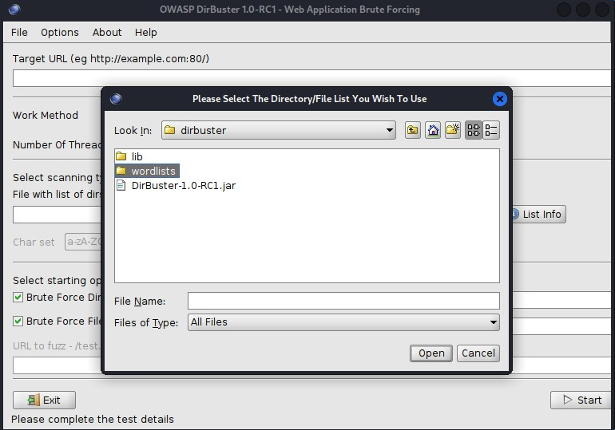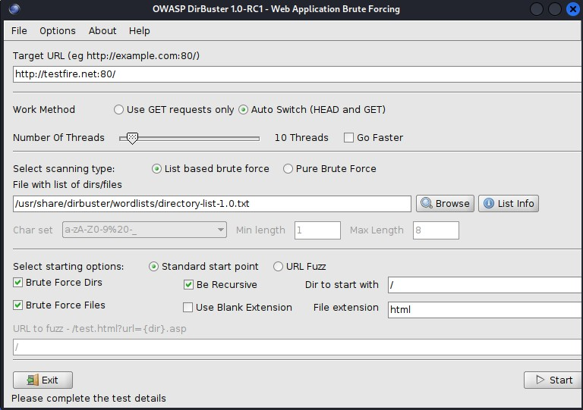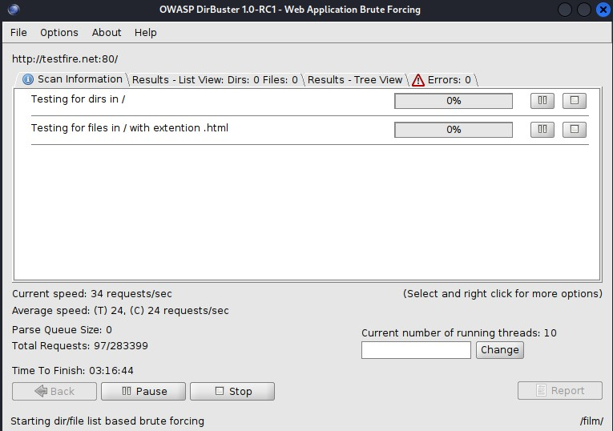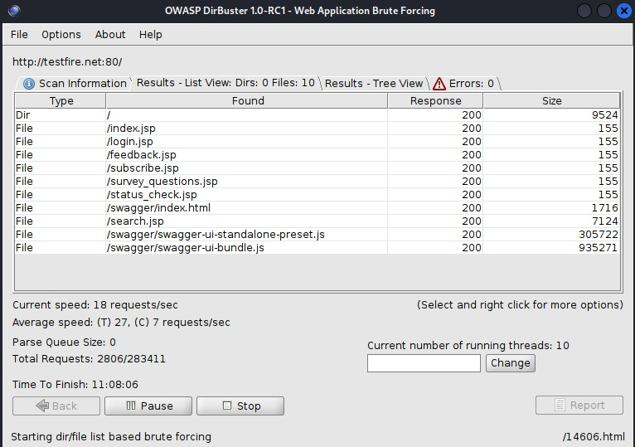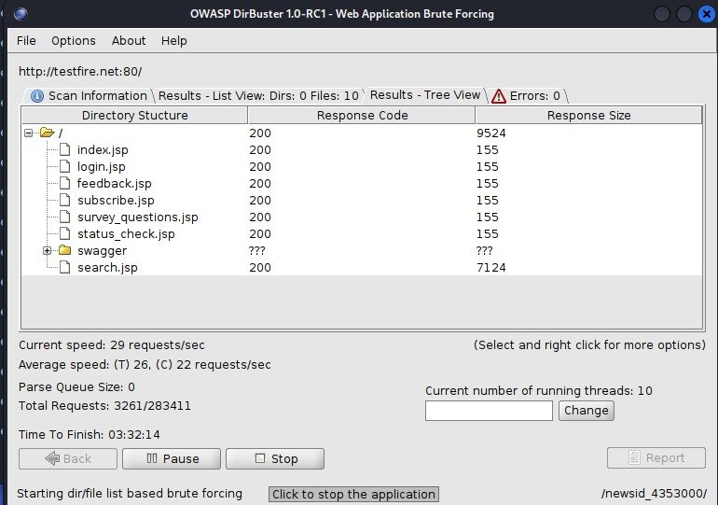

1. **Mirroring a website from the command line**

Here we will use HTTRACK, which is a n open-source web-crawler that can completely clone a website along with all its directories and its overall file structure.

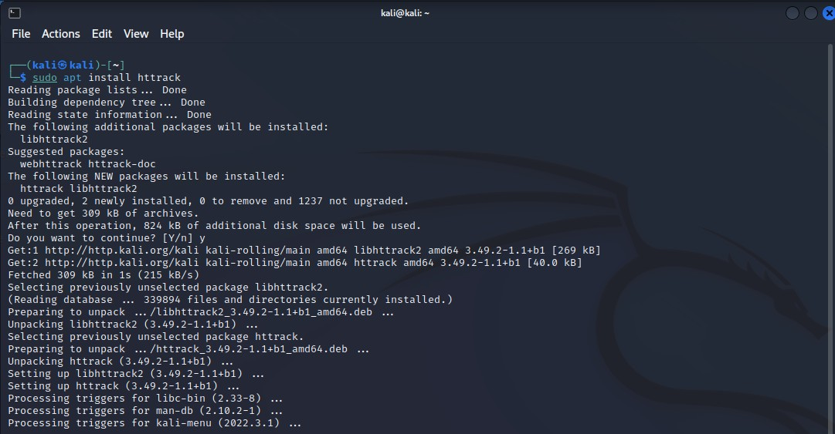

Since this tool is not a part of Kali Linux, we will have to install it.

Then we will copy our target website [www.testfire.net](http://www.testfire.net/) by using this tool and will save it on our machine under the directory copied_site.

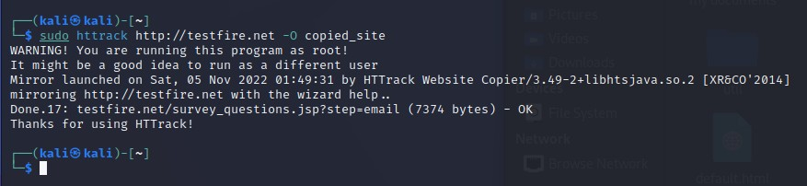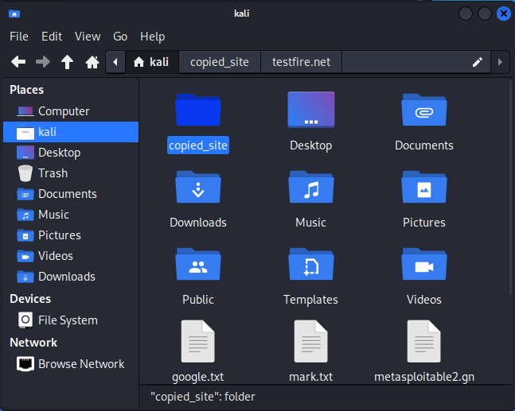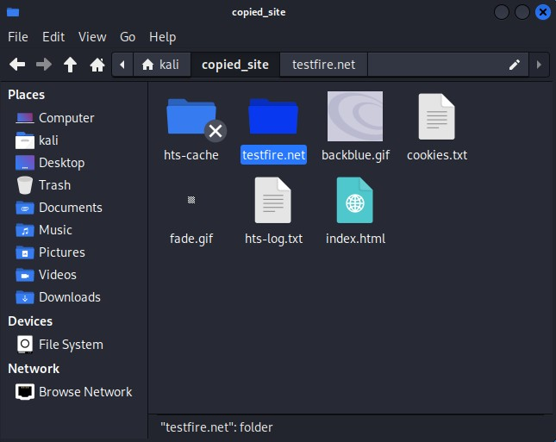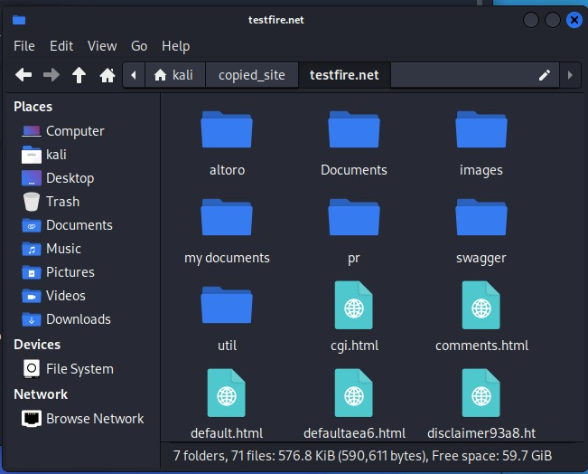

1. **Now will use Burp Suite to perform reconnaissance and exploits.**

We can access it in the start window of Kali Linux since it comes pre-installed.

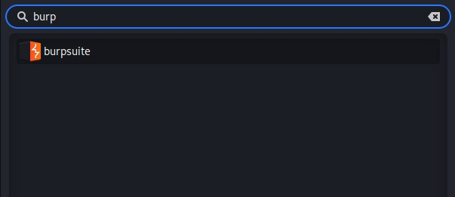

Next we will create a temporary project.

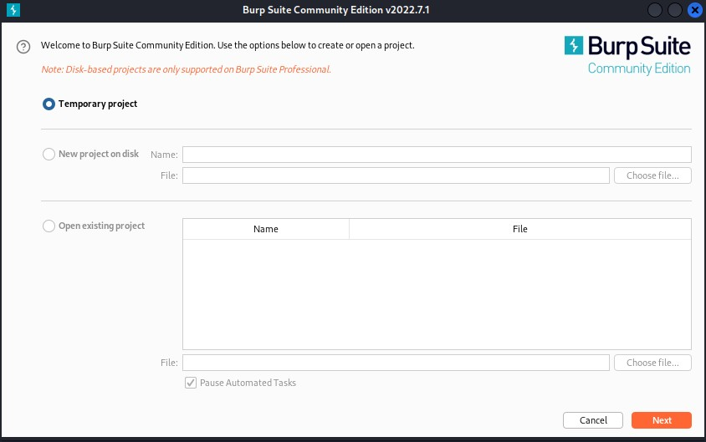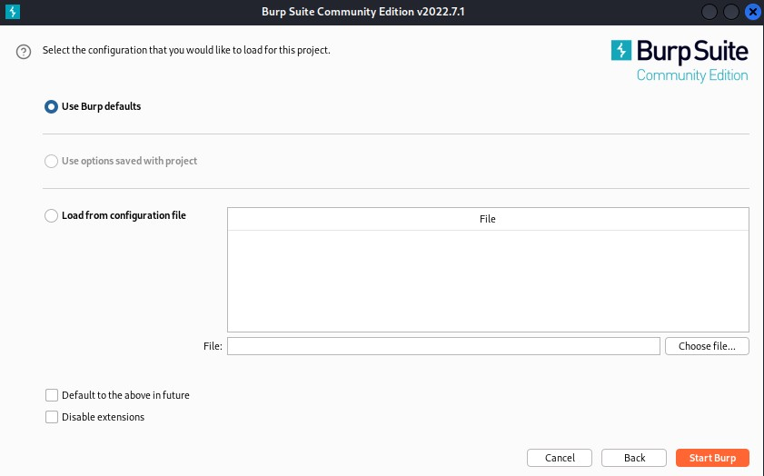

Then will perform a passive crawl through our target website. Here our target website is “www.testfire.net”. To perform the passive crawl, we have to navigate to the “Target” sub-menu access the in-built browser on the “Sitemap”. We enter our target website into the in-built browser.

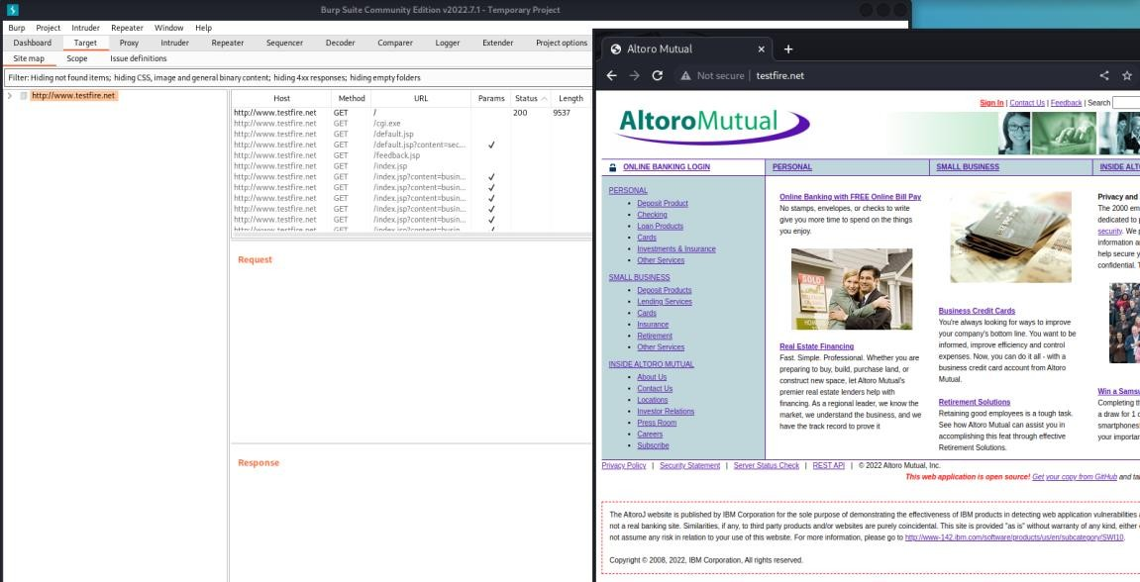

We will start to see the traffic, or the requests being issued on the website in the SiteMap.

Then we can add the target website to our scope to continue tracking its traffic.

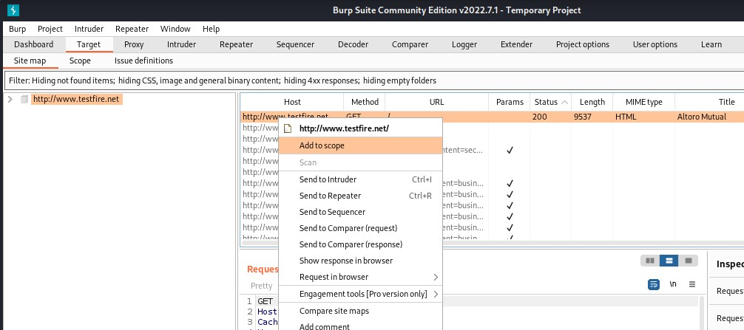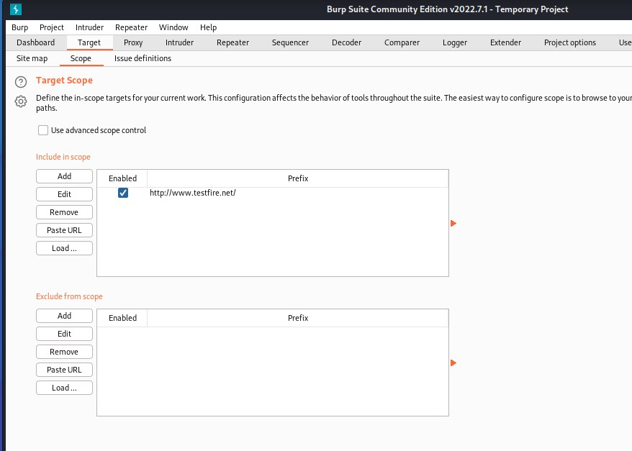

We can also create our own customized passive crawlers by using the following steps.

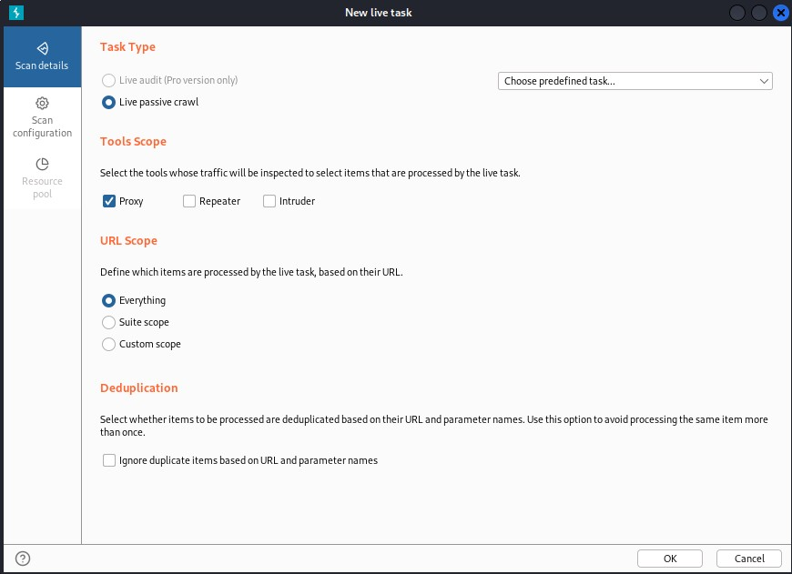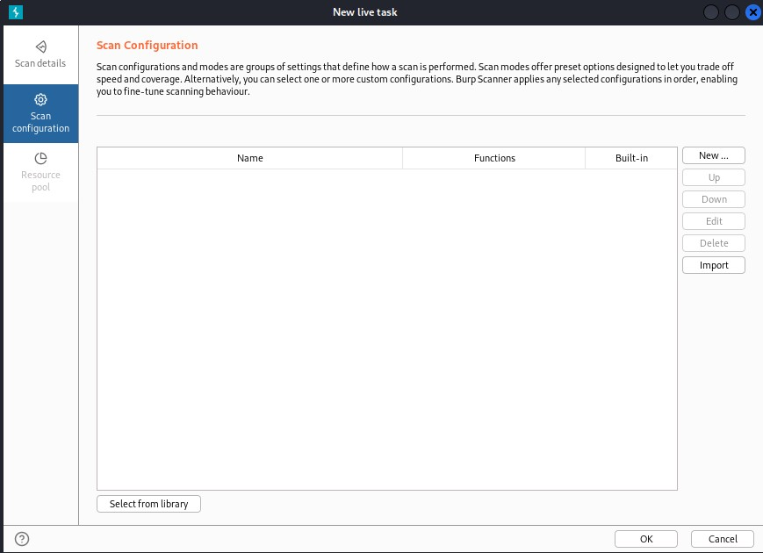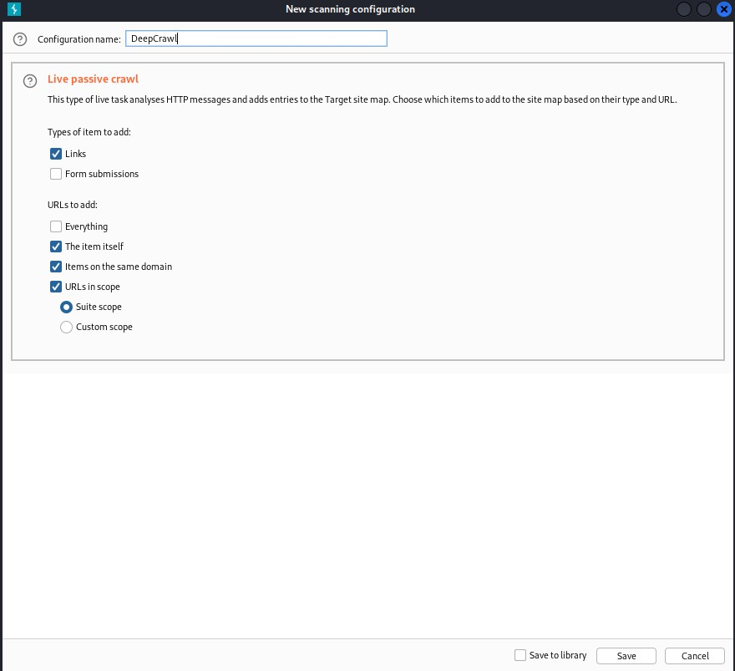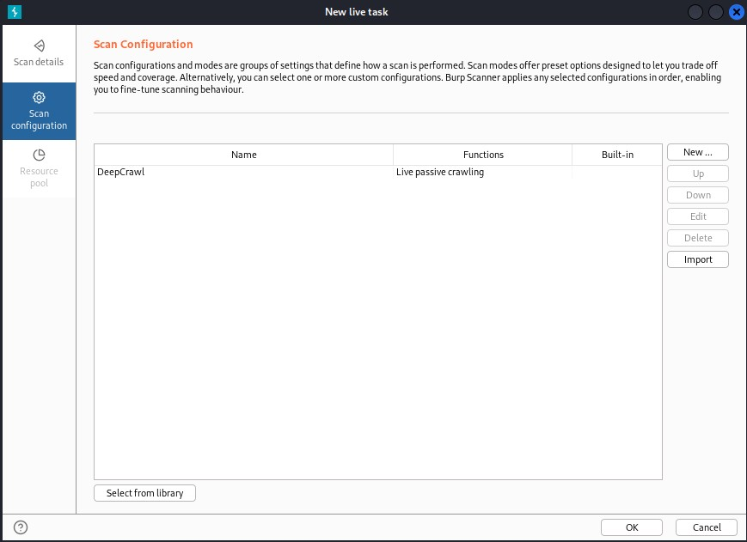

Next we perform an intercept on the target website to capture the data being input by its users. We will have to navigate to the “Intercept” tab under the “Proxy” tab. Here you will firstly open the target website in the in-built browser, then you will turn on the Interceptor.

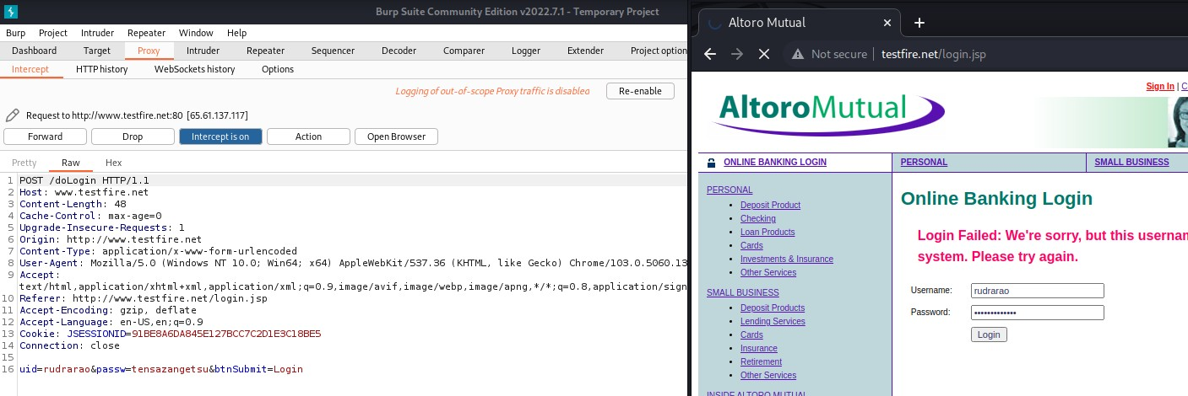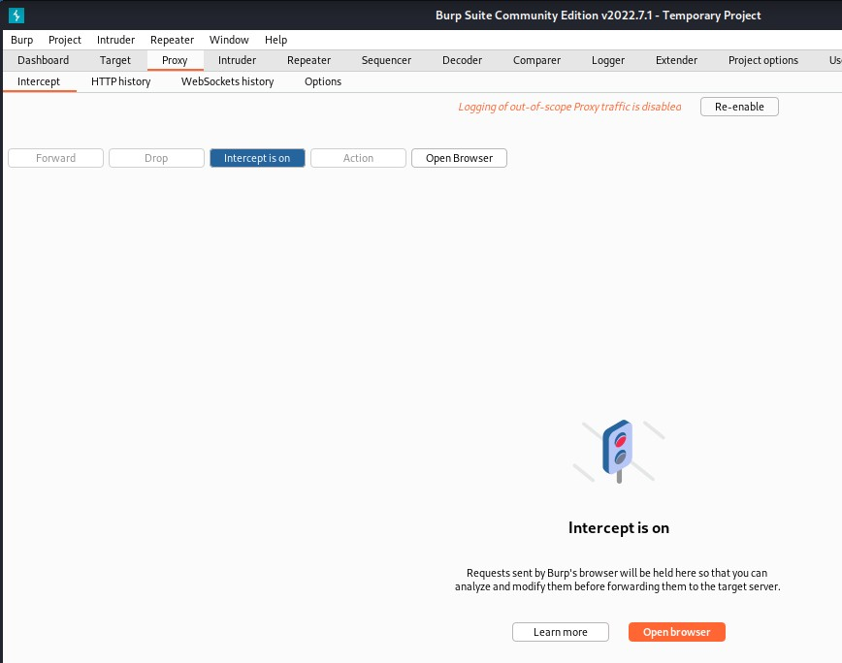

What you see below is the intercepted input of the user on the website. We can see what they have entered on their login page.

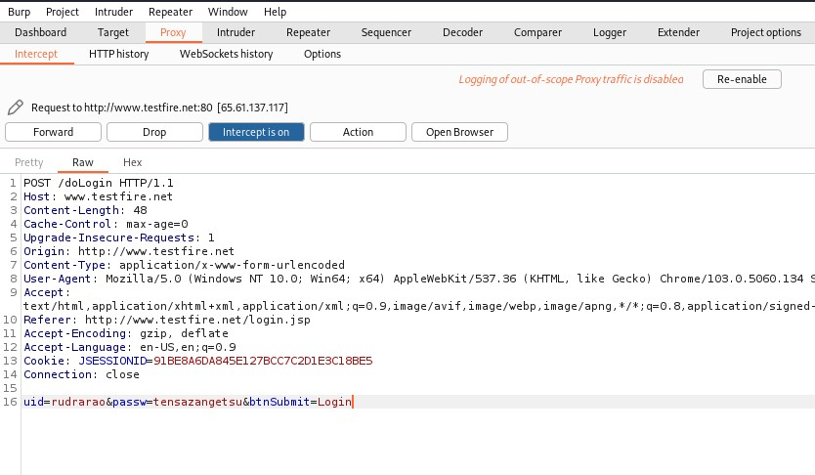

Next we will try to perform SQL Injections using Burp Suite.

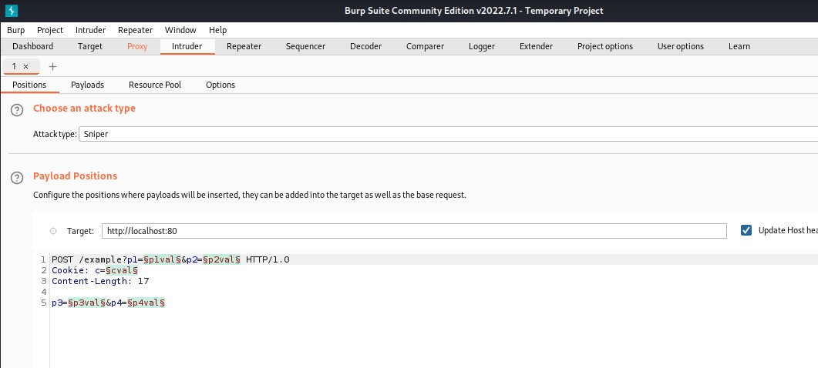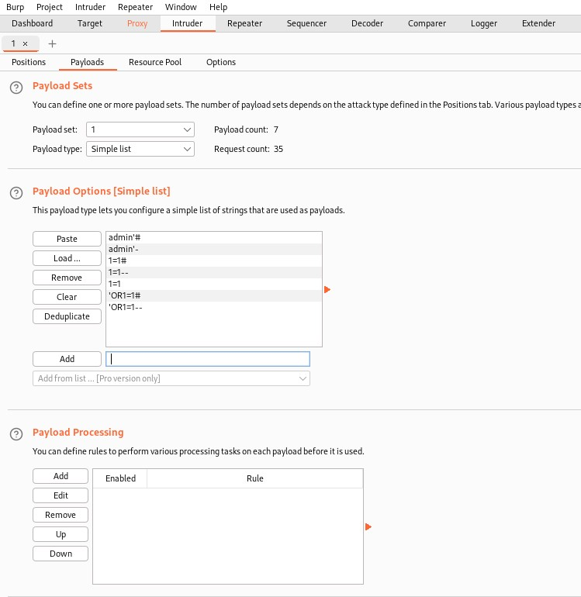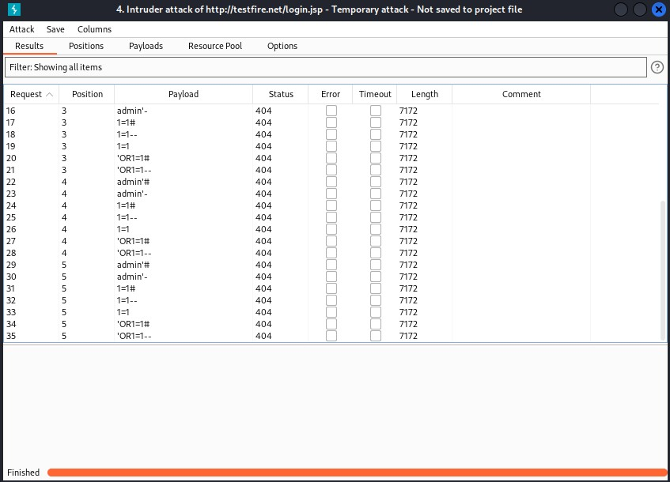

**4. SQL Injection using DVWA:**

Here we will clone the DVWA(Damn Vulnerable Website Application) from its GitHub page. We can use DVWA to target vulnerable websites and perform SQL injection on them.

To perform DVWA SQL Injection, perform the following steps.

Here we clone DVWA from its GitHub repository and store it under “/var/www/html”.

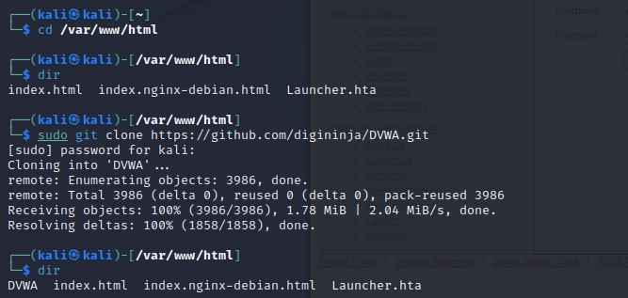

Then we create a copy of its config file.

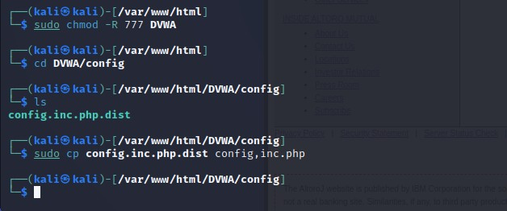

Then we will open the config file and make some changes. For db_user, we will put the SQL user, db_pass, we will put the user’s password, and for default_security_level, we will set it to low. Then we will click Ctrl+O followed by Enter to save the changes and then click Ctrl+X to exit the config file.

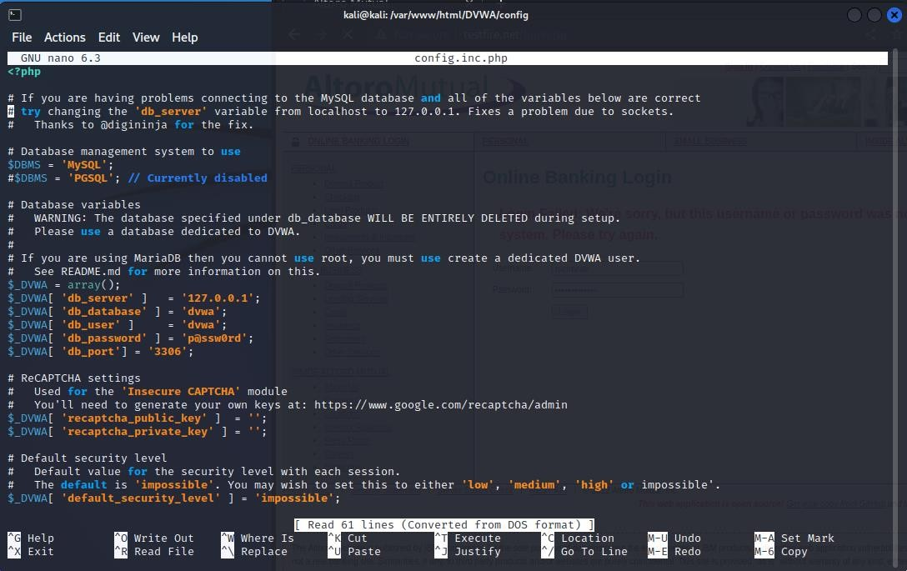

Next we will access our MySQL database, in this case we will use MariaDB. Here we will create our user that was mentioned in the previous step, followed by granting that user will all the privileges of the database.

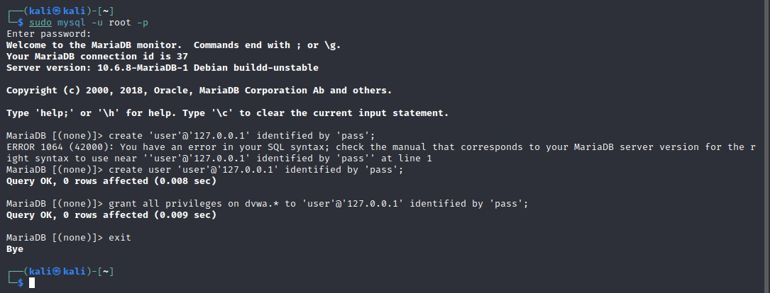

Next we will check if our apache2 server exists, and if it is up to date. Then we will access the php.ini file and will make some changes to the server settings.

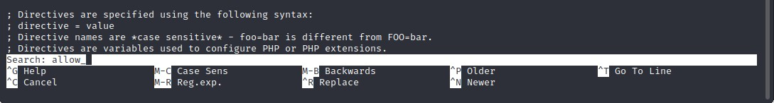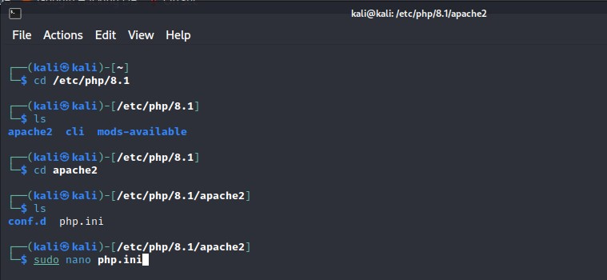

In the file, we will search for “allow_” by clicking Ctrl+W followed by the text, followed by pressing the Enter key.

Here we will set the “allow_url_fopen” and “allow_url_include” to On.

Then we will press Ctrl+O to save the changes and Ctrl+X to exit the file.

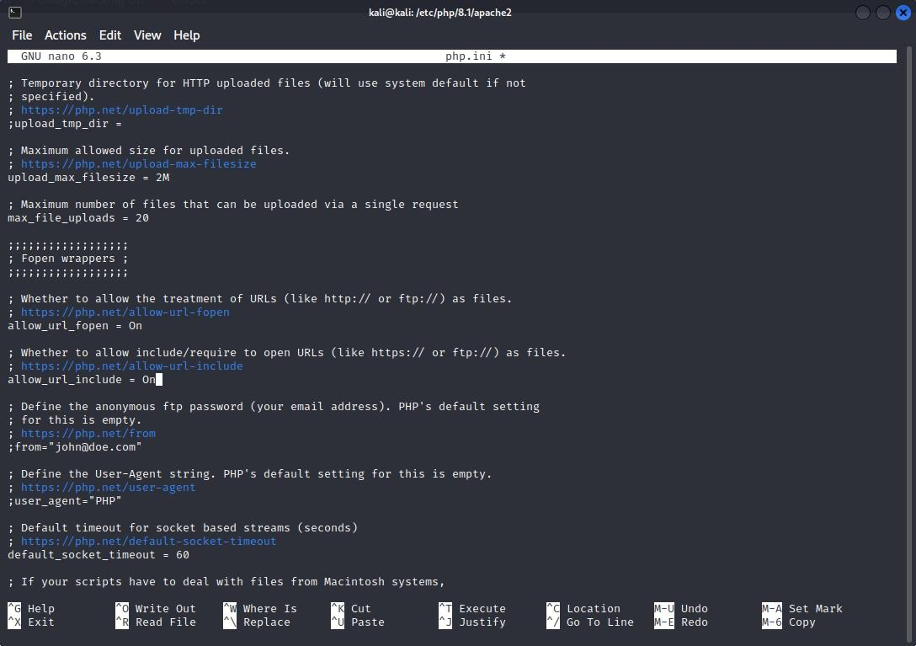

Then we will start MySQL followed by the apache2 server.

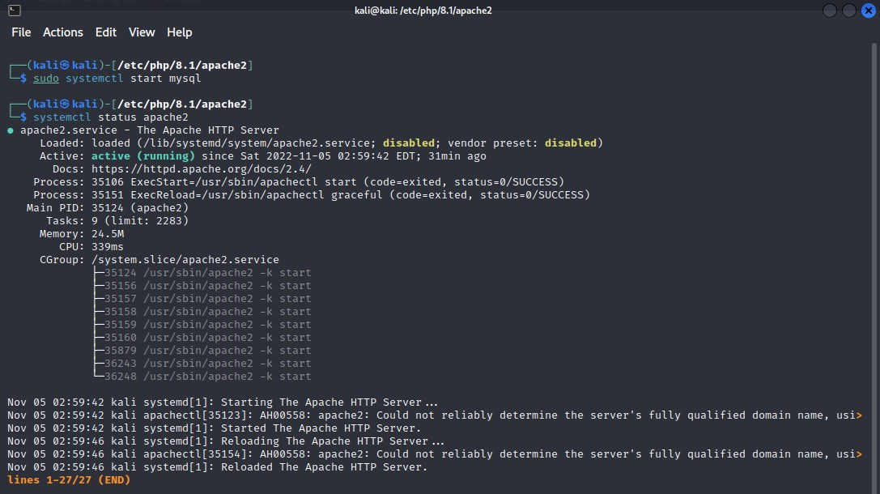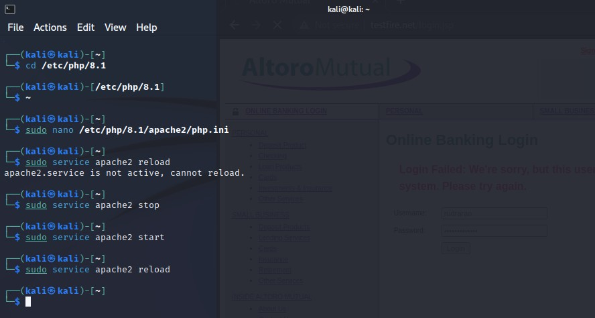

Then we will open our browser and navigate to the page on “127.0.0.1”.

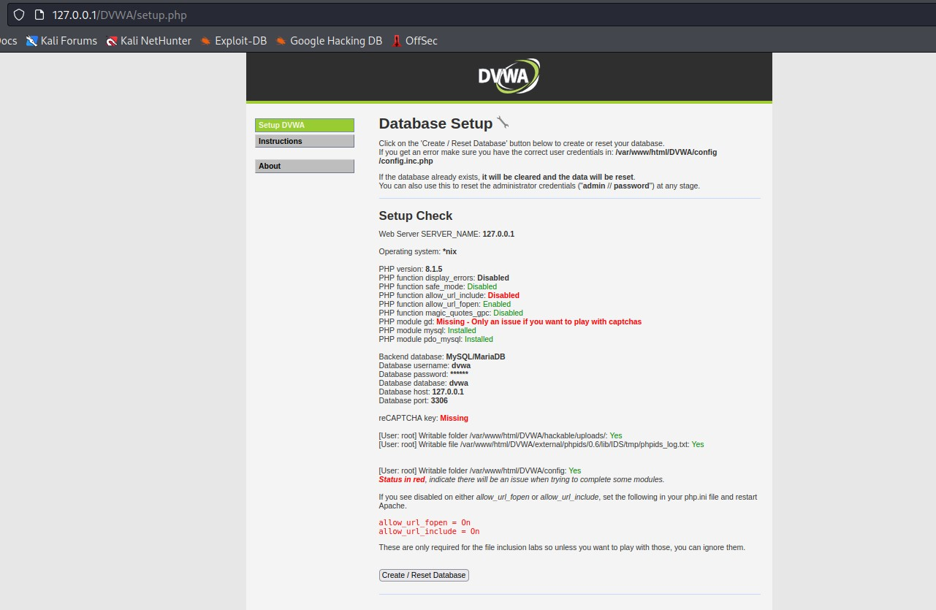

After creating the database, you will be redirected to a login page where you will enter the username – “admin” and the password – “password” to access the site.

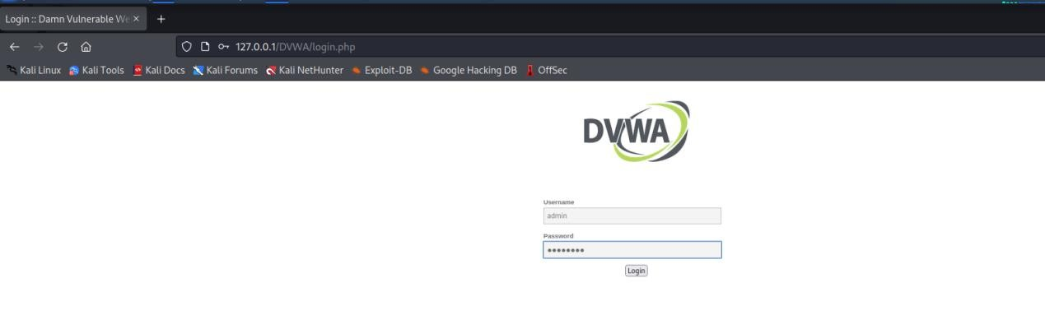

Then you will be redirected to the Home page. Over there you will have to initially lower the security under the DVWA security tab. Then you will head over to the SQL Injection tab.

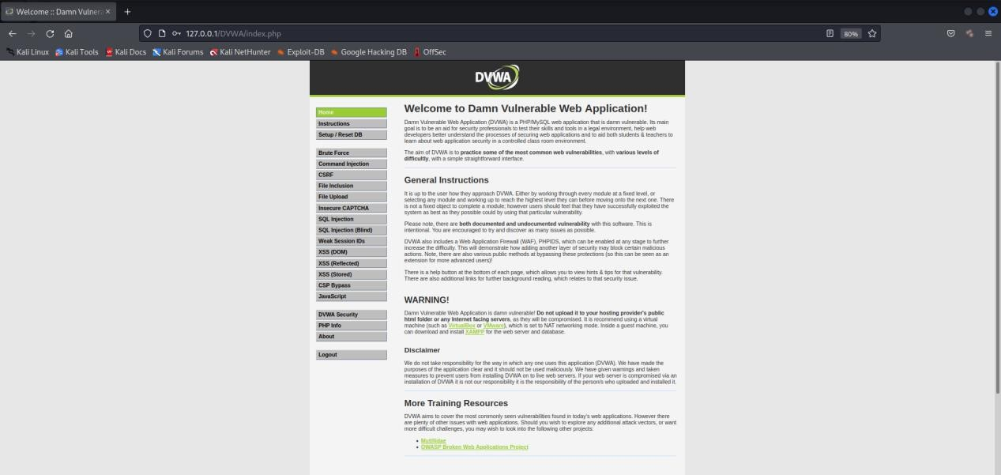

Here you can enter the injection payload for the User ID on the database.

Here we enter the payload 1=1.

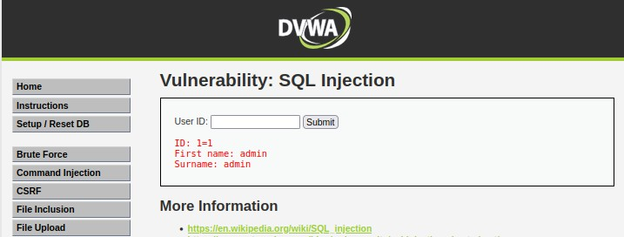

Here we enter the payload 1=1--.

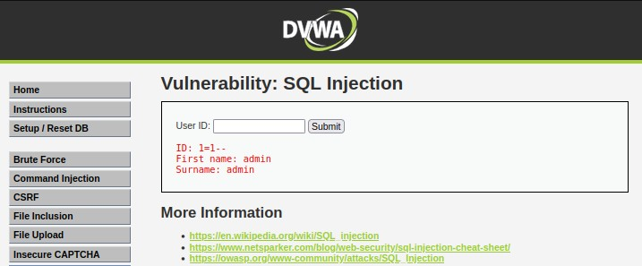

Here we enter the payload

2

.

Here we enter the payload

%

’

or

’

0

’

=

’

0

.

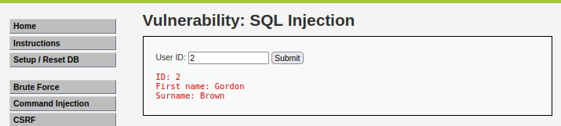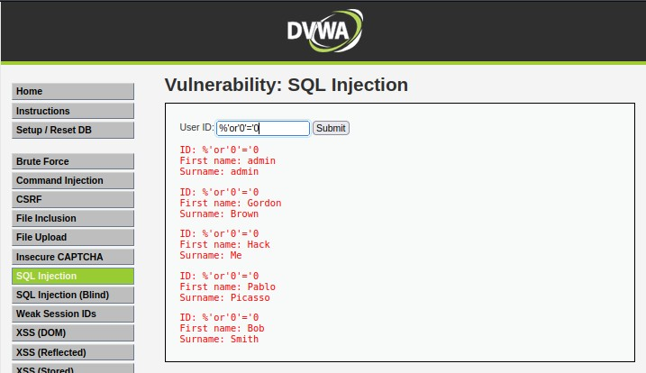

Here we enter the payload %' or 0=0 union select null, user() #.

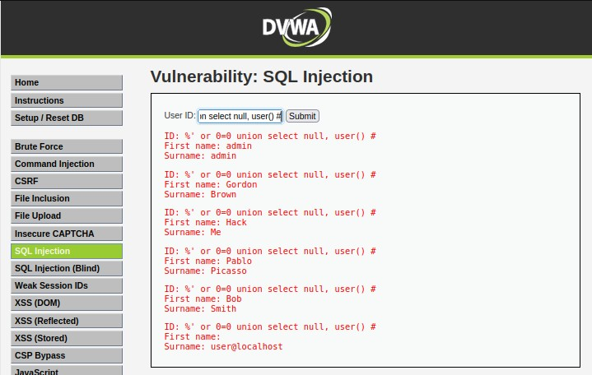

Here we enter the payload %' and 1=0 union select null, tablename from information_schema.tables #.

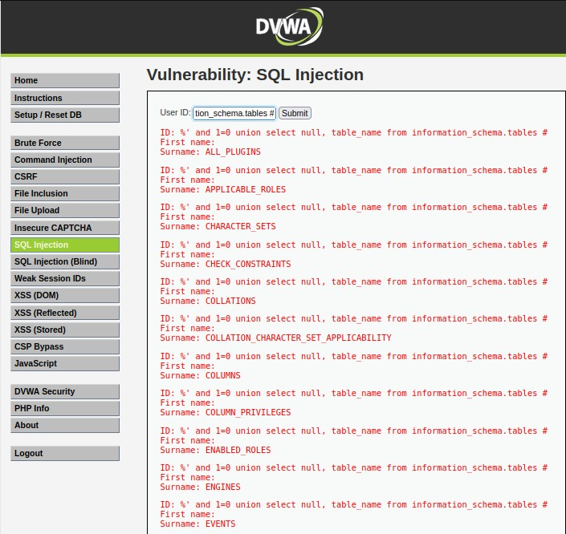

**Practical 7**

**Aim: Practical on Using Metasploit Framework for exploitation**

1. **Access Metasploit and Exploits:**

Here we are checking whether if we can access Metasploit on Kali Linux. We will use the command “sudo msfconsole”.

2.

Initialize the

Metasploit Database

.

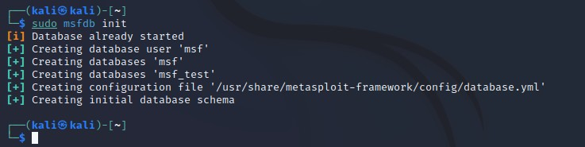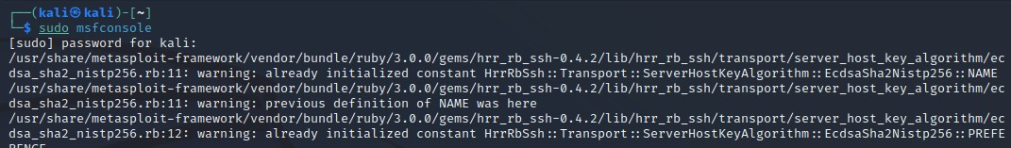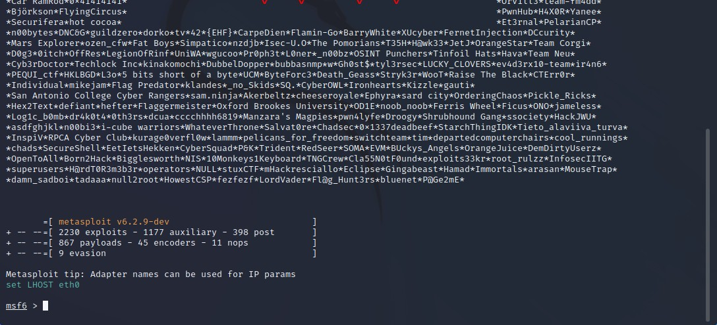

1. **Database setup and configuration**

1. Start PostgreSQL by running “sudo systemctl start postgresql.service” in the terminal. We will also use the command “sudo systemctl status postgresql.service” to check whether the database is running.

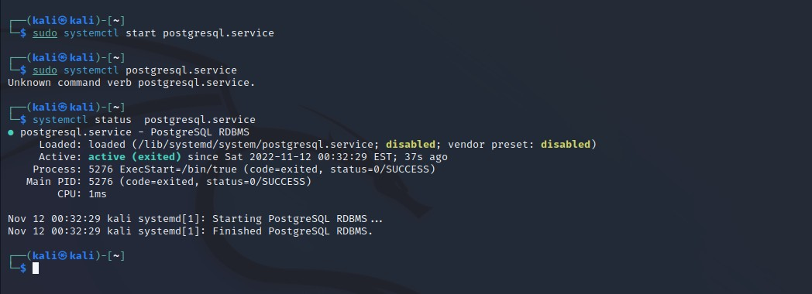

1. Now you are ready to access the msfconsole
2. Once you are inside the Metasploit console, you can use the command “db_status” to check whether your database is connected to Metasploit.

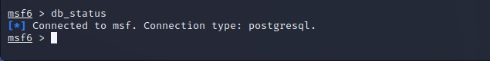

1. In case of multiple targets, you can create a workspace which will help keep the exploits that you run on your targets separate and will prevent any further complication.

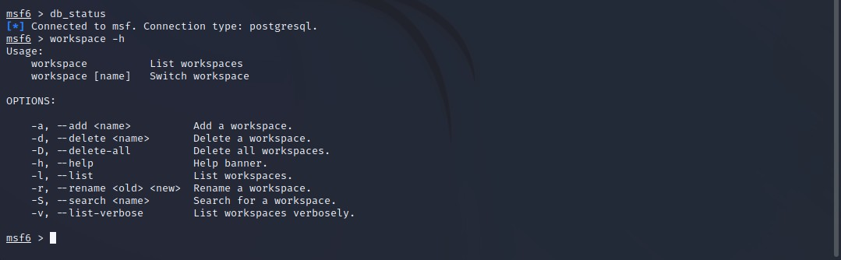

Here we are going to use the “Fourthedition” workspace to conduct our exploits.

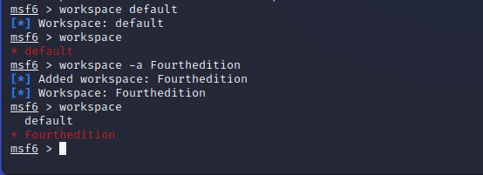

1. The following example represents a simple **Unreal IRCD** attack against the target

Linux-based operating system. When installed as a virtual machine. Metasploitable3 Ubuntu running on 192.168.37.130 which can be scanned using the “db_nmap” command, which identifies open ports and associated applications.



Here when the “--save” command is used, the output is saved under the /root/.msf4/local/ folder.

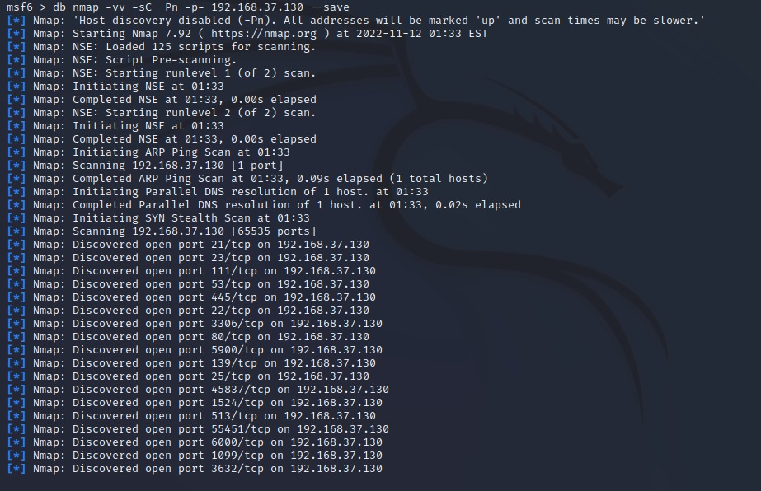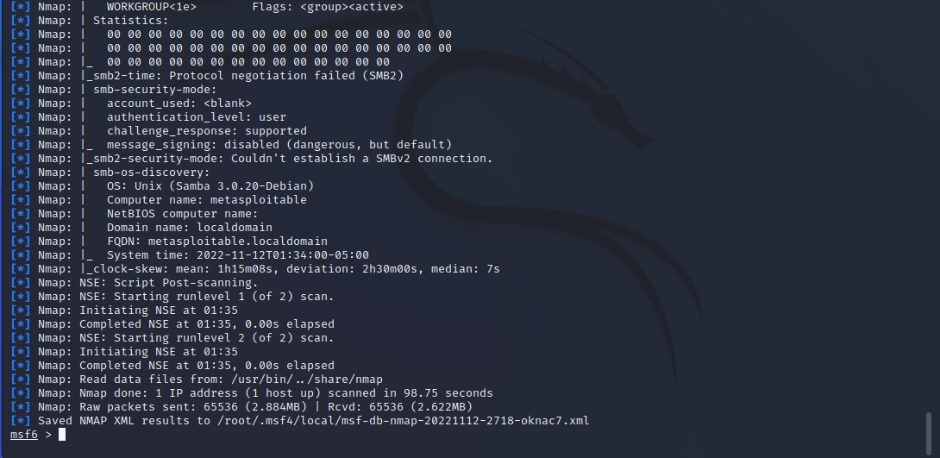

1. As a tester, we should investigate each one for any known vulnerabilities. If we run the services command in the msfconsole, the database should include the host and its listed services. We can use the “services” command to see all the running services and their network details.

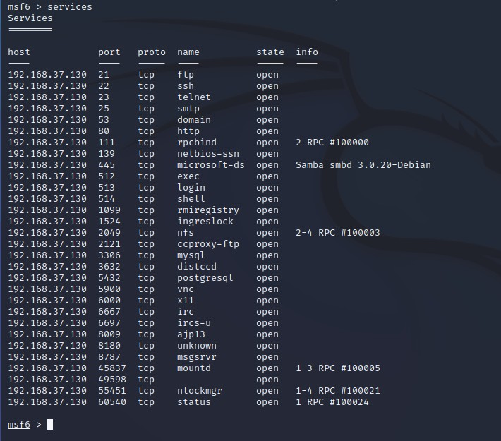

1. UnrealIRCd service:

Here we will search for the exploit UnrealIRCd by using the command “search UnrealIRCd”. The unix/irc/unreal_ircd_3281_backdoor exploit was used as Metasploit deems the exploit to be excellent for our task.

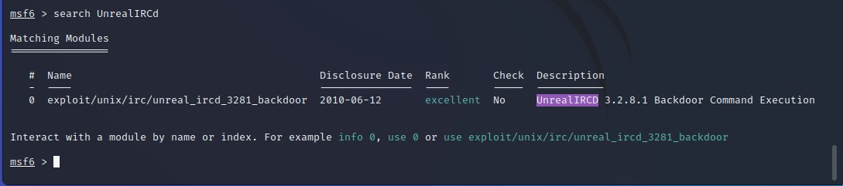

1. Additional information on the exploit can be found using the “info” command followed by the exploits index number.

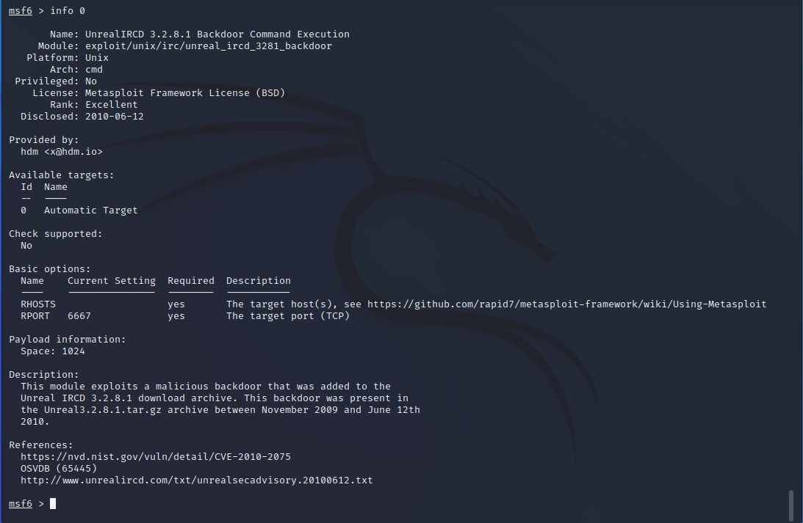

1. We should initially find the network configuration of our system as well as the target system before we conduct the attack. We can achieve this by pinging the target system and checking if get any response.

For Kali

:

For our Target(

Metasp

loitable Linux

)

:

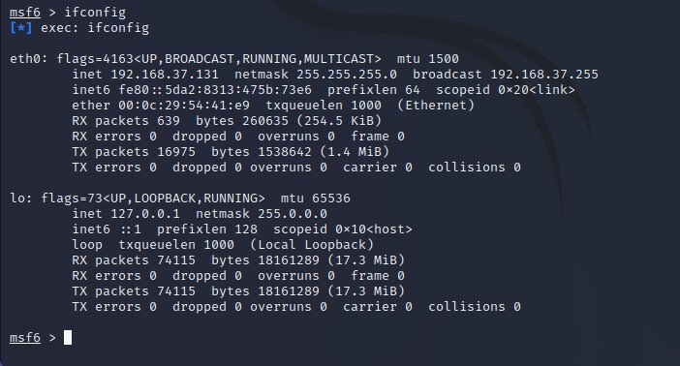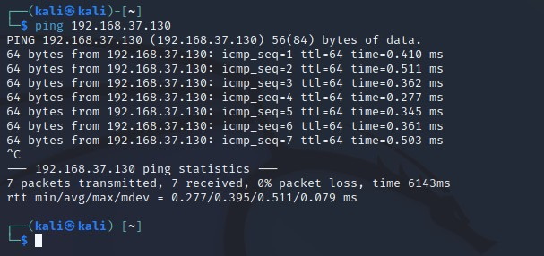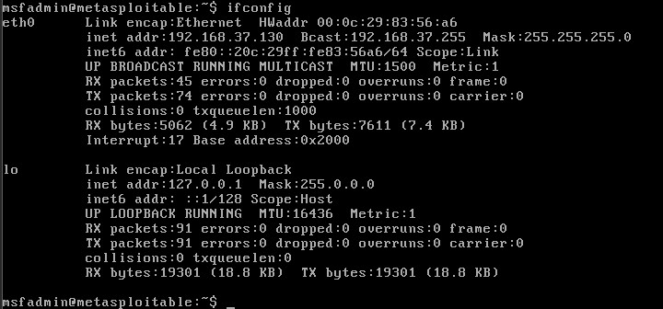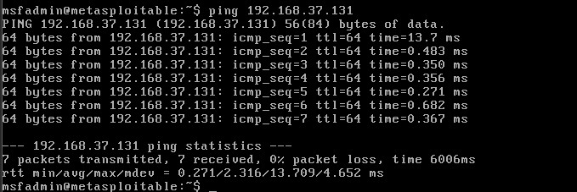

1. To instruct Metasploit we will attack the target with this exploit, we will issue the following command: “use exploit/unix/irc/unreal_ircd_3281_backdoor”. Metasploit will change the prompt from “msf” to “msf exploit(unix/irc/unreal_ircd_3281_backdoor)”.

Metasploit will prompt the tester to select the payload (i.e., a reverse shell from the compromised system back to the attacker) and sets the other variables like:

* + Remote host (RHOST): This is the IP of the system being attacked. Here our target system is Metasploitable Linux whose IP is “192.168.37.130”.
  + Remote port (RPORT): This is the port number that is used for the exploit. In our case the port number used is “6697” as there was another service running on port “6667”.
  + Local host (LHOST): This is the IP address of the system used to launch the attack (i.e., our system). The IP address of our system is “192.168.37.131”. The attack will be launched using the “exploit” command. Here Metasploit will initiate the attack and will confirm a reverse shell between Kali Linux and the target system.

A successful attack will be indicated by the shell session that is created.

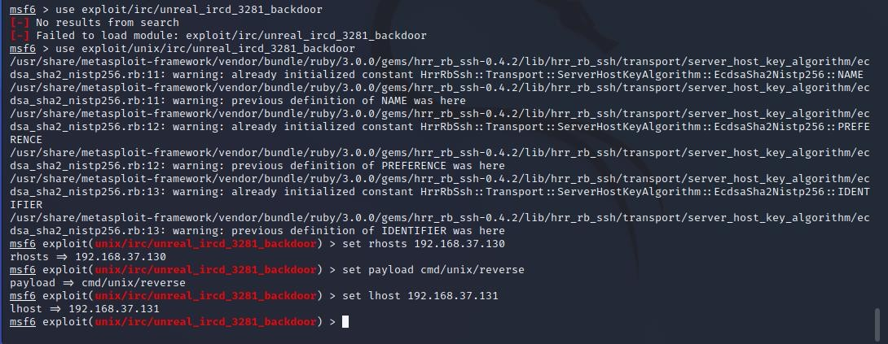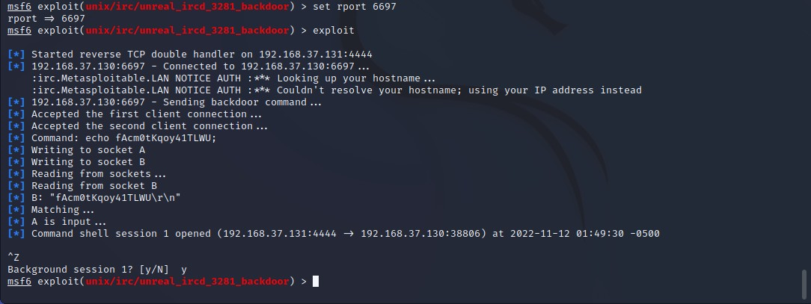

C. **Gaining Access to a Target Machine via a vulnerability**

1. Open Windows XP VM which will be our next target.
2. First we will find the network configuration our target system as well our own system and we will check whether the two systems can communicate using the ping command.

For Windows:

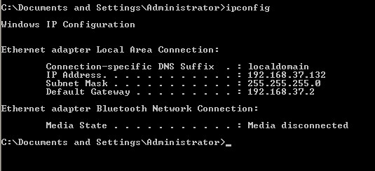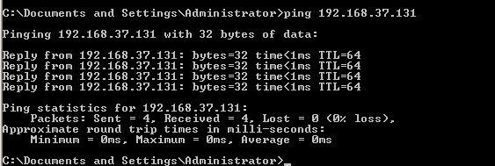

For Kali:

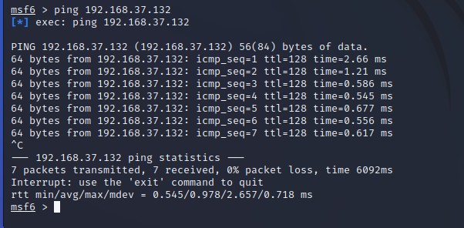

1. Set Kali Network to NAT and Tick checkbox, Restart Kali

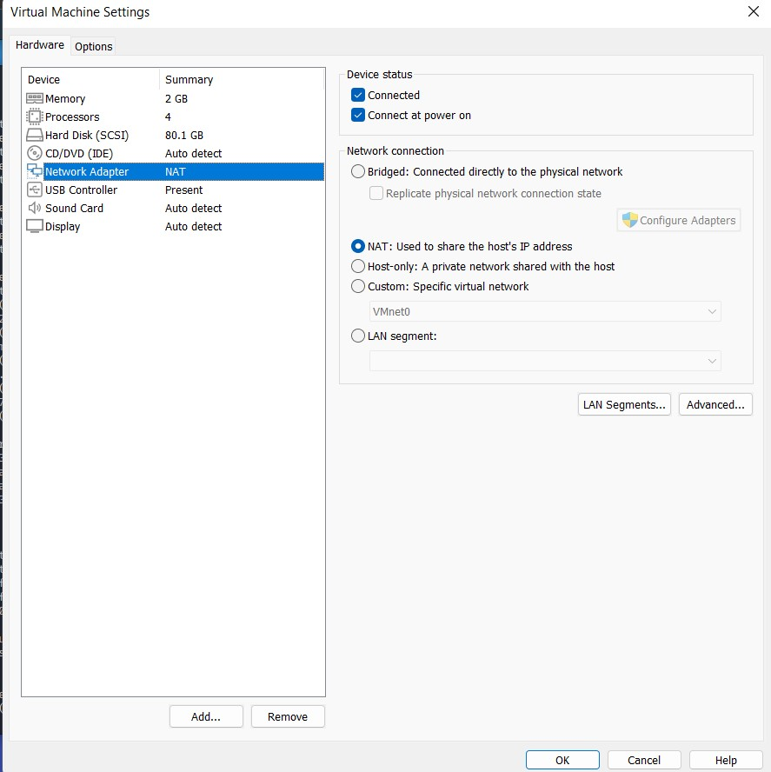

1. Set Windows to NAT, and restart Windows.

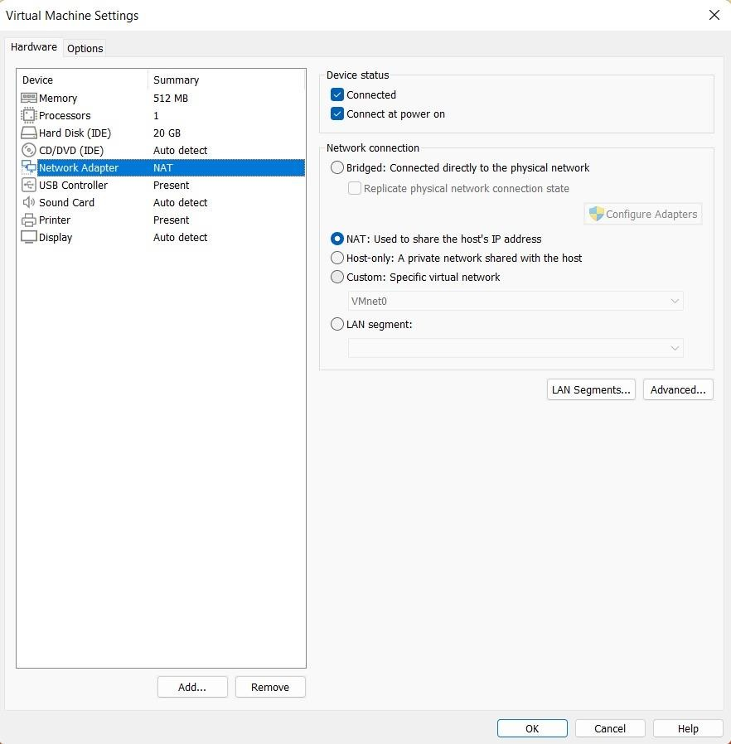

1. Go to the control panel in start and turn off the firewall

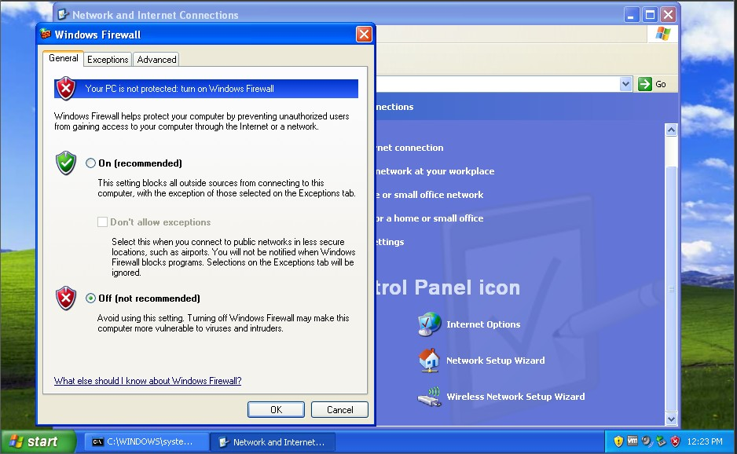

1. Run the “netdiscover” command to see the target machines IP.

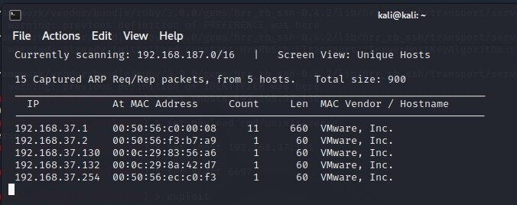

1. Go back to Kali and run the command “sudo msfconsole”

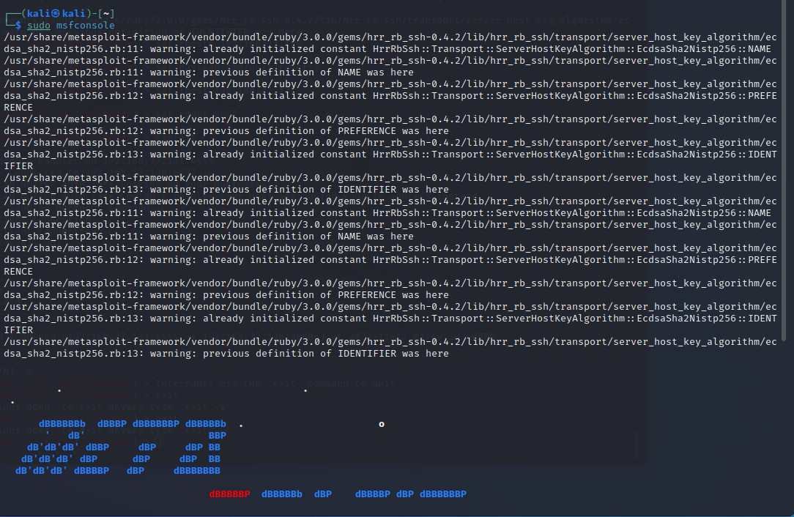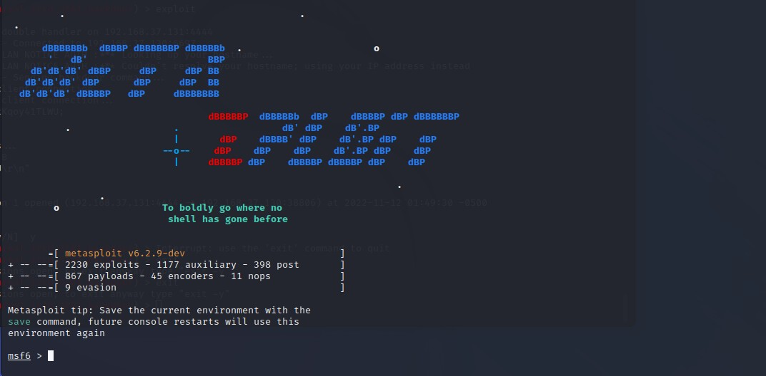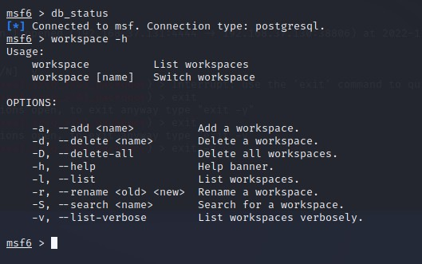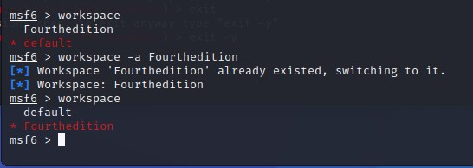

1. Search for the exploit “ms08_067_netapi”.

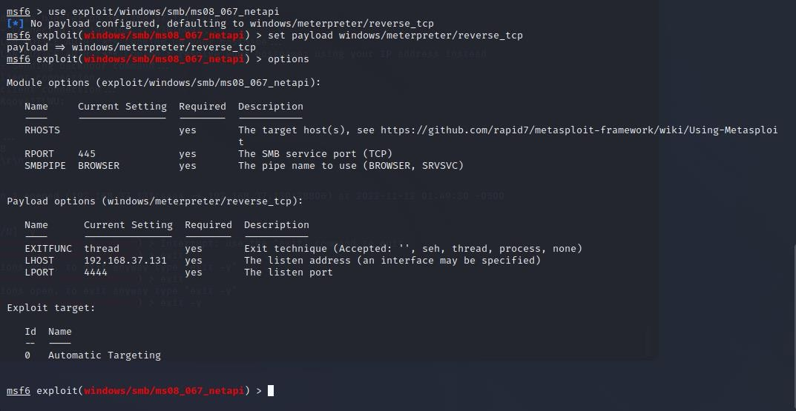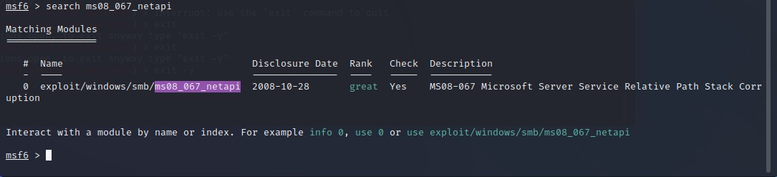

1. Then we will run the exploit “windows/smb/ms08_067_netapi”. Followed by the payload, which is a meterpreter reverse shell. We can also use the “options” command to see as to what we can do with our payload
2. Then we have to set the RHOST, LPORT, and the LHOST. After all the configuration has been done, we will use the command “exploit” to initiate the attack.

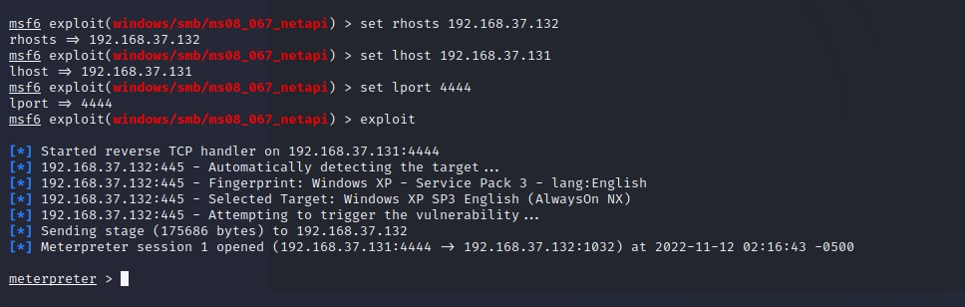

1. Once the attack is successful, you will be prompted with the meterpreter shell. Here we can use the command “sysinfo” to get the information about our target system

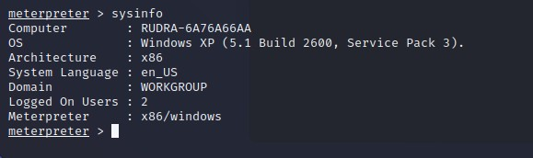

We can use the “shell” command to access the target systems shell, in this case it is the Windows XP CMD. Here we can execute “ipconfig” command to get the network configuration details of the target system.

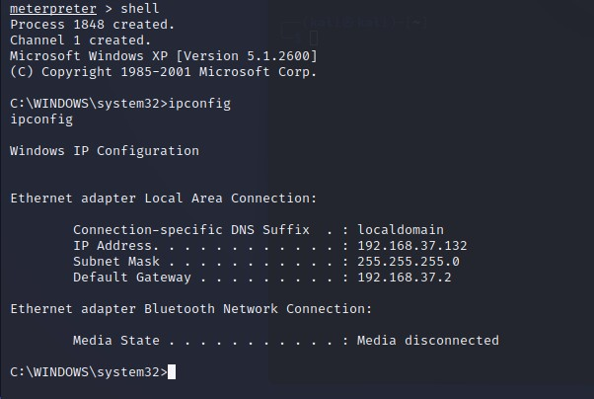

We can use the “dir” command in the target machine shell to see all the folders and files on the target machine.

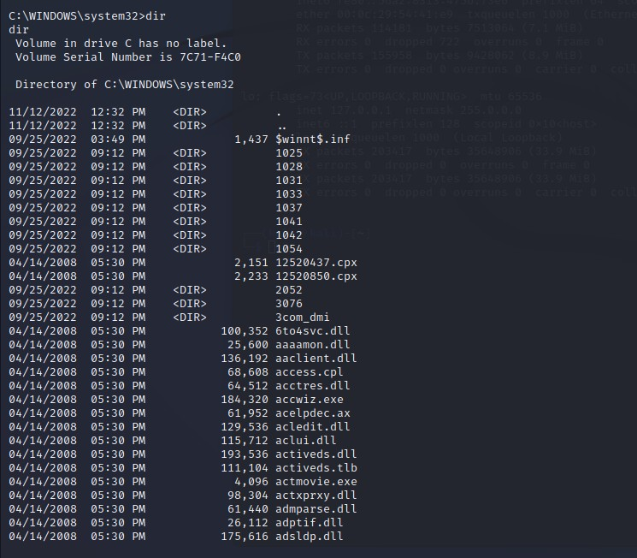

We can also use the “ps” command on the target machine shell to see all the active processes on the target machine.

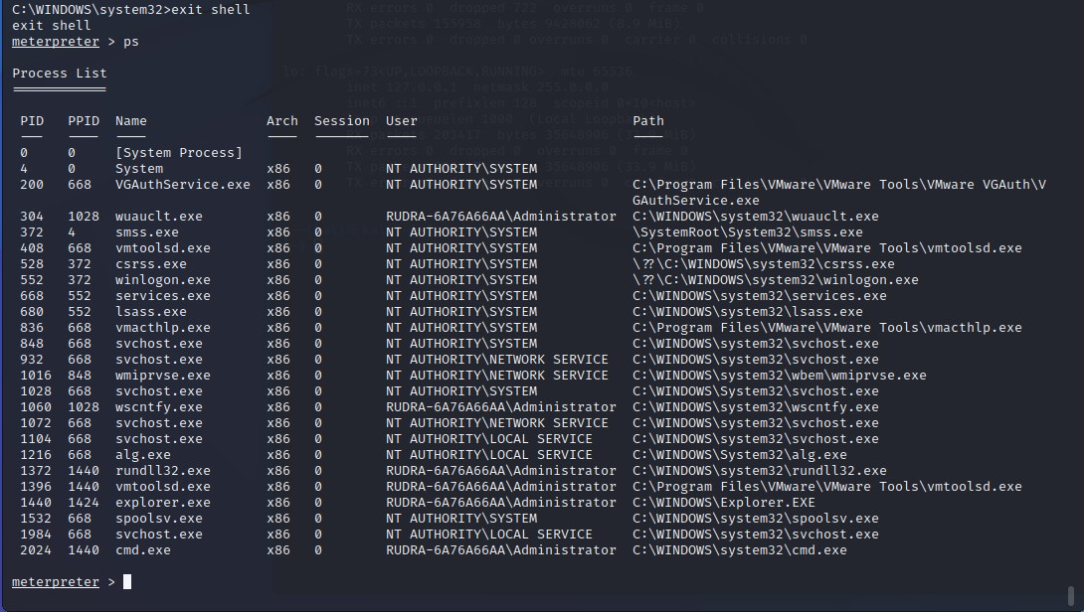

We can also use the “?” command on the Meterpreter CLI to see all the available commands that we can execute.

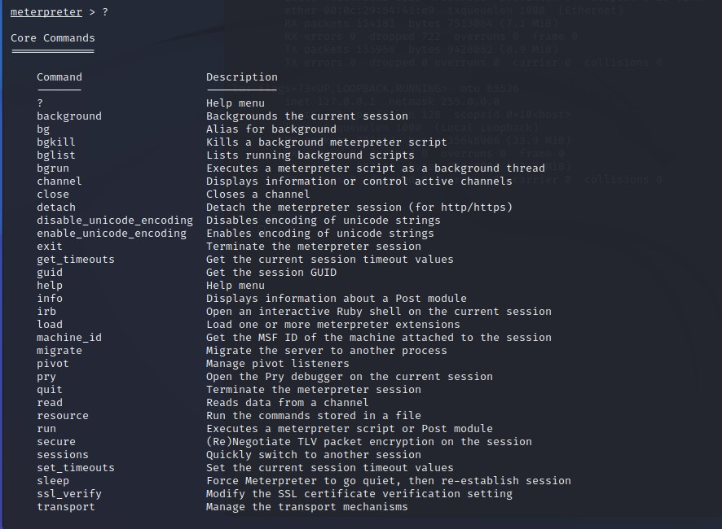

We can also take a screenshot of the target screen using the “screenshot” command on the Meterpreter CLI.

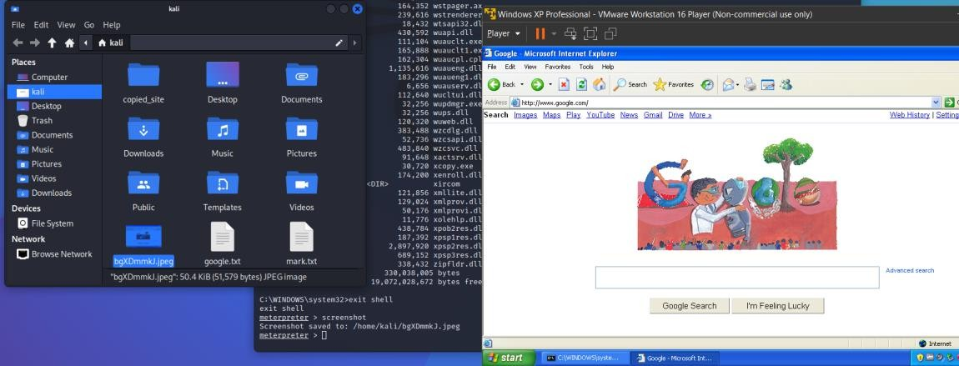

With the help of the “ps” command, we can use the commands like “suspend” and “kill” to remotely suspend and kill processes on the target machine. To perform the operation, we just need to use the command followed by the process id (pid).

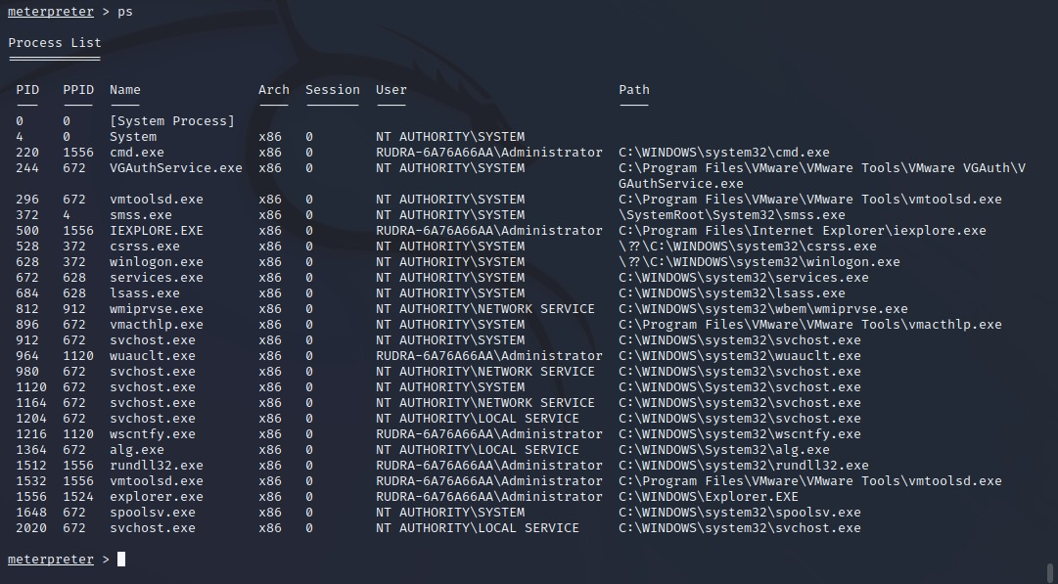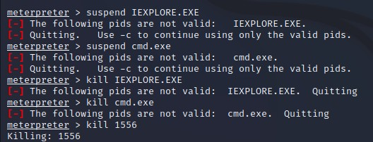

Here you can see all the processes on the target machine have been killed (i.e, terminated).

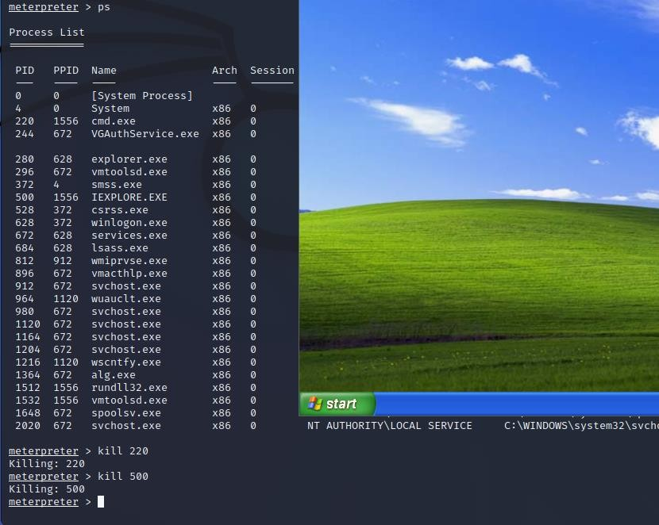

Finally, we can use the command “shutdown /s” on the target machines shell to remotely shutdown the target machine.

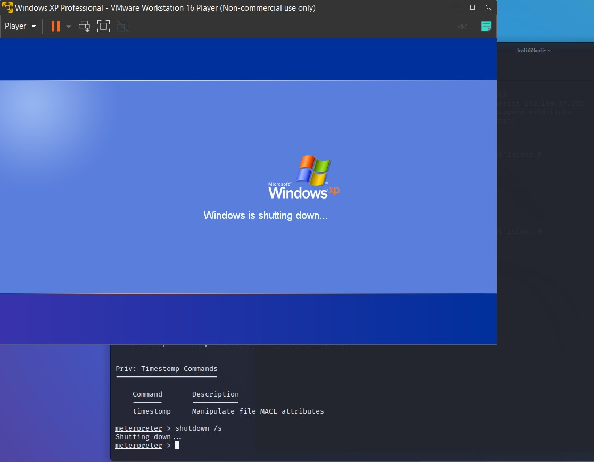

**Practical 8**

**Aim: Practical on Injecting Code in Data Driven Applications: SQL Injection A. Using SQLMap:**

1. Run metasploitable2 and Kali Linux and check the Ip address of metasploitable2.

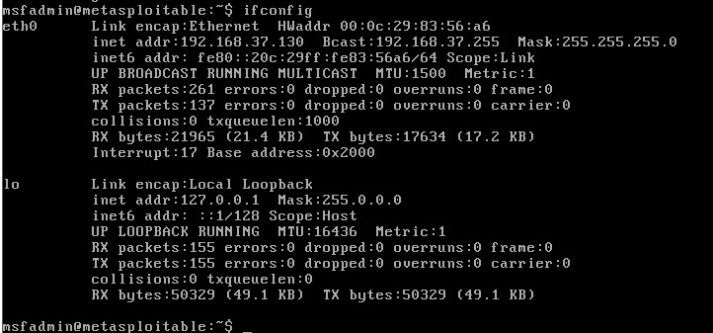

1. Type the metasploitable2 ip address (i.e., 192.168.37.130) on the browser to display all the vulnerable web applications that are available. Make sure your metasploitable2 network is bridged and matches the subnet of kali linux (Note, this is also possible on a NAT connection).

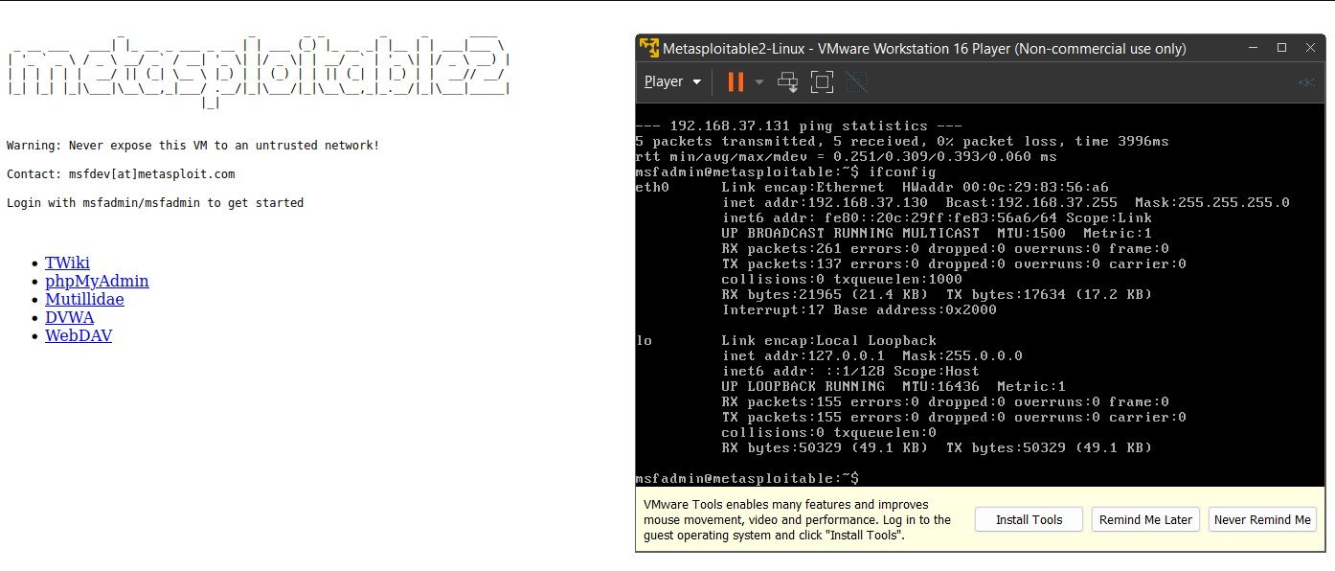

1. Select the Mutillidae option. On the Mutillidae page, click on the Login /Register Page.

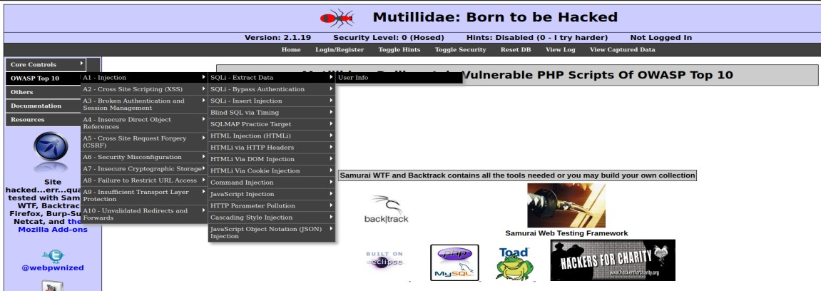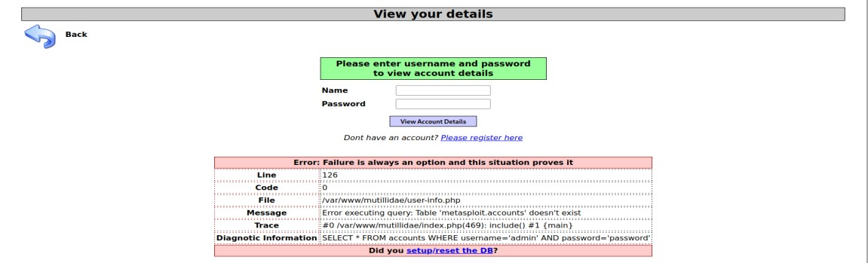

1. First we will run the command “sqlmap -h” to see all the available commands for sqlmap.

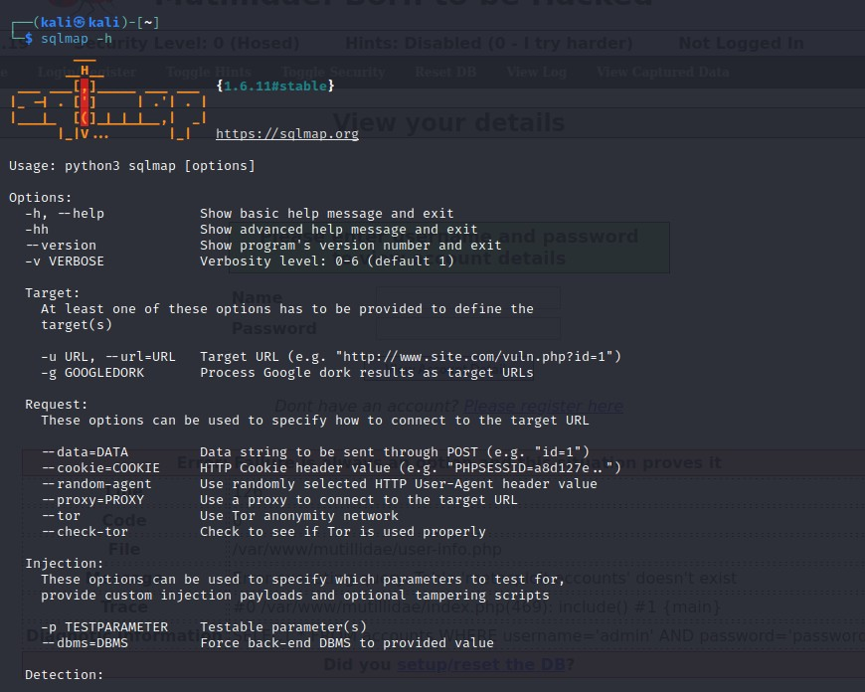

1. Now we will copy the link of the login page and run sqlmap in kali. We will use the command “sqlmap -u ‘the link of the login page’ –dbs –dump --batch”.

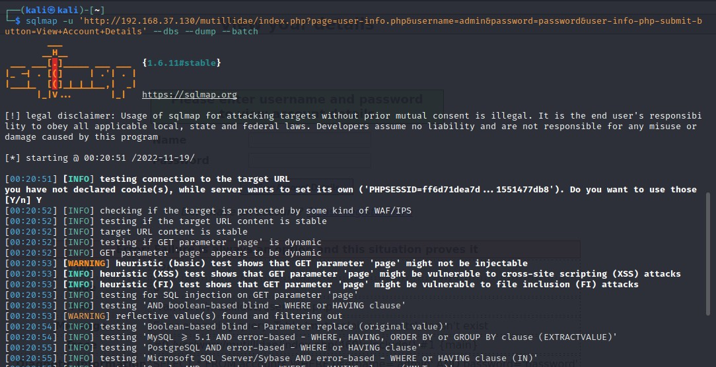

1. Type Y for all the Questions.

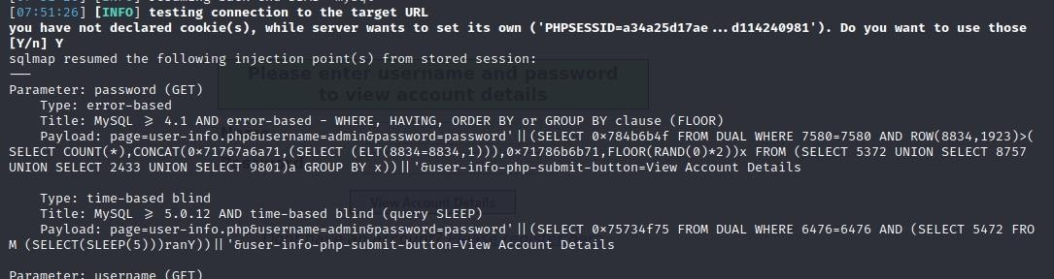

1. It will take quite a while for the process to complete as it is checking the vulnerabilities

8.

You will get the followin

g error.

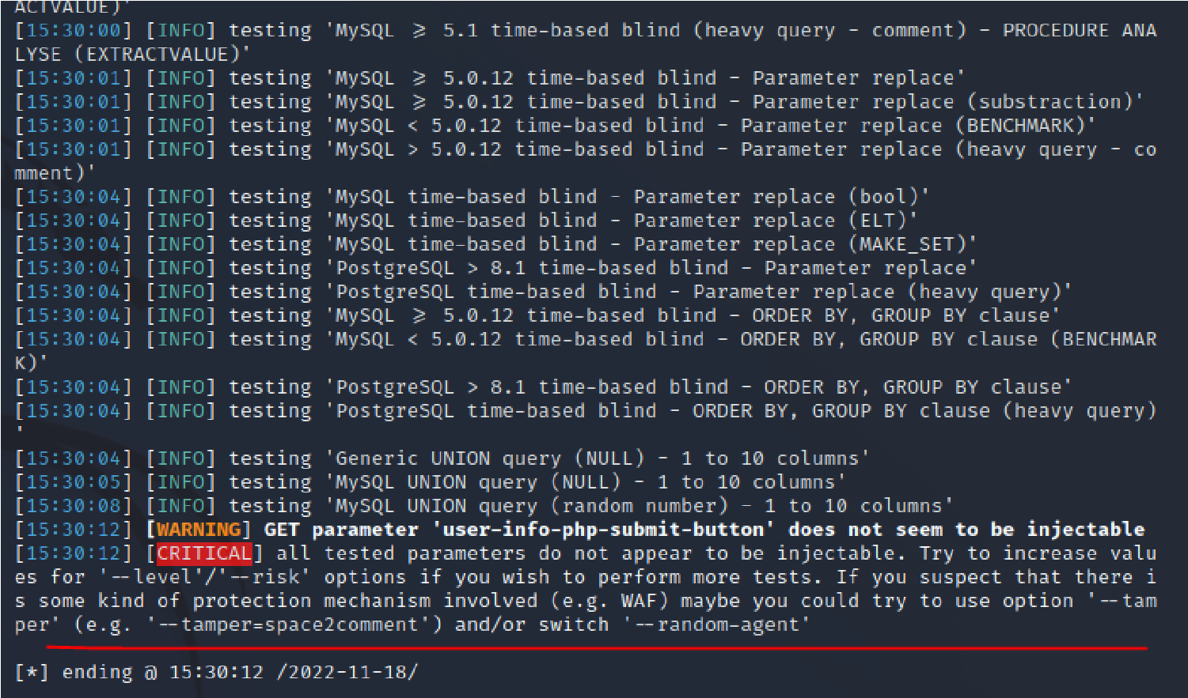

1. To solve the error below modify the config file of metasploitable2. First we will run the command “sudo nano /var/www/Mutillidae/config.inc” to open the config file.

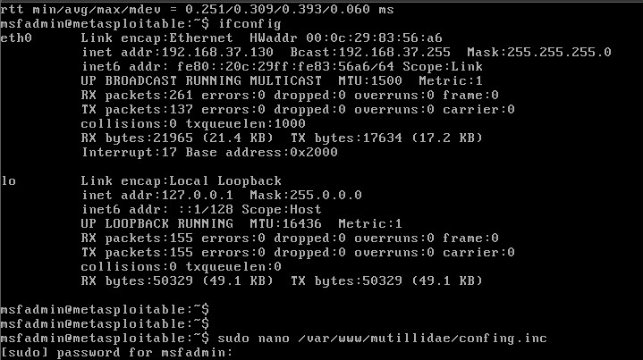

Here we will change the “dbname” to owasp10. Followed by pressing Ctrl+O to save the file and Ctrl+X to exit the nano editor.

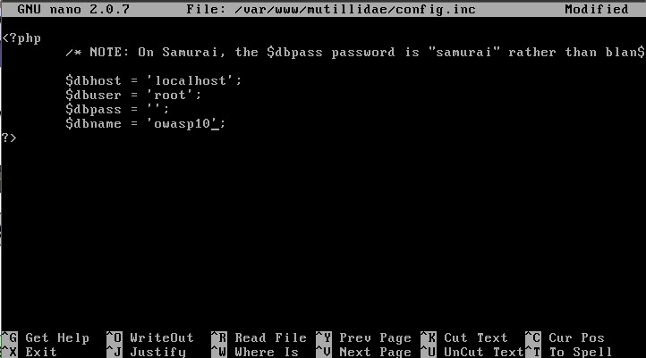

1. After making changes in metasploitable2 you should be able to fix the login page on the website, which will show you the proper error message as it is shown below.

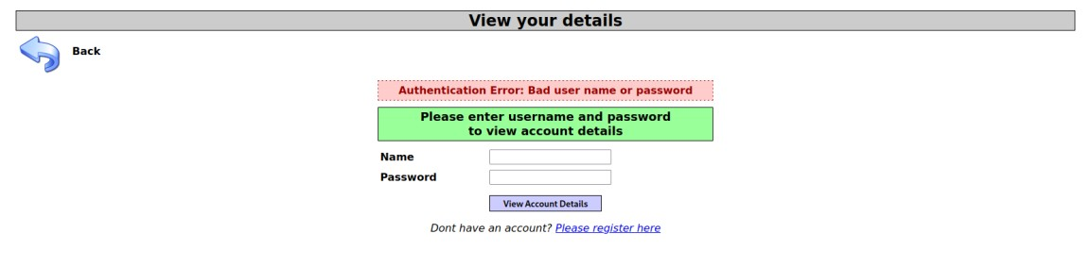

1. Now retry the command and test. The issue should be resolved.

“sqlmap -u

'http://192.168.37.130/mutillidae/index.php?page=userinfo.php&username=admin&p assword=password&user-info-php-submit-button=View+Account+Details' --dbs”

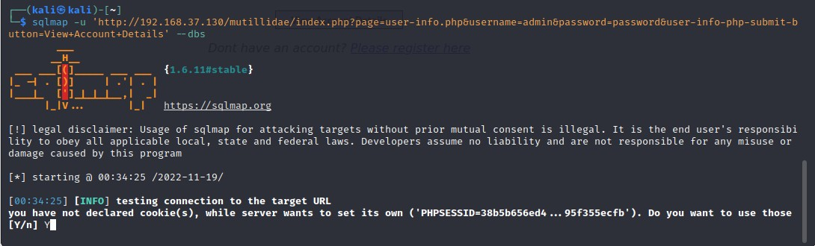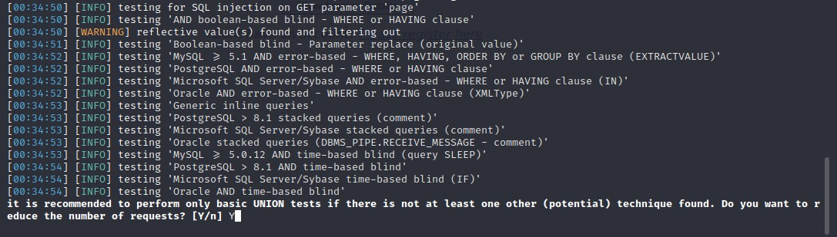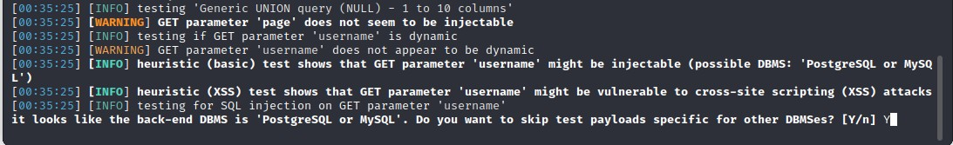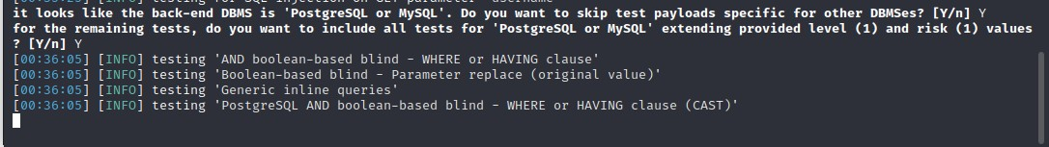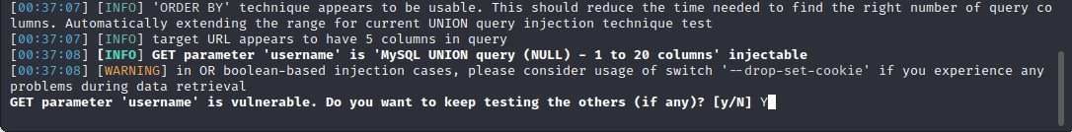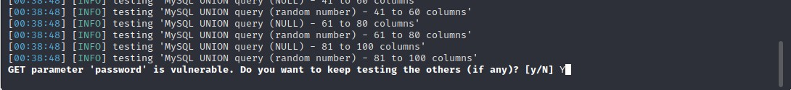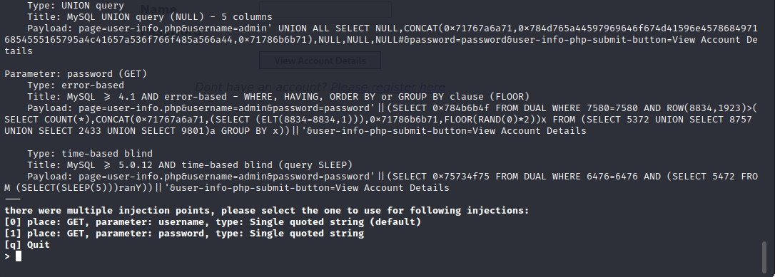

1. You should now be able to view all the databases hosted on the server

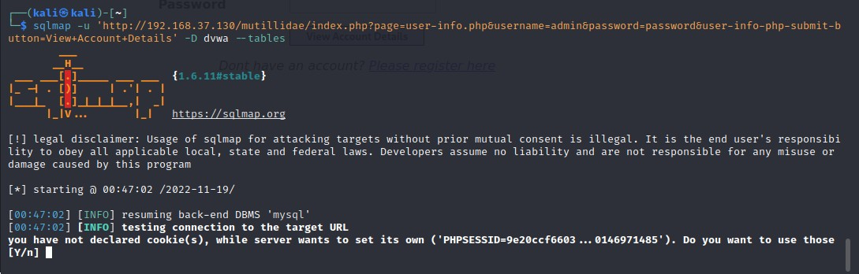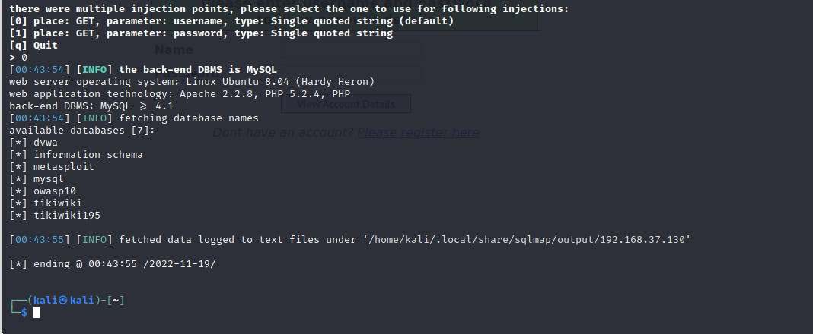

1. Now find the users table for the accounts in the dvwa database. We can run the command:

“sqlmap -u

'http://192.168.37.130/mutillidae/index.php?page=userinfo.php&username=admin&p assword=password&user-info-php-submit-button=View+Account+Details' -D dvwa -tables”

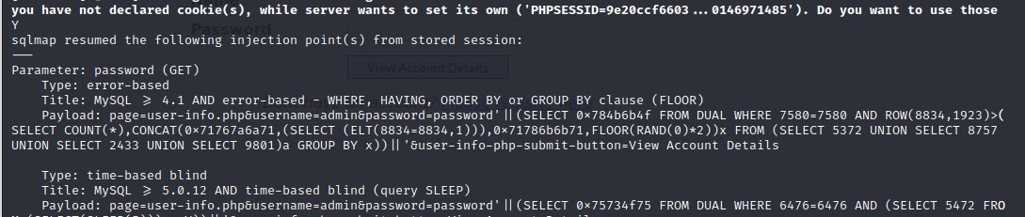

1. Select the ‘0’ Injection point to view the tables

17.

List down the

columns of

‘

users

’

table

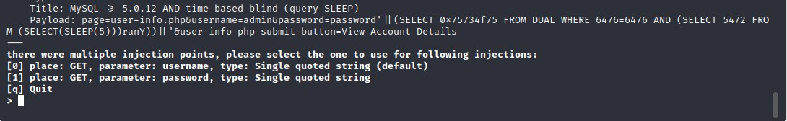

15.

Find the columns of the

‘

users

’

table

.

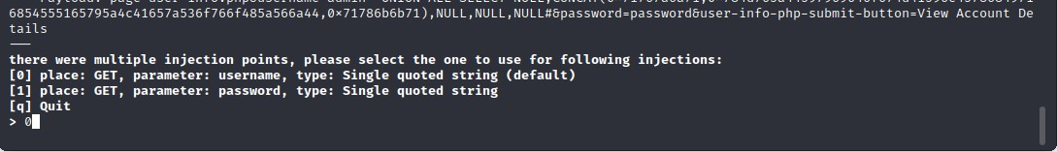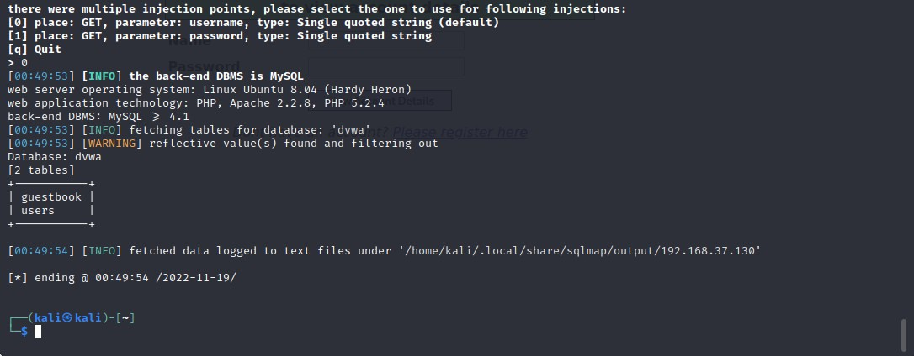

16. We can run the command:

“sqlmap -u

'http://192.168.37.130/mutillidae/index.php?page=userinfo.php&username=admin&p assword=password&user-info-php-submit-button=View+Account+Details' -D dvwa T users --columns”

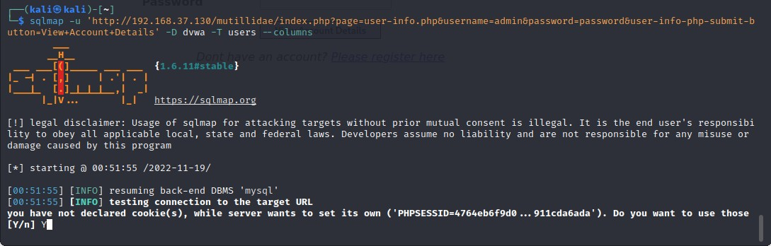

18.

Dump all the details of the

‘

users

’

table

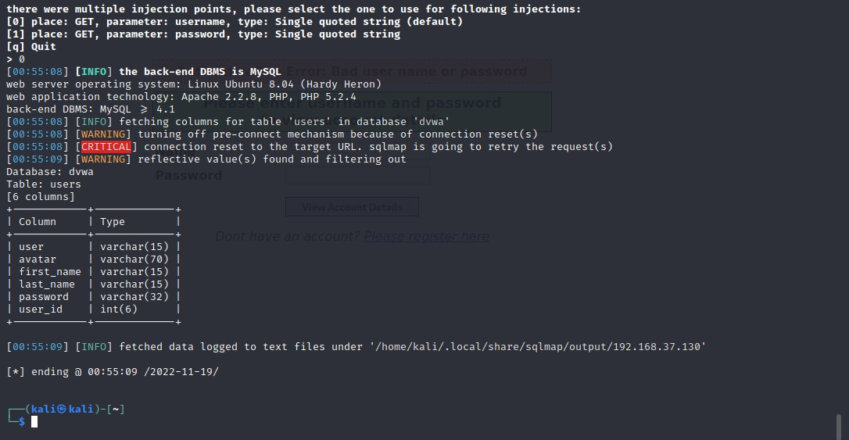

“sqlmap -u

'http://192.168.37.130/mutillidae/index.php?page=userinfo.php&username=admin&p assword=password&user-info-php-submit-button=View+Account+Details' -D dvwa T users --dump”

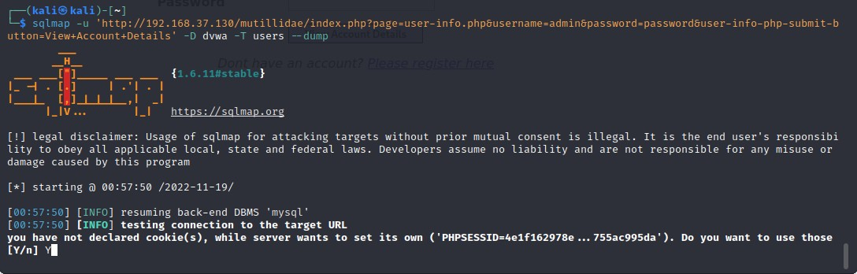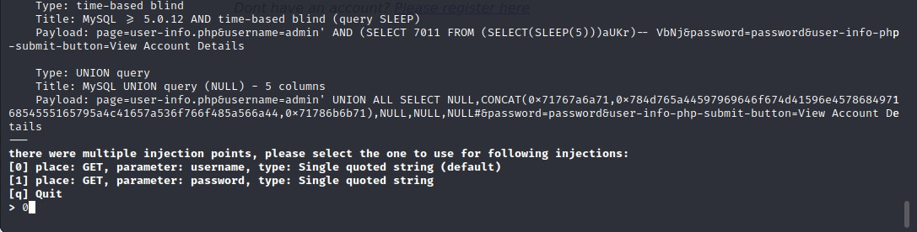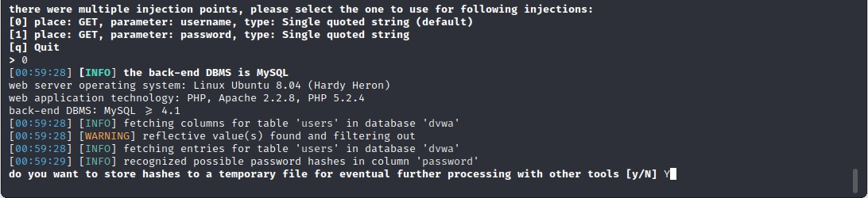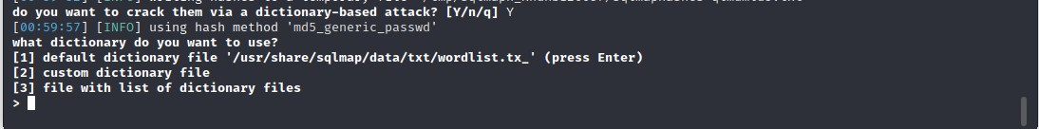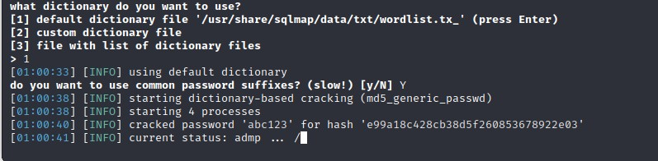

1. Passwords will be cracked once the process is complete. Here you can see all the passwords for every user that is present in the DVWA database.

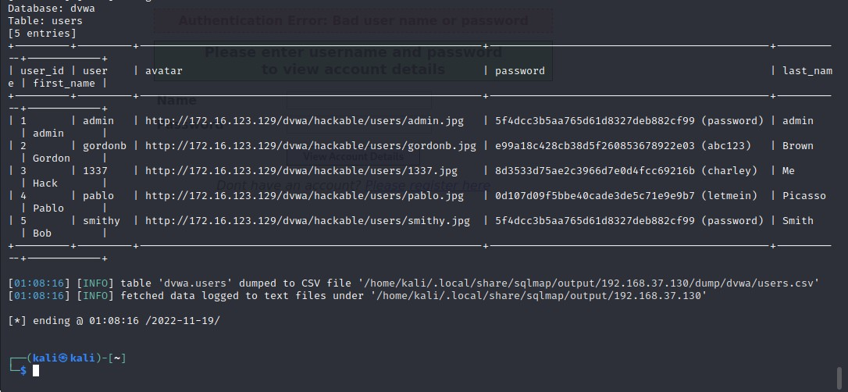

1. Enter one of the cracked username and passwords on the DVWA website and you will be able to log in.

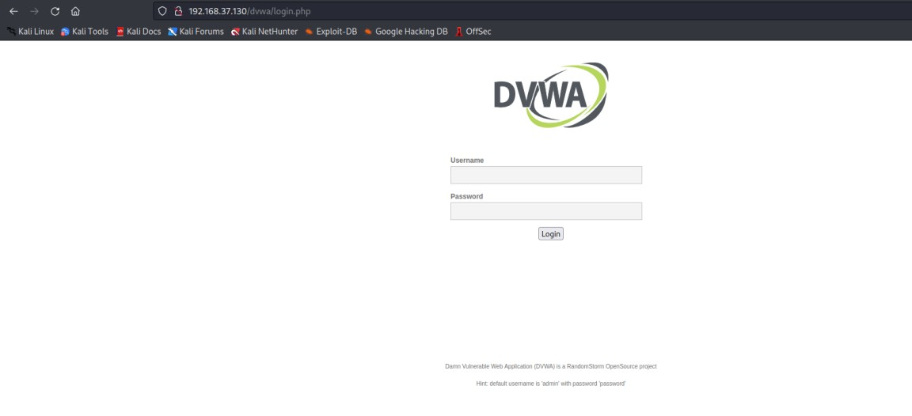

Here we will use the login credentials of the user Pablo with his password ‘letmein’.

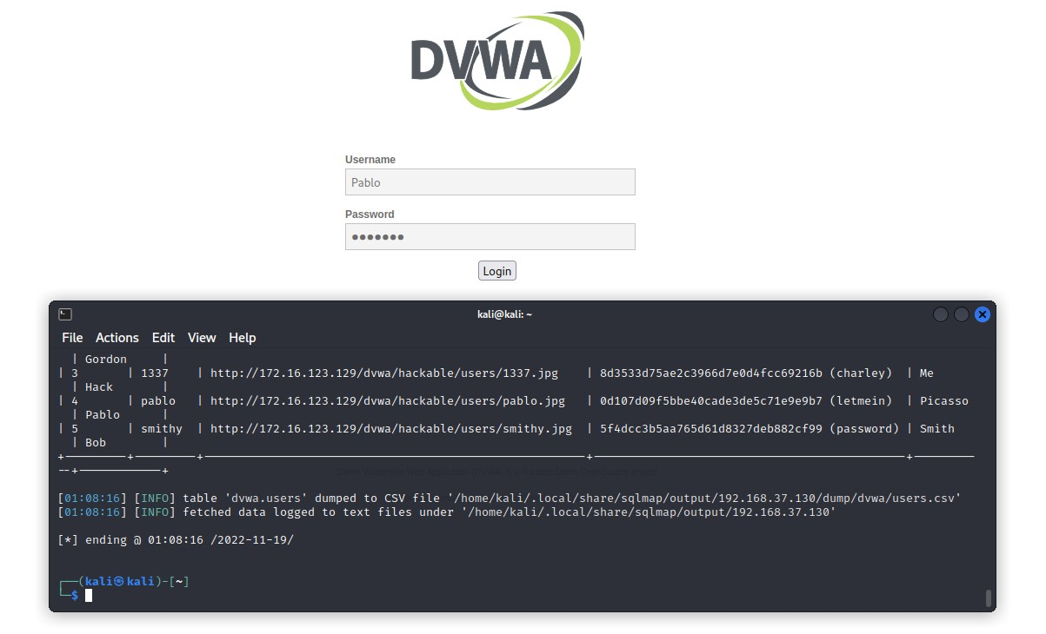

After entering the cracked credentials, you should have access to the main page of the DVWA website.

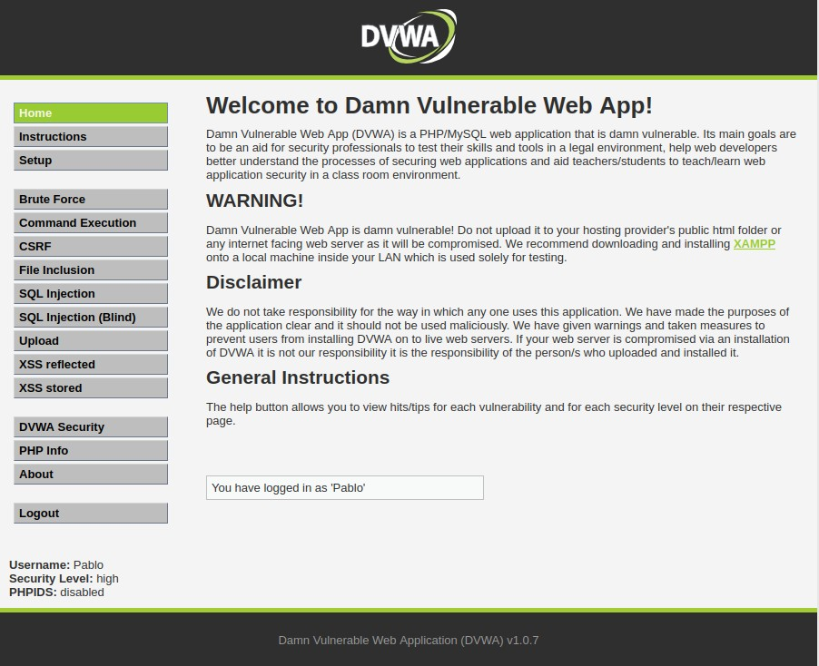

1. Evaluate the same SQL Injection with the Mutillidae website.

Here we will see all the available databases. We will run the following command:

“sqlmap u'http://192.168.37.130/mutillidae/index.php?page=userinfo.php&username=admin& password=password&user-info-php-submit-button=View+Account+Details' --dbs ”

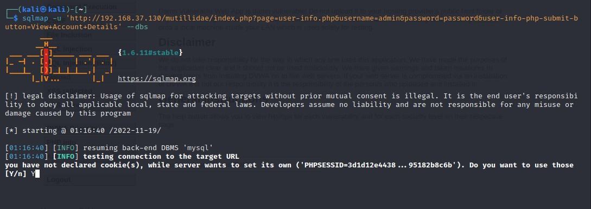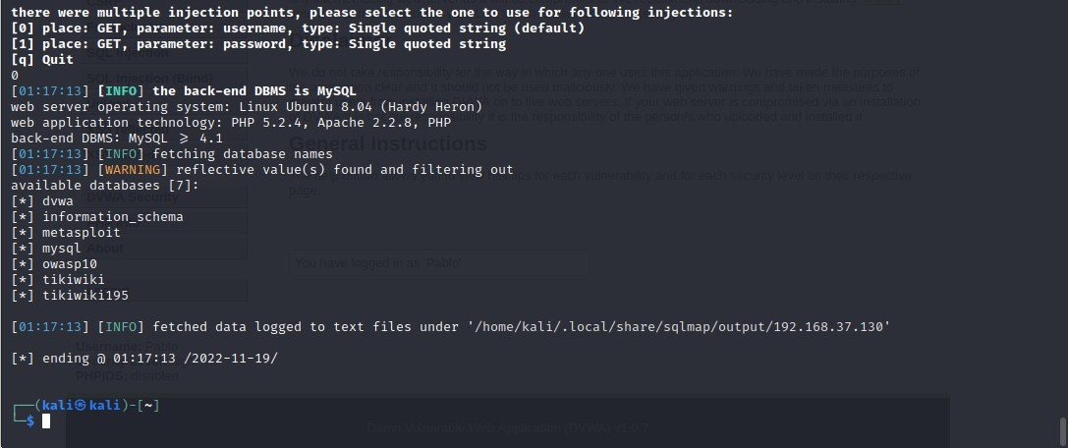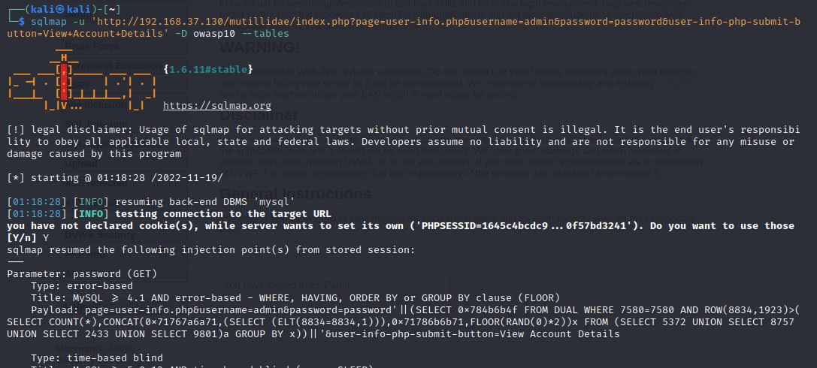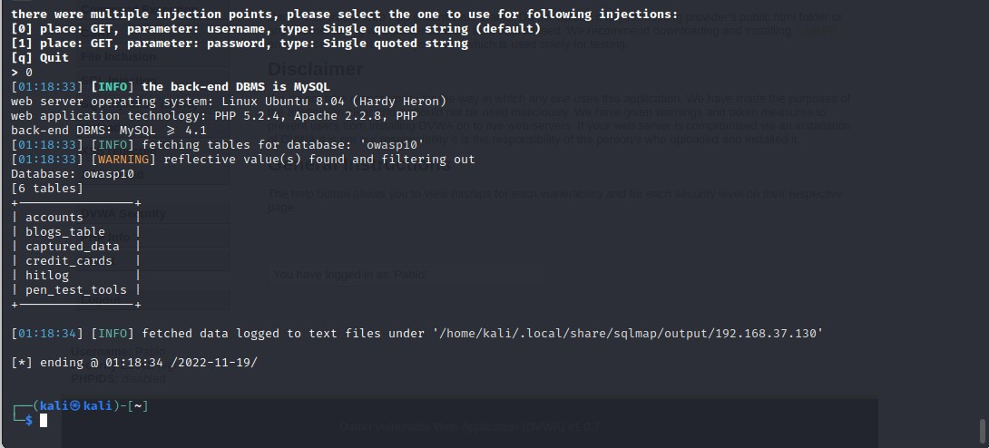

Then we will enter the command to check for the ‘accounts’ table in the ‘owasp10’ database.

“sqlmap -u

'http://192.168.37.130/mutillidae/index.php?page=userinfo.php&username=admin&p assword=password&user-info-php-submit-button=View+Account+Details' -D owasp10 -T accounts --dump “

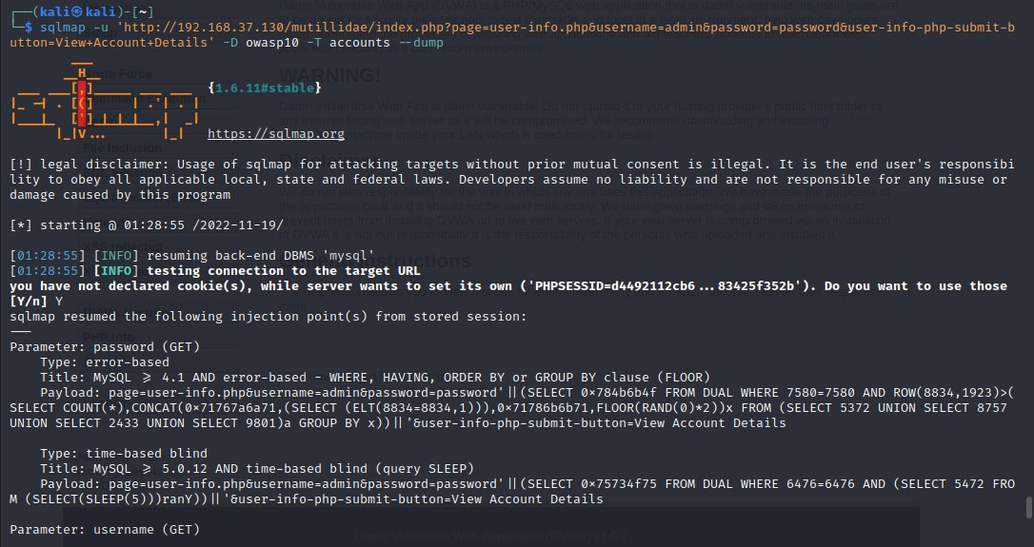

Here we can see all the cracked passwords of every user mentioned in the accounts table.

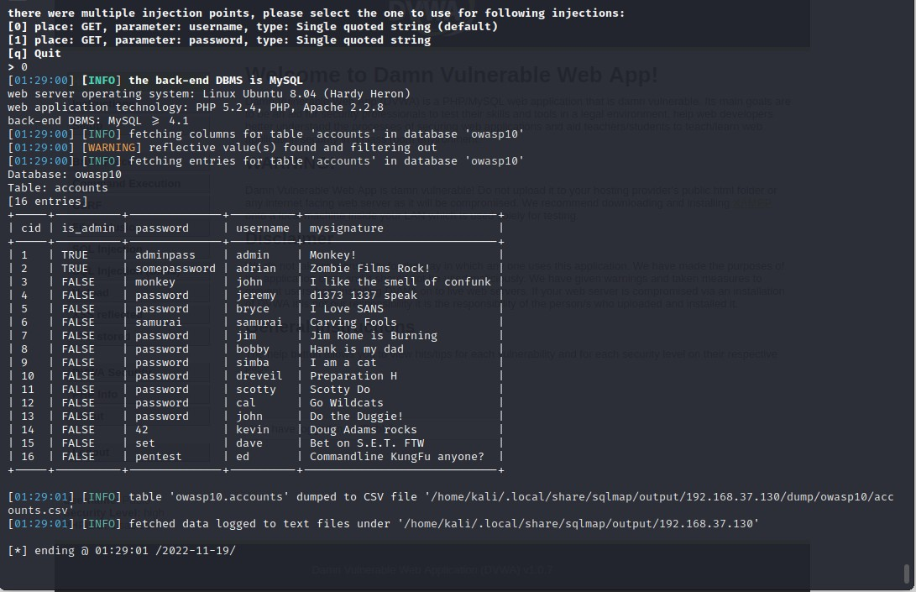

Now we will use one of these credentials, to log into the Mutillidae website.

